

3DKi3 Prusa i3 Build Manual

Table of Contents
1 Changes to the Manual 4
2 The Kit 5
3 Health and Safety 6
4 How To Read This Manual 7
5 Hints and Tips 9
6 Bill of Materials / Parts Identification 10
7 Tools 13
8 Assembly 14
8.1 Assemble Long Sides of Y Axis Frame 14
8.2 Assemble Y Axis Idler 17
8.3 Assemble Y Axis Motor Mount 18
8.4 Assemble Y Axis 20
8.5 Attach Y Carriage and Belt to Y Frame 24
8.6 Assemble Bed and Attach to Y Carriage 29
8.7 Assemble X Axis Motor Mount 32
8.8 Assemble X Axis Idler Mount 35
8.9 Assemble X Axis 38
8.10 Attach Z Motors to Z Axis Frame and Mount Y Axis 40
8.11 Attach X Axis to Z Axis 45
8.12 Attach Stabilisers, Endstop and Timing Belt 49
8.13 Assemble Hot End and Mount 53
8.14 Assemble Extruder 56
8.15 Attach Extruder to X Carriage 62
8.16 Attach Electronics 64
8.17 Clip Borosilicate Printing Surface to Bed 68
9 Toolchain and Software Installation 69
9.1 Installing the Arduino Development Environment 71
9.2 Installing Pronterface and Slic3r 72
Getting Pronterface 72
Installing Pronterface 72
Getting Slic3r 73
Installing Slic3r 73
Configuring Pronterface 73
Configuring Slic3r 75
10 Wiring 77
10.1 RAMPS 77
10.2 A Note About Stepper Drivers 79
10.3 Cabling 80
10.4 Extruder and Stepper Motors 81
10.5 Thermistors 82
10.6 End Stops 83
10.7 Smart Controller 85
10.8 Heated Bed, Blower Fan and Hot End 86
10.9 Power Supply and Cooling Fans 87
11 Commissioning and Calibration 91
11.1 Commissioning your Printer 91
11.2 Calibrating Your Printer 99
12 Printing With Your Printer 100
13 Maintenance 103
13.1 Regular Maintenance 103
13.2 Cleaning the Print Head 104
14 Licence, Attributions and Thanks 105
14.1 Licence 105
14.2 Attribution 105
14.3 Thanks 105

Changes to the Manual

Version | Chapter | Description
1.2 | 8.13 | Added instructions for making the extruder compatible with flexible filament.
1.2 | 10.9 | Corrected polarity of fan connections on diagram.
1.2 | 10.4 | Added warning regarding disconnecting / connecting stepper motors with power to RAMPS.
1.2 | 10.4 | Clarified wiring guide for stepper motor connections.
1.2 | 6 | Removed redundant hot end thermistor cable from the kit. NB: hot end thermistor cable is supplied with the E3D hot end package in the kit.
1.2 | 8.7, 8.8, 8.9 | Improved X axis idler and motor mount designs; assembly instructions modified to reflect improved design.
1.2 | 8.10, 8.11 | Replaced flexible couplers with spider couplers, as the latter work better under compression.
1.2 | 9.2 | Clarified Slic3r configuration instructions.
1.2 | 12 | Changed chapter from “what next” to “printing with your printer” and improved printing instructions.
1.2 | 14 | Added Licence, Attribution and Thanks chapters.
1.2 | 11.1 | Improved Z axis end stop calibration instructions.
1.2 | 8.16 | Changed use of M3 20mm nuts to secure full graphic controller, to M3 25mm nuts.

The Kit
RepRap is a community project with the stated goal of making self-replicating manufacturing machines (3D printers) freely available for public benefit. The Prusa i3 is the third iteration design (i3 = 3rd iteration) design of a reprap 3D printer by Josef Prusa, one of the RepRap core developers. The i3 has a number of improvements over the Prusa Mendel Iteration 2, including:
- Improved frame rigidity.
- Easier assembly.
- Parametric design files to support multiple sizes of bearings.
The 3DKi3 is based on the Prusa i3 rework variant, with some specific additional modifications:
- Improved frame stability.
- Improved bed stability.
- Support for the E3D V6 all-metal hot end.
- X-axis belt tensioning.
- Integrated electronics cooling.
As well as improvements in design, the components of the 3DKi3 kit are specified to a high level of quality:
- All nuts, bolts and threaded rods are, wherever possible, made from A2 stainless steel for a combination of corrosion resistance and durability.
- All smooth rods are surface hardened and precision ground.
- The kit comes supplied with an E3D v6 hot end, one of the newest and most highly regarded hot ends in the 3D printer world.
- The kit comes supplied with RAMPS v1.4 electronics. RAMPS v1.4 is one of the most stable and reliable electronics packages available for reprap printers – with the added benefit that it has support for an additional extruder and hot end, should you wish to enhance your kit.
- The kit comes supplied with a smart controller for headless printing. This means you'll be able to print without having a dedicated laptop connected to your computer.
- The kit comes supplied with a borosilicate glass sheet printing surface. Many kits come with a pane of ordinary glass, if they are supplied with one at all. Borosilicate glass will withstand the heat stresses of the heated bed; normal glass tends to crack after repeated heating / cooling cycles.
The prusa i3 design, and the 3DKi3 design, are open source, so you are free to download the designs, modify them and hack your printer to create something unique and personal. The 3DKi3 kit is enough to get you up and running – where you go from there is up to you.

Health and Safety


This is a kit of components requiring assembly by the end user. Building and using the printer involves the use of electricity and high temperatures and is potentially very dangerous.
Parts of your printer are capable of reaching very high temperatures. Both the heated bed and hot end are more than capable of burning you. Never touch the bed or hot end when heated or leave your printer running unattended.
Building and using the printer involves the use of electricity. Appropriate precautions should be taken to ensure assembling and operation your printer are conducted in a safe manner.
Your printer should not be left unattended while in use.
Ensure your printer is powered off and unplugged before doing any work on the electrics of your printer.
Please be careful when assembling your printer. Knives, screwdrivers and spanners can cause a lot of damage.
Ultimately we cannot be responsible for your health and safety while building or operating your printer. Please use your common sense and ensure you build and use your printer in a safe manner.

How To Read This Manual
The assembly of your printer is broken down into logical steps, each in its own chapter. Each step will start with a list of all the parts needed to complete that step, including pictures and the quantity required:
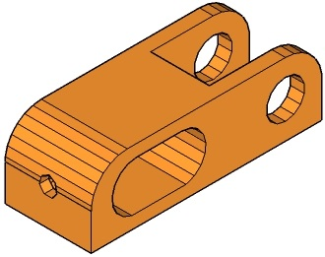 | 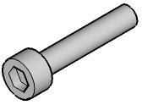 | 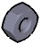 | 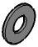 | 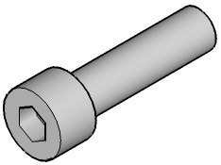 | 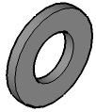
[1x]  Y Axis Idler | [1x]  M3 16mm  Cap Head Screw | [2x]  M3 Nut | [1x]  M3 Washer | [2x]  M8 30mm  Cap Head Screw | [4x]  M8 Washer

Immediately below the list of parts will be a top or side view of the completed assembly for that step. Each assembly will be labelled so that it can be referenced for use in other steps later in the build:
A
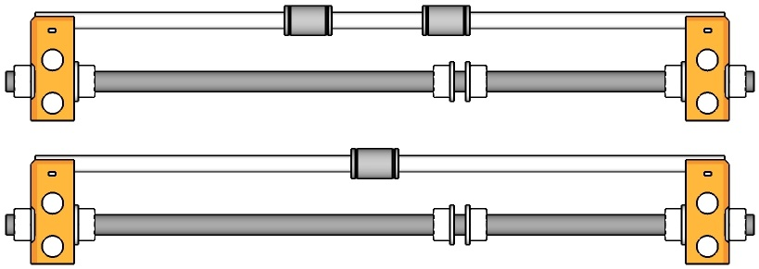
B

Following the assembly diagram will be an isometric exploded diagram showing how the parts fit together, and following that will be a description of the steps required to put the assembly together Where required, measurements will be included within the diagrams:

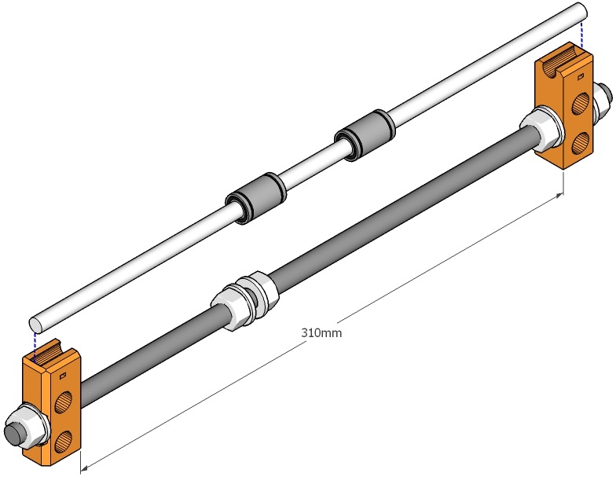

Hints and Tips
Work on a flat and level surface. This will help make sure that the frame of your printer is square.
At certain points during the build process, you will need to press bearings, smooth rods or nuts into plastic parts. The easiest way to do this is with a pair of multi-grips – but take extra care. Plastic is obviously a lot softer than metal and if you use too much force the part will crack. Go slowly and only use as much force as you need to get the job done.
At times you will also need to tighten bolts against plastic parts. Don't use too much force or you risk deforming or cracking the part.
Some of the holes in the parts can be a tight fit. If necessary, use a drill bit to ream holes out. Don't use a power drill – you run a significant risk of destroying the part. Go slowly, by hand.
Plastic parts will wear over time. One of the first jobs you should do, once your printer has been built and calibrated to your satisfaction, is to print a set of replacement plastic parts for your 3D printer. You can download the full set of STL files for all the plastic parts in your printer from our download page at http://www.3dkarma.com/content/7-downloads.

Bill of Materials / Parts Identification
As well as this manual, we provide a downloadable A2 poster that includes pictures of most of the parts included in your kit, in 1:1 scale. This is your main source for identifying parts in the kit. You can either download the poster from our website and print it yourself, or order a copy from our webshop. The poster can be downloaded from our downloads page, at
http://www.3dkarma.com/content/7-downloads
The easiest way, for example to find out which of your M3 cap head screws is the 25mm one is to find out which of the screws in the kit is the same size as the one printed on the poster.
The top left quadrant of the poster contains a 1:1 scale diagram of the Y frame of your printer. You can use this to lay out the frame to the correct spacing. Dimensions for the frame are also given in the relevant assembly instruction chapters.
In addition to the parts pictured on the poster, your kit comes with:
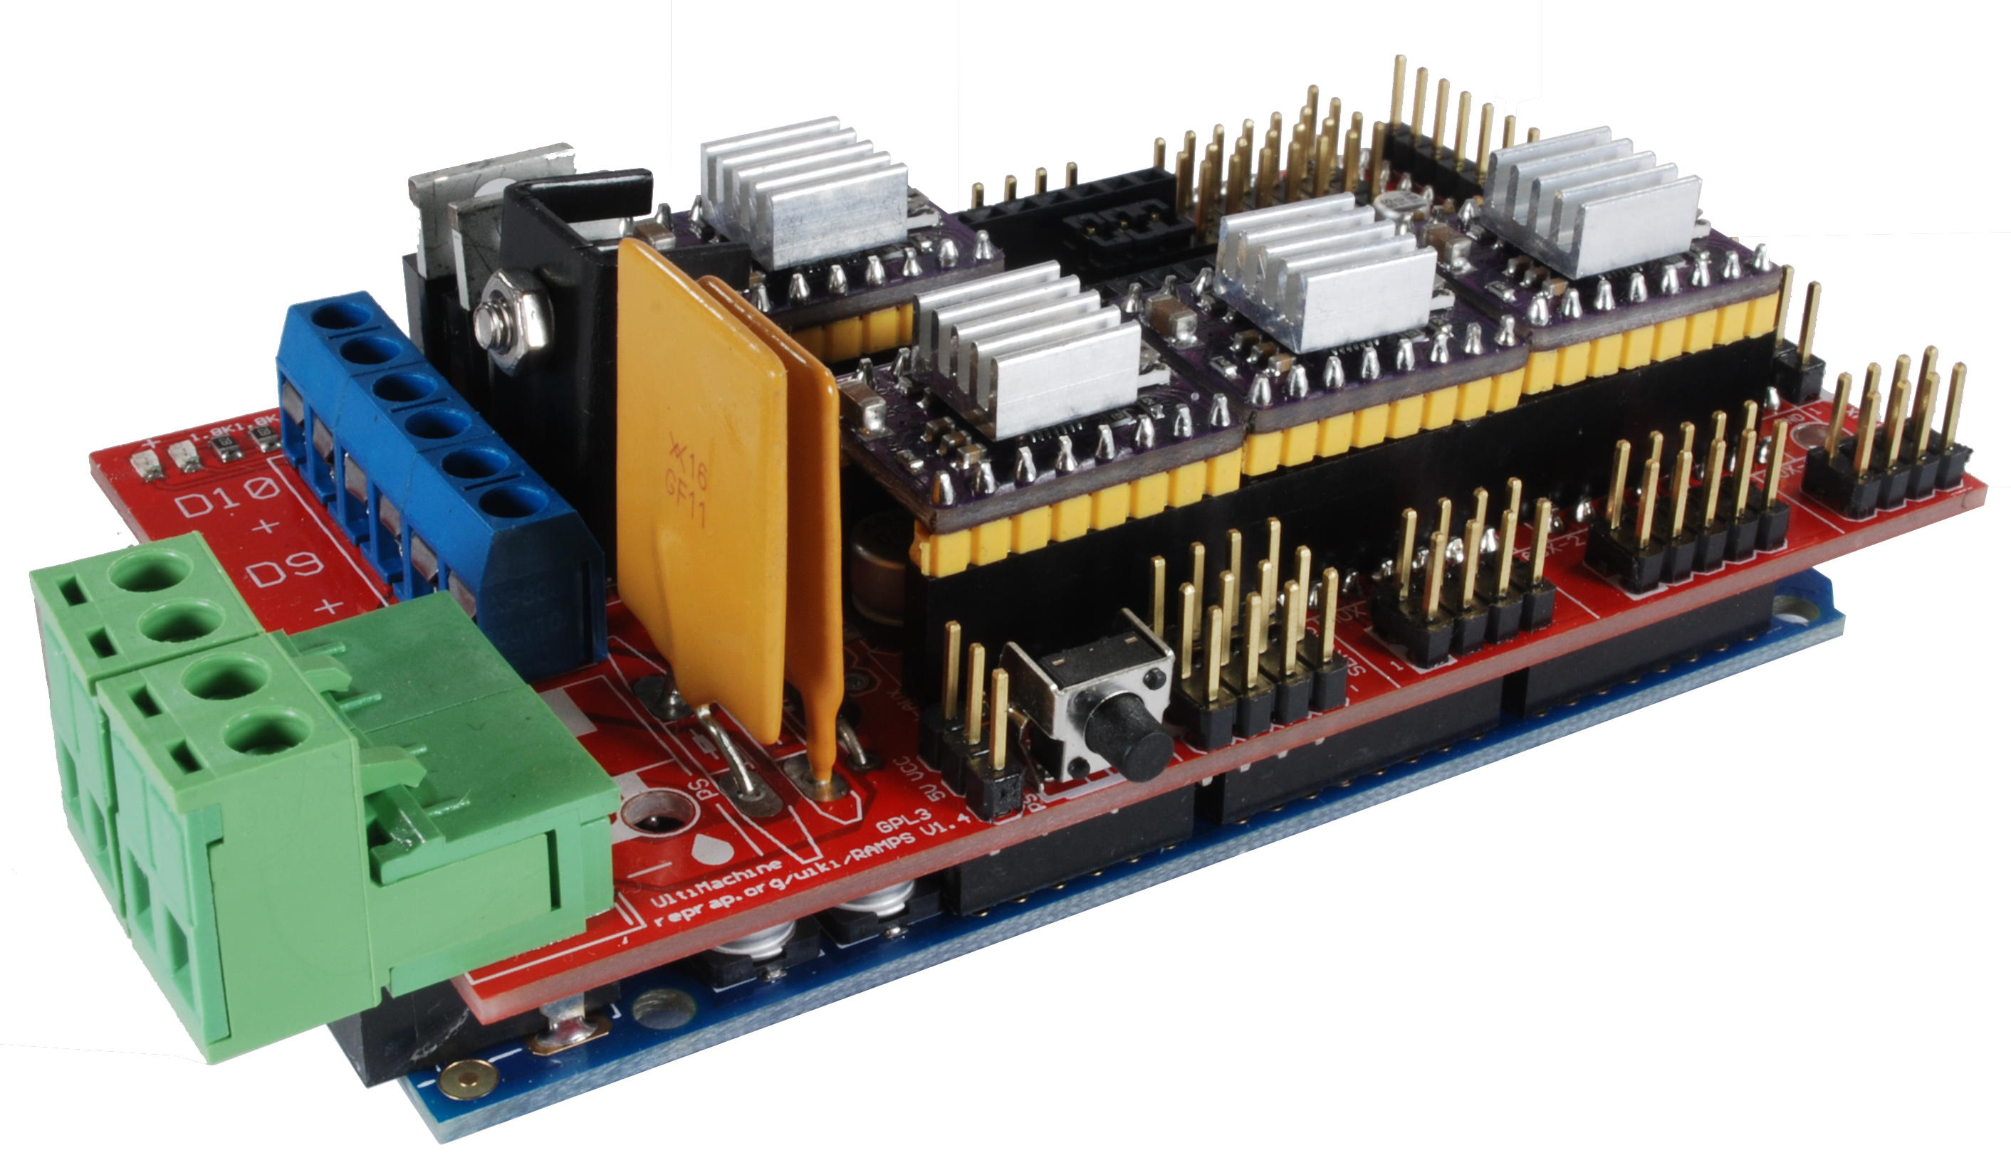 | RAMPS, Arduino and stepper driver electronics.
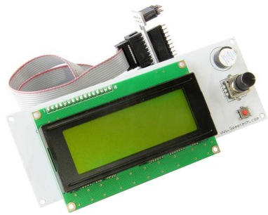 | A smart controller with SD card support, cables and an adaptor for connecting to the RAMPS board..
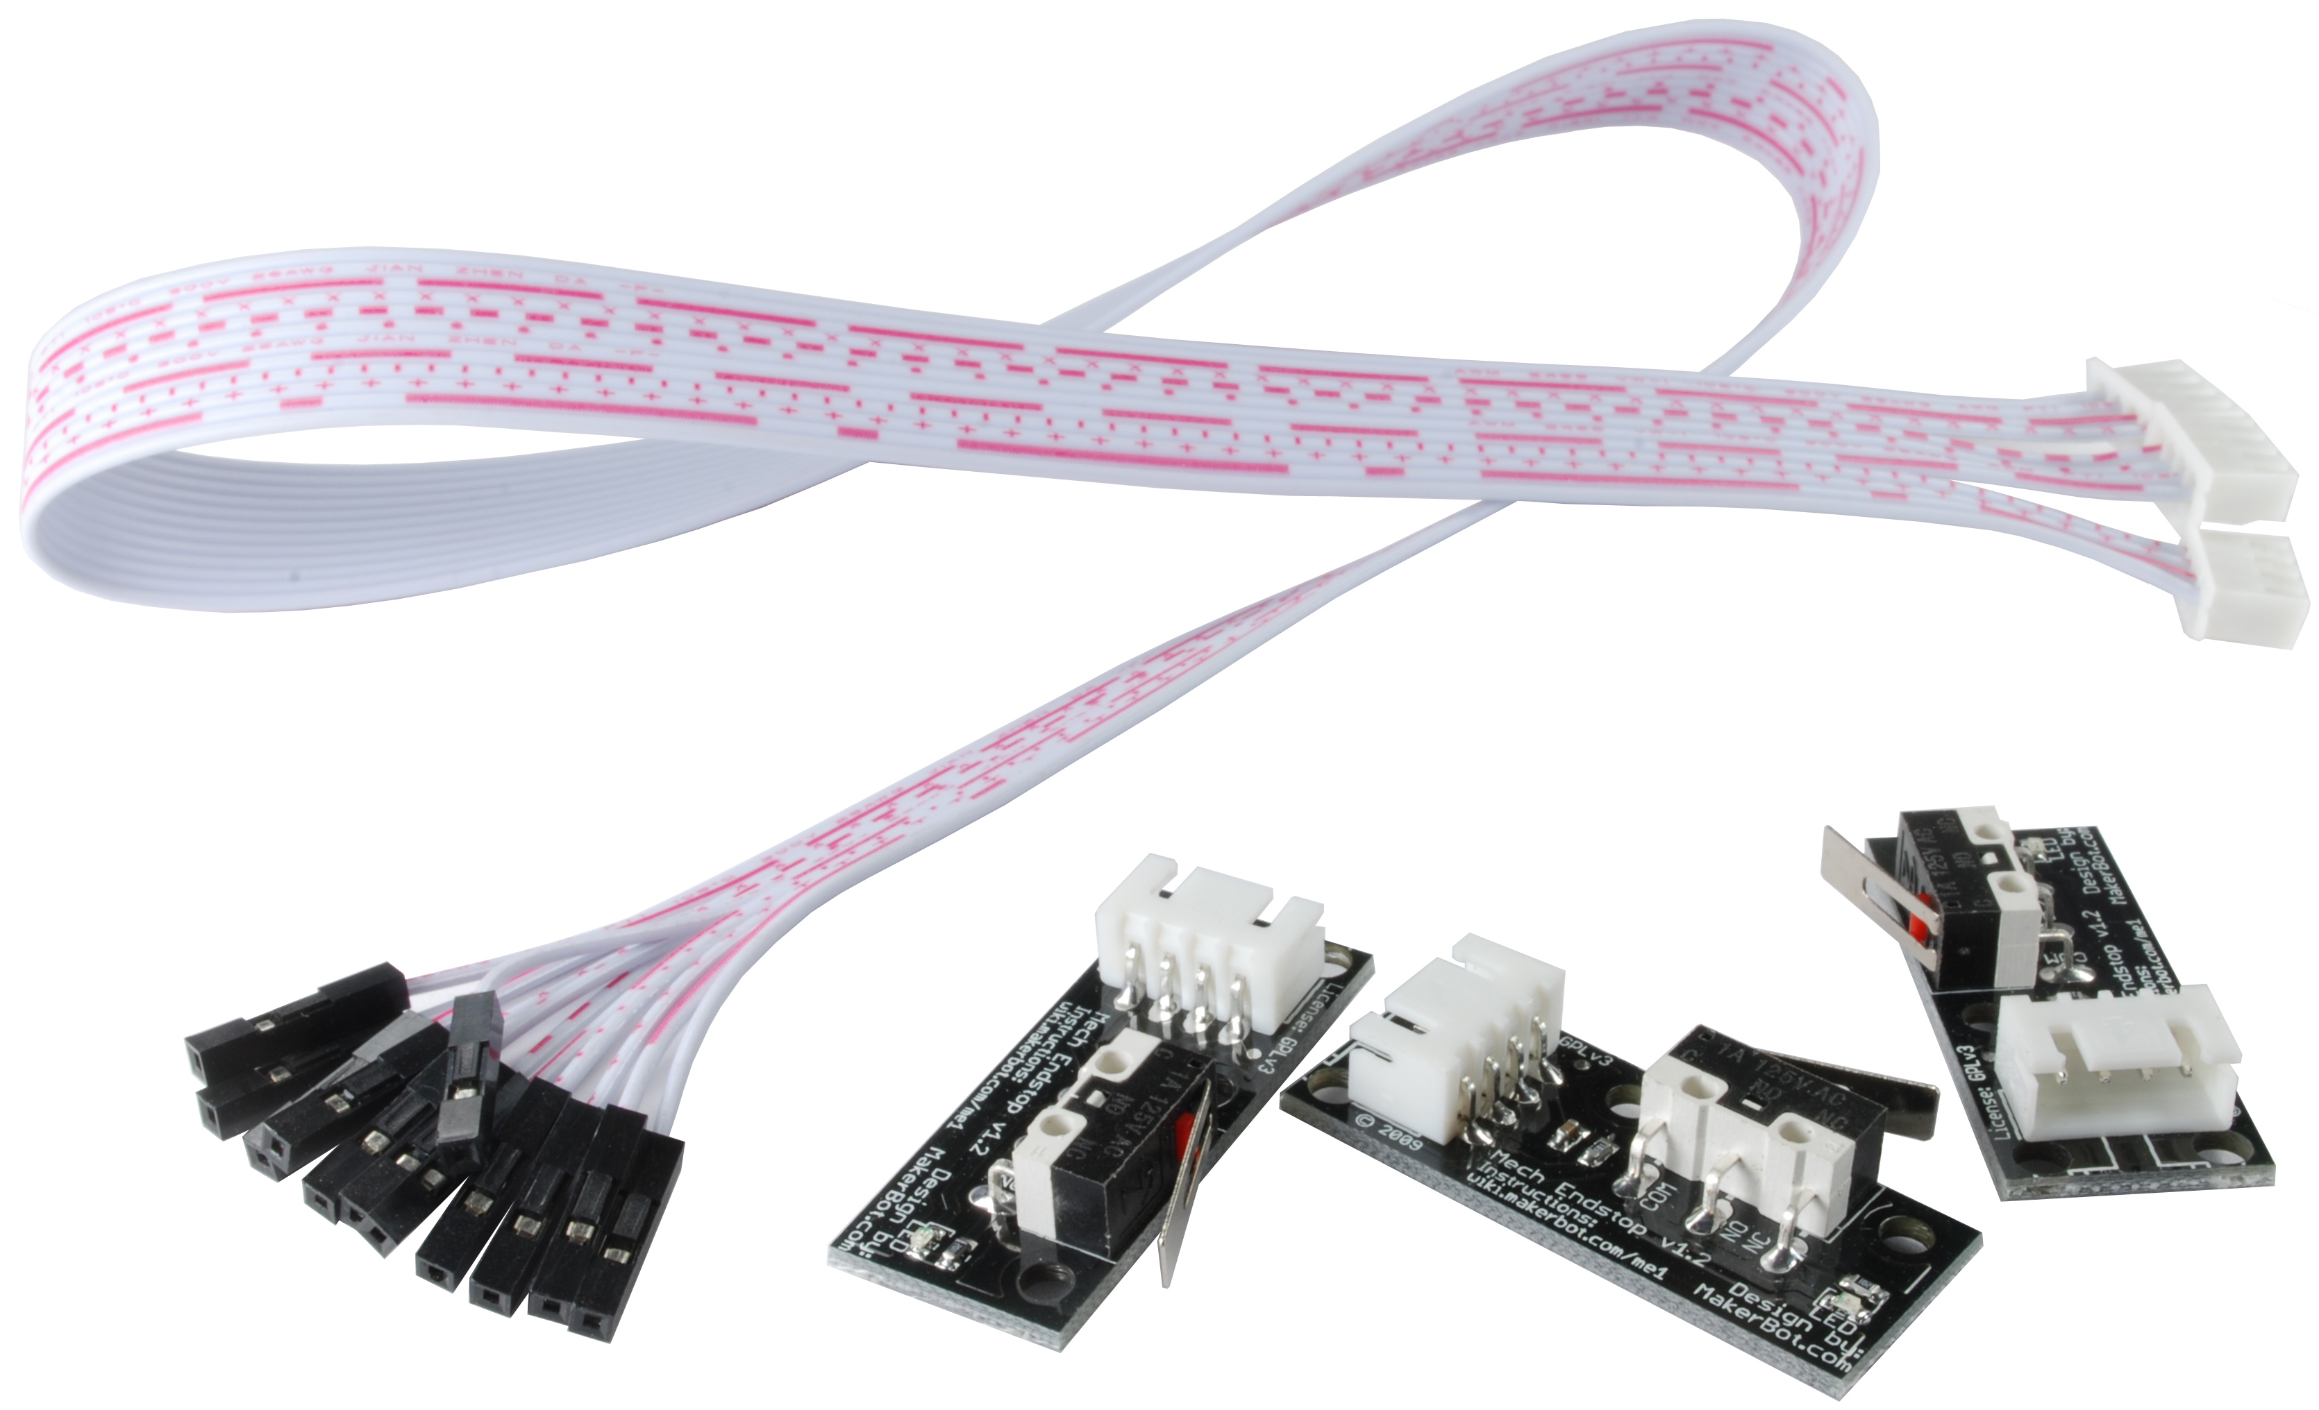 | Mechanical end stops [x3] with cables.
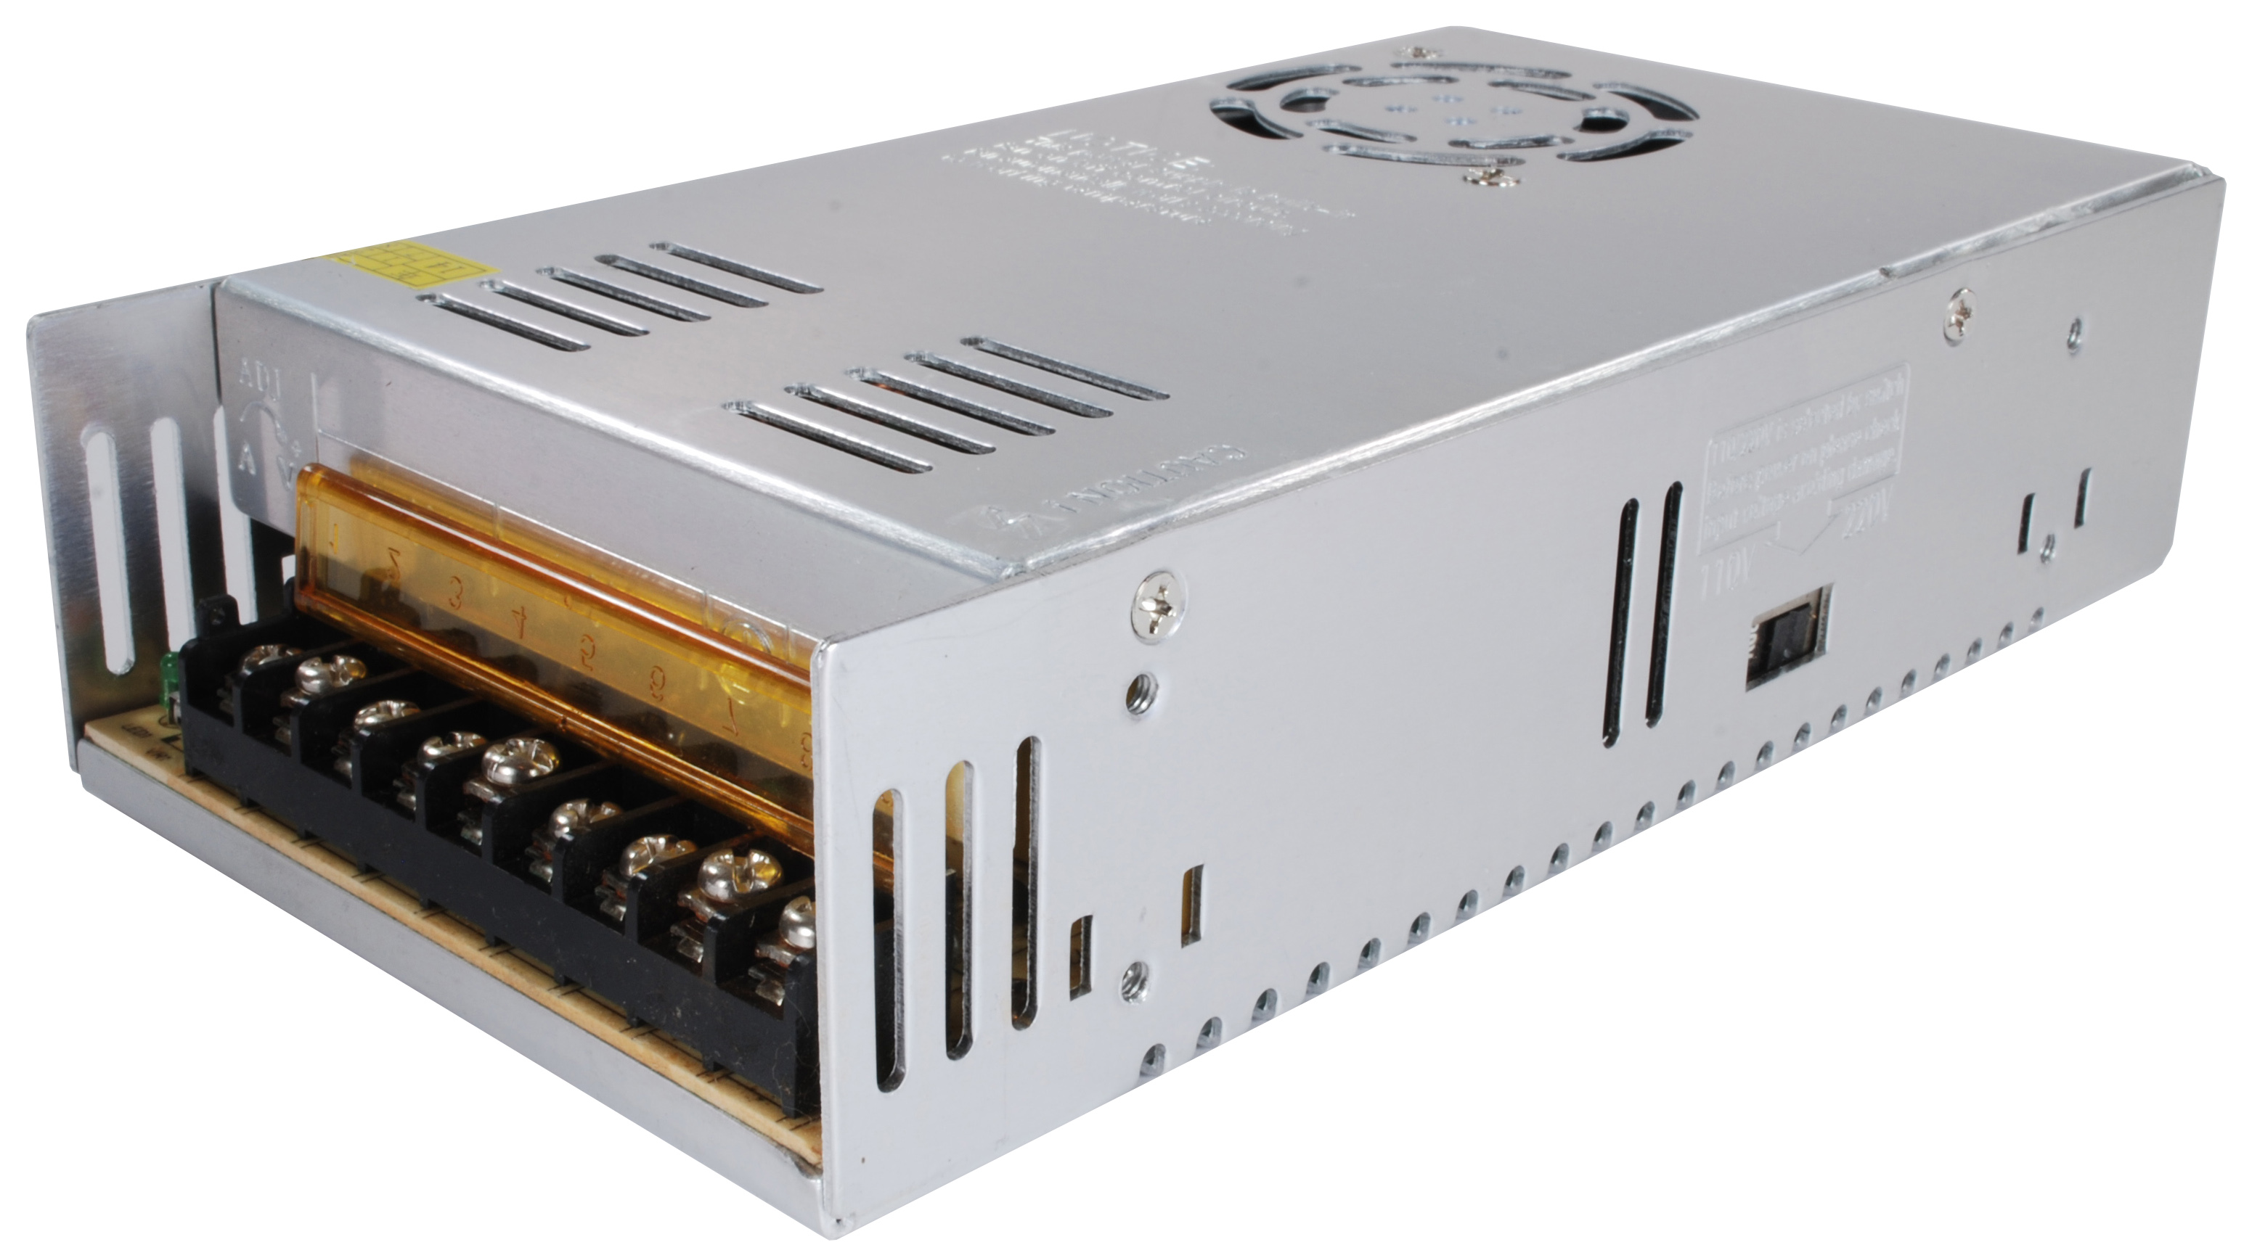 | A power supply.
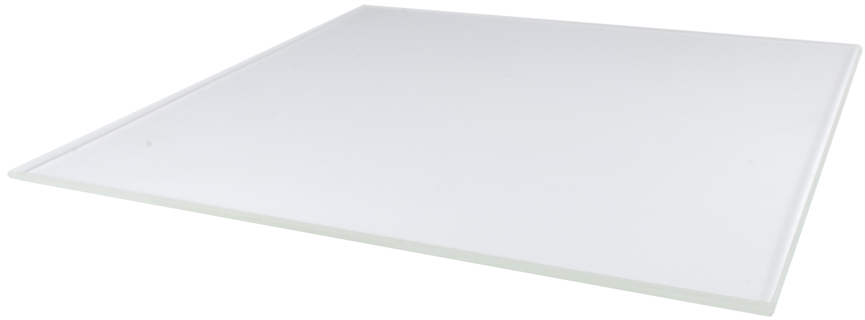 | A borosilicate glass sheet printing surface.
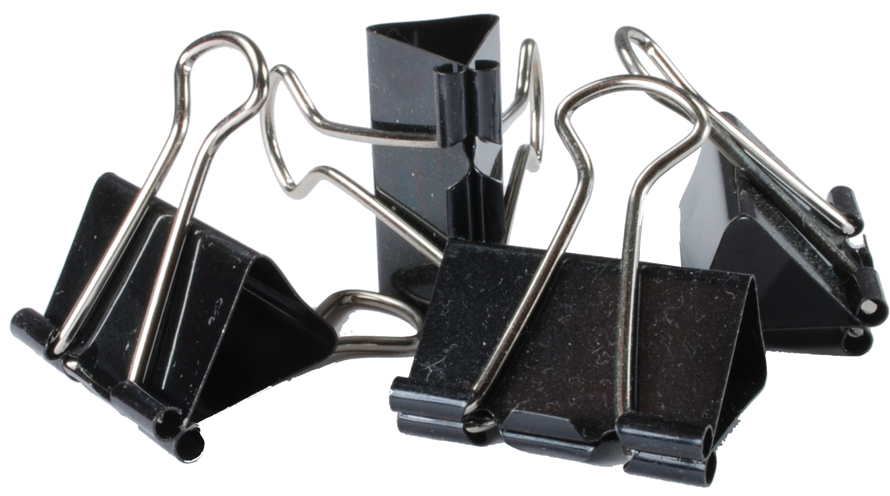 | Clips to secure the borosilicate sheet.
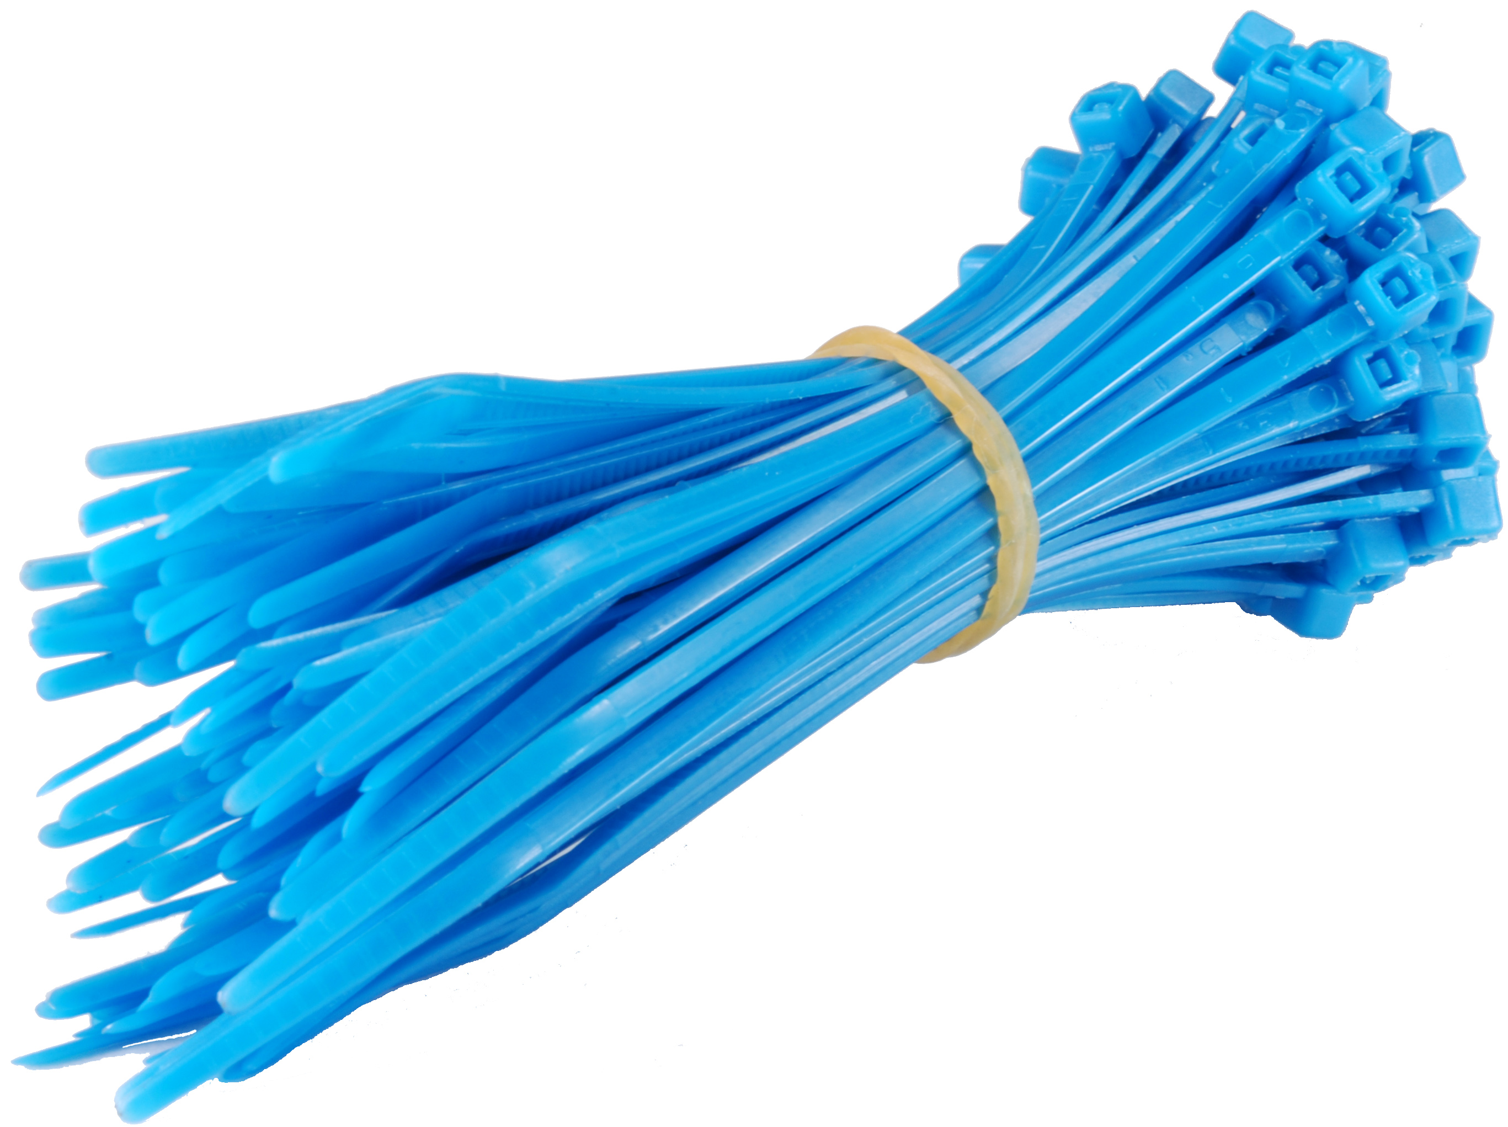 | Cable ties. These probably won't be blue, but white doesn't photograph that well.
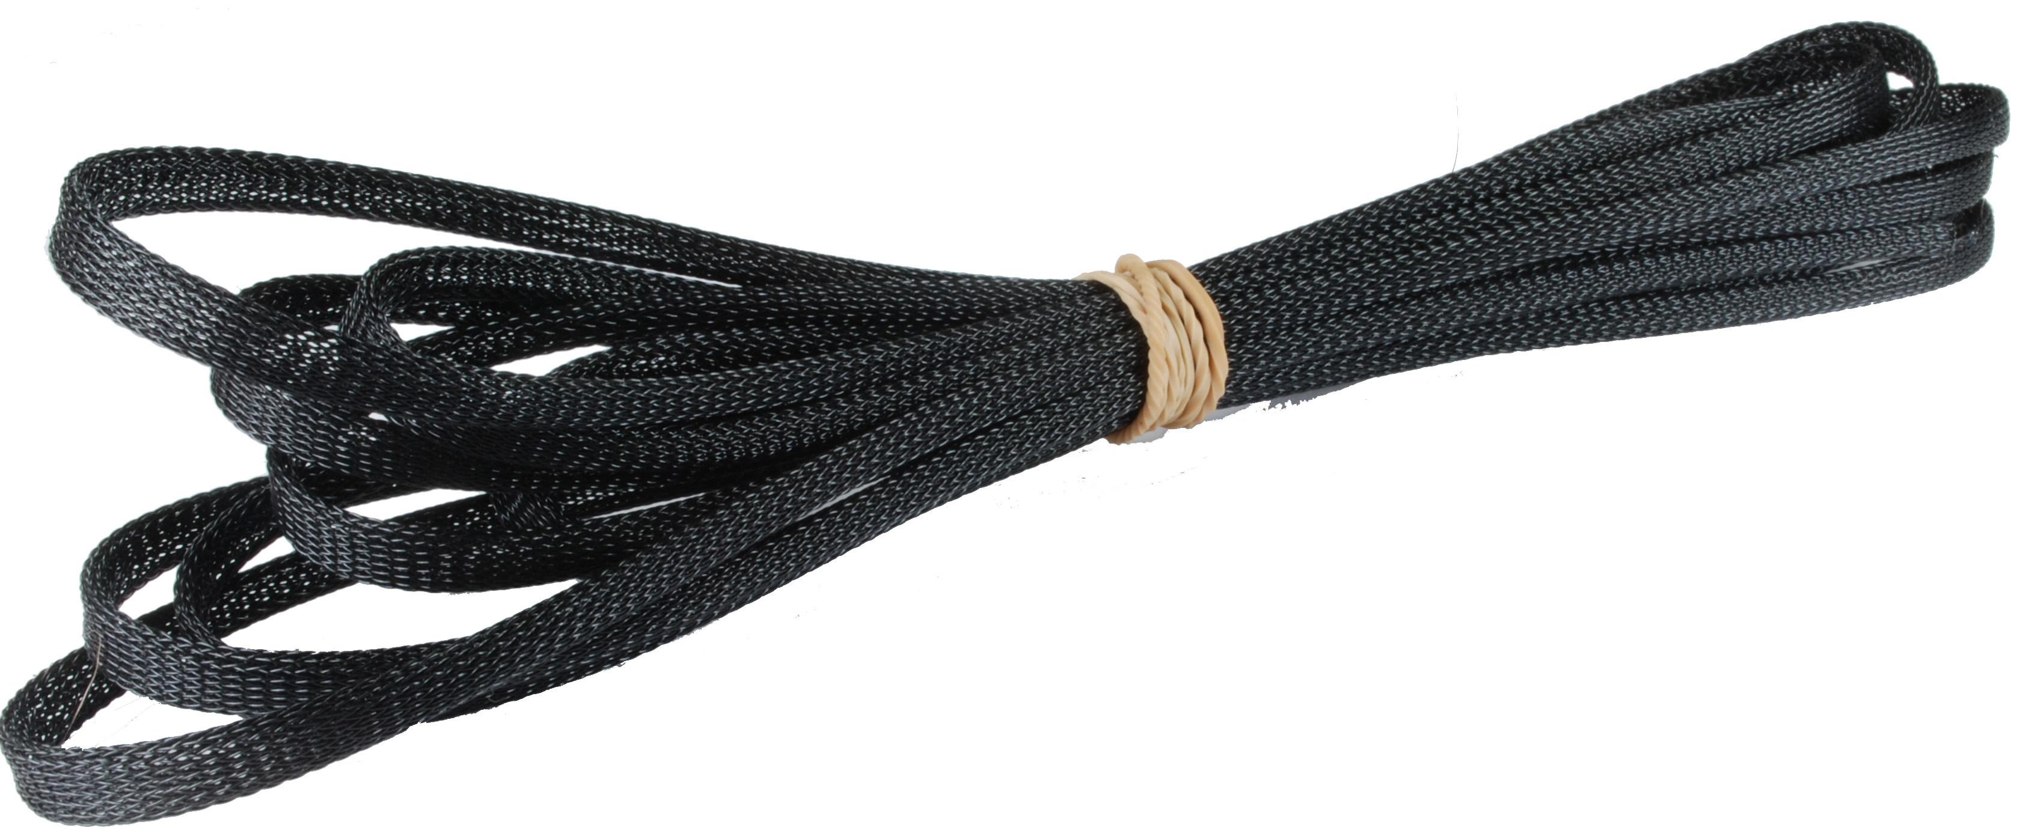 | Cable sheathing.
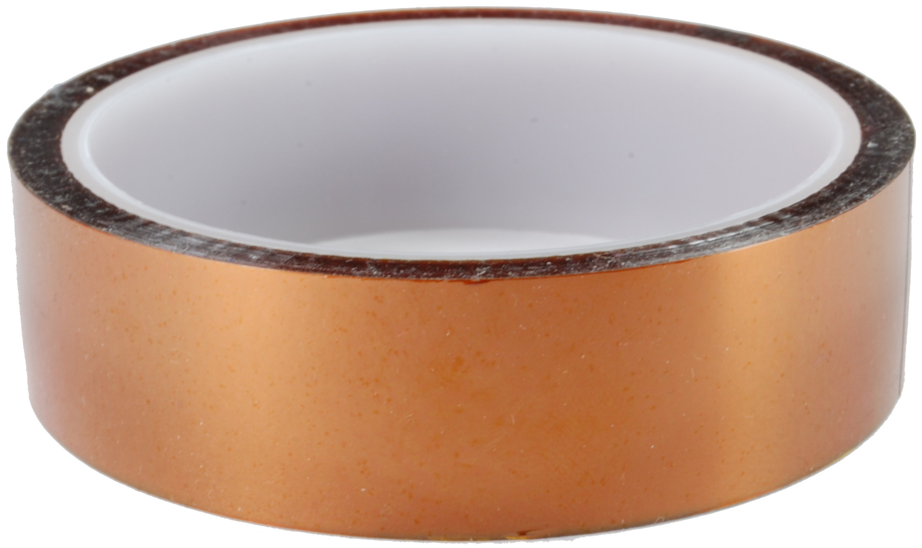 | A roll of Kapton tape.
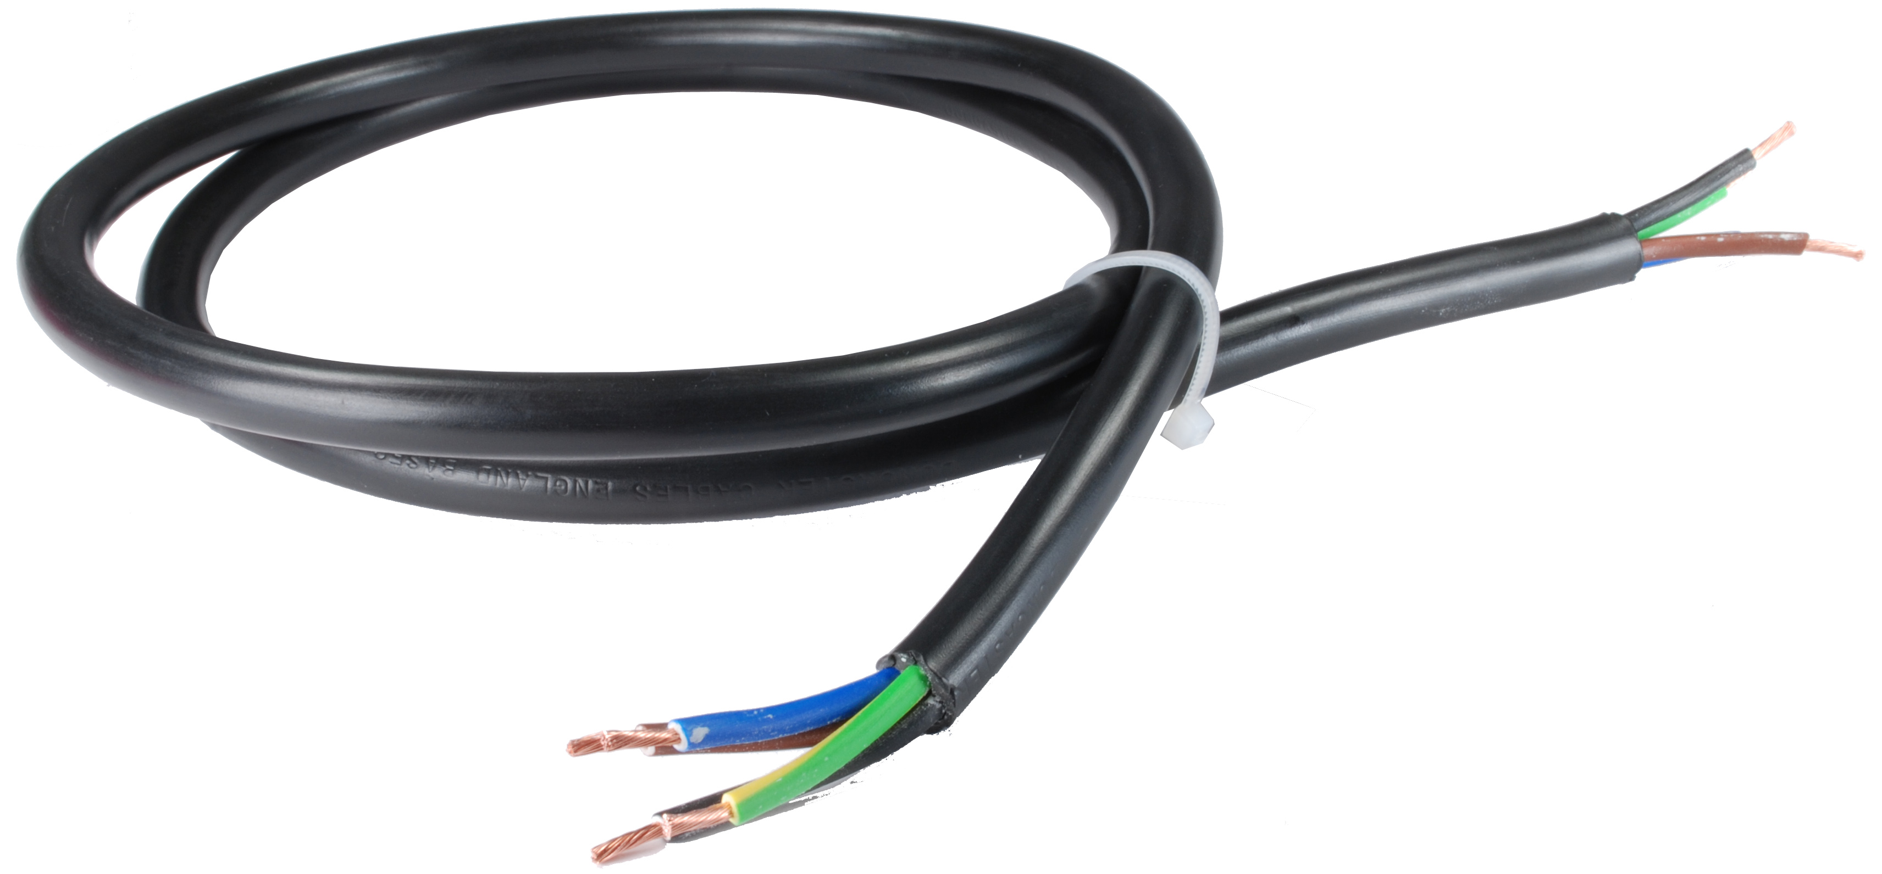 | 4-core flex to connect the power supply to the RAMPS board.
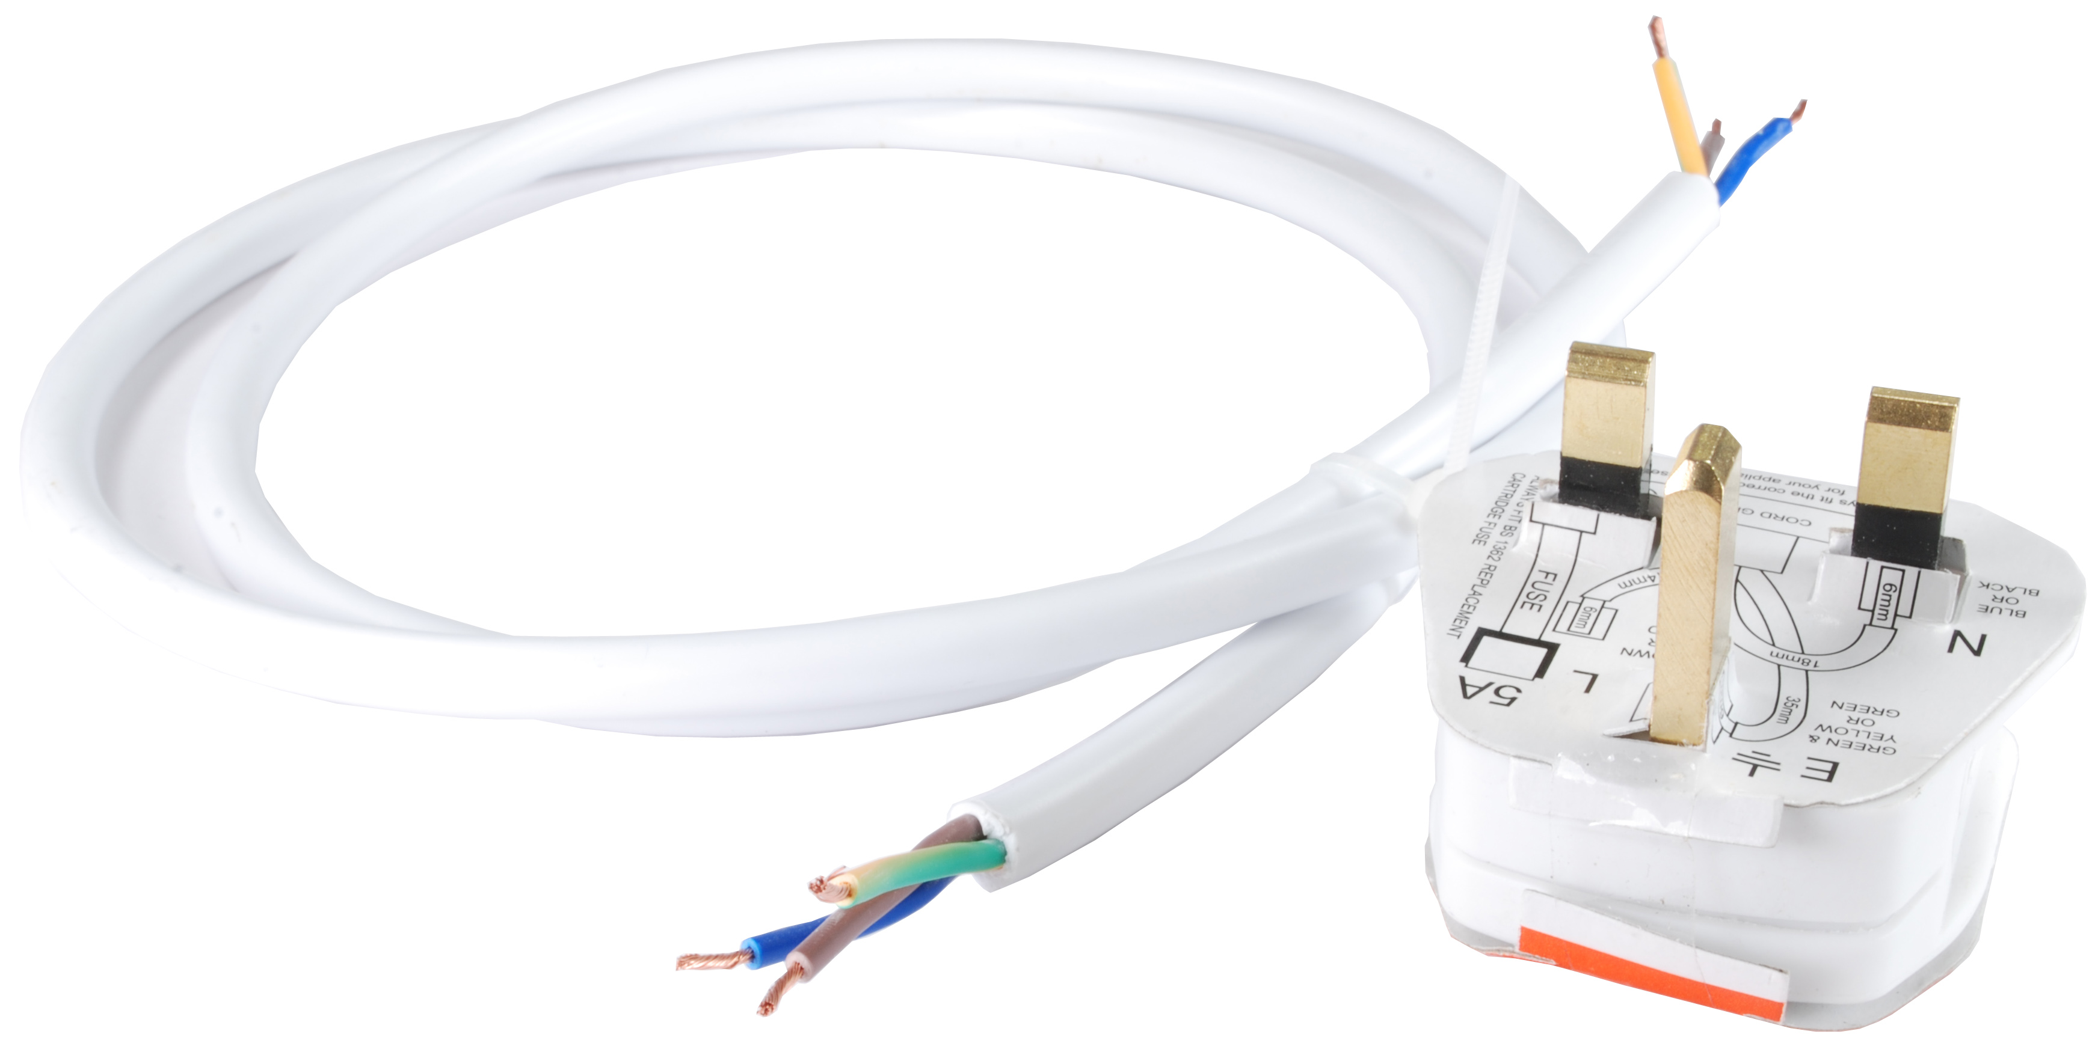 | 3-core flex and a plug to connect the power supply to the mains.
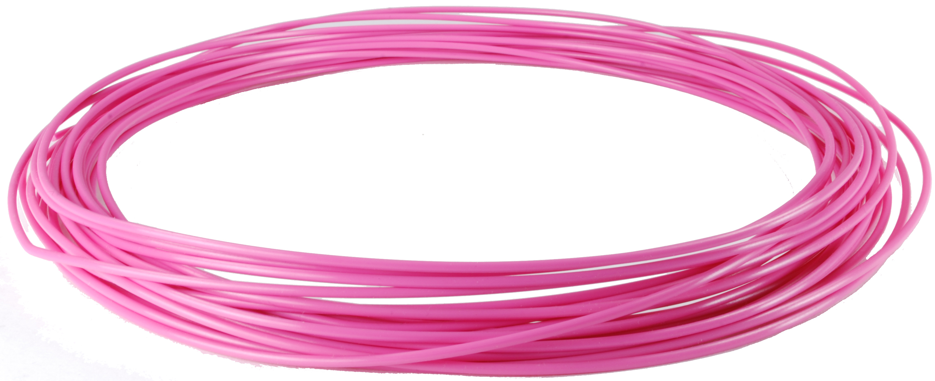 | A length of PLA filament to get you started (it probably won't be pink, but it does photograph well).
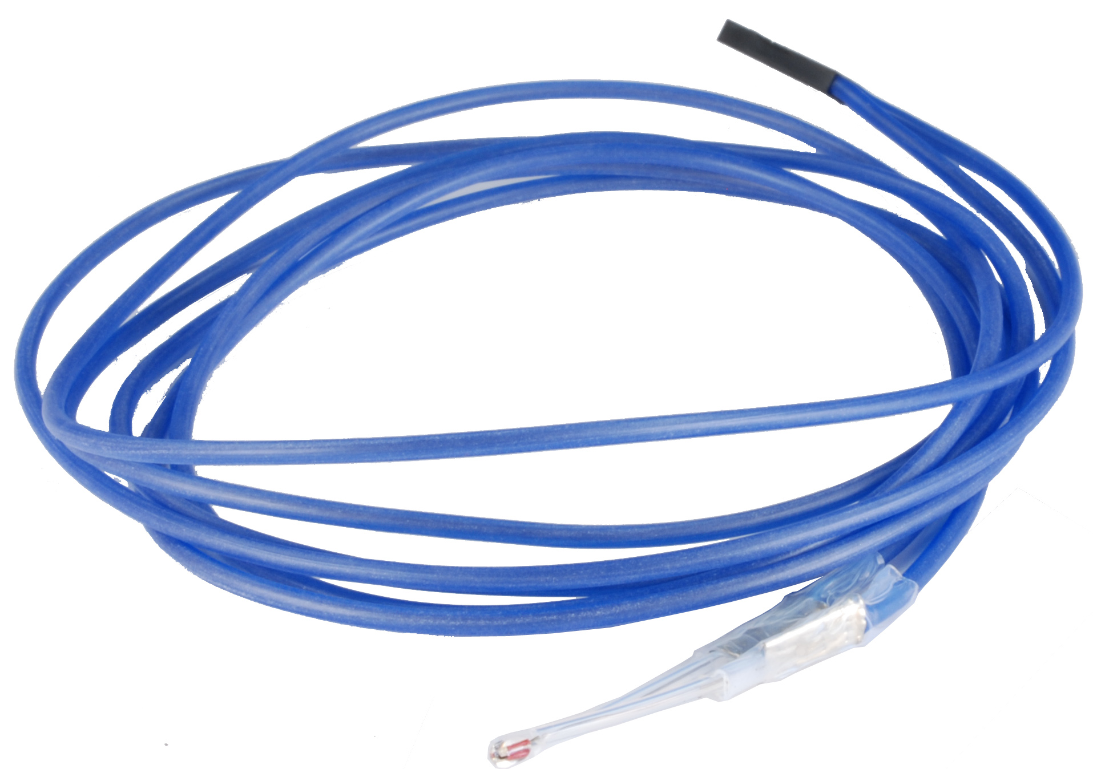 | A thermistor for measuring the temperature on your heated bed, pre-crimped to a length of high-temperature silicone cable.
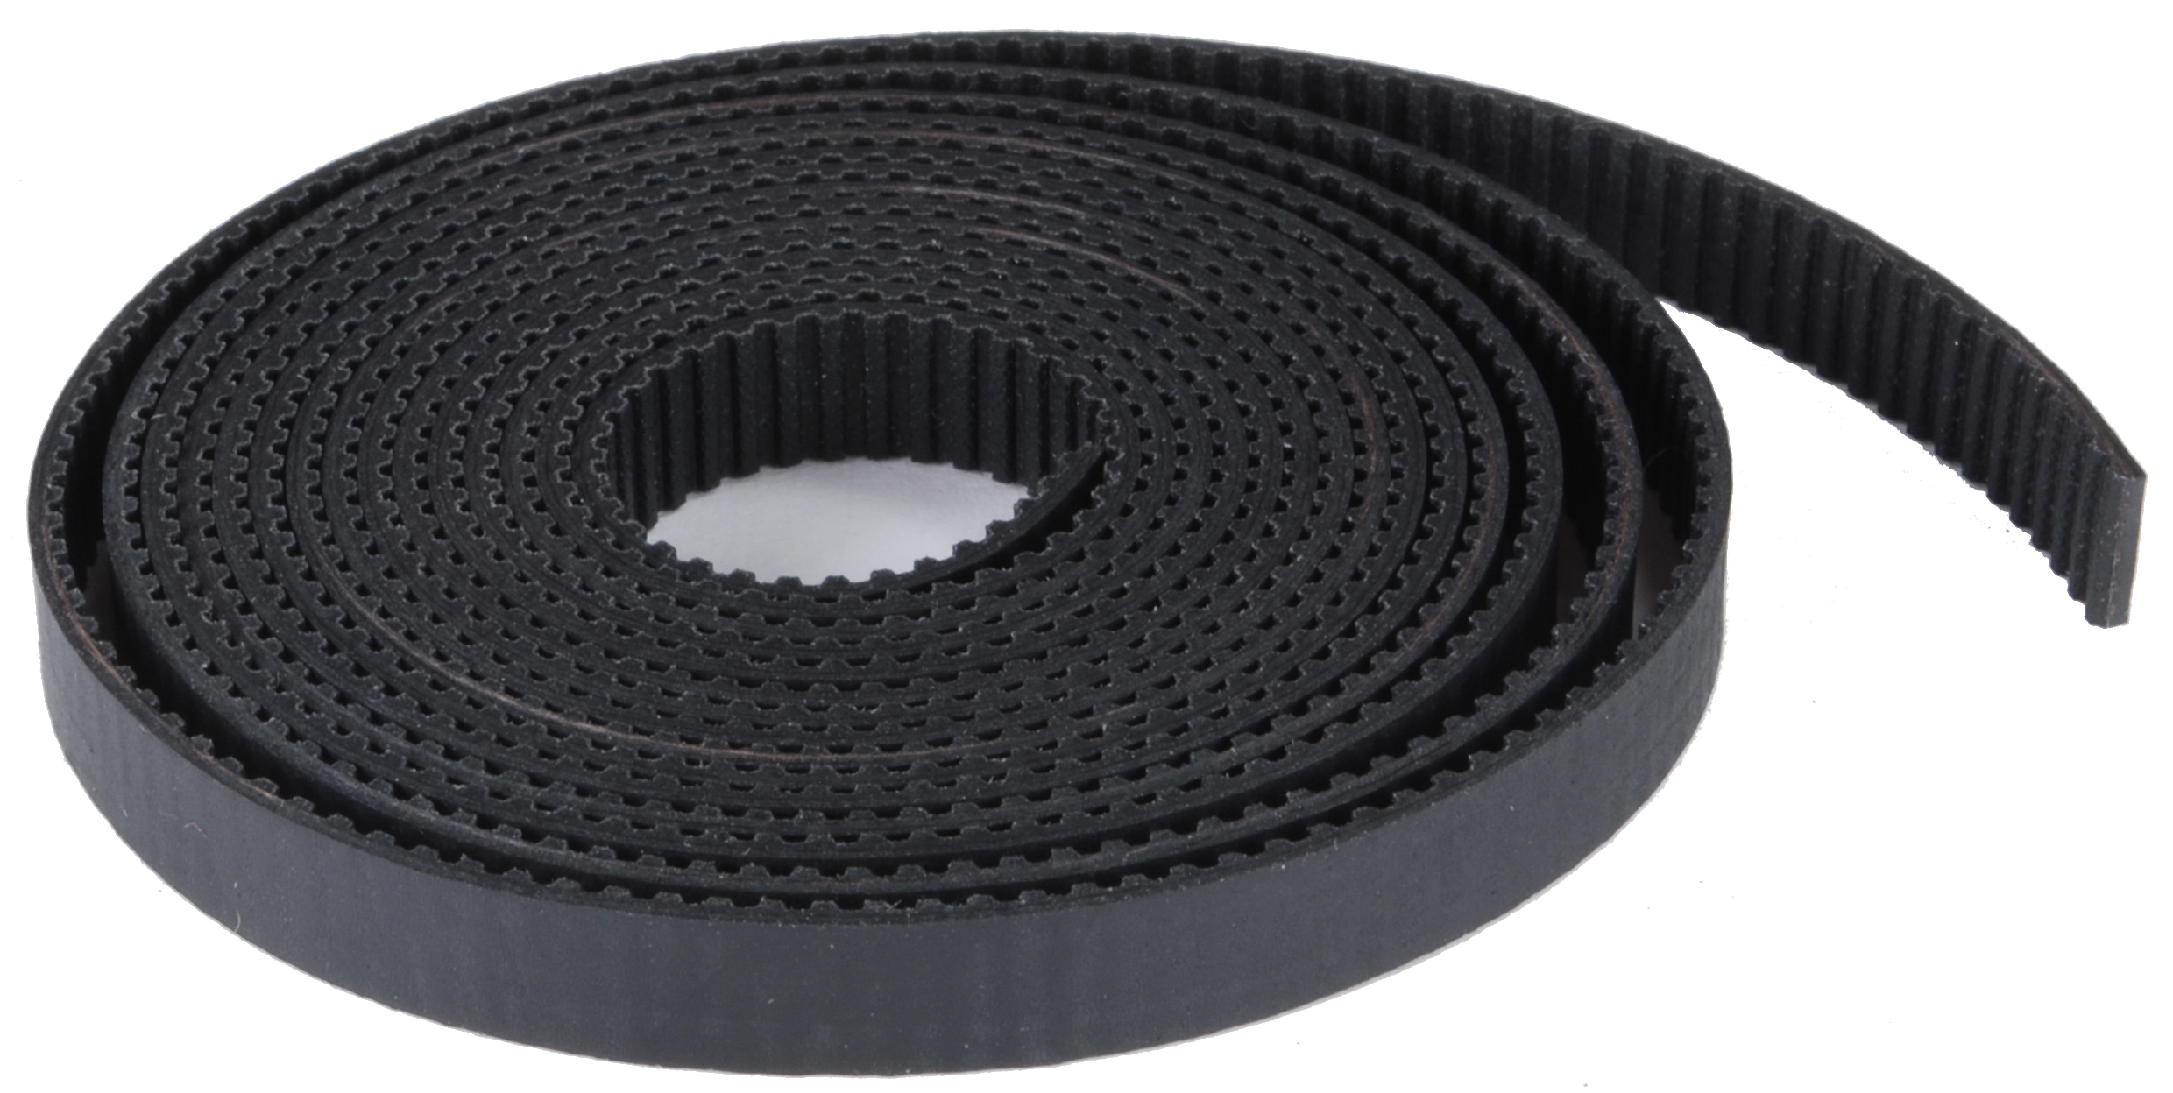 | A 2m length of GT2 timing belt (for both X and Y axes).

Tools
You will need the following tools to assembly your printer:
- 2.5mm, 3mm and 6mm Allen Keys (for M3, M4 and M8 cap head screws).
- 5.5mm spanner (for M3 nuts). A socket screwdriver set will do in a pinch.
- 2 x 16mm spanners (for M10 nuts).
- 2 x 10mm spanners (for M6 nuts).
- A set of multi-grips.
- A set of precision or jeweller's screwdrivers.
- A set of needle files (these are well worth the investment – you will get a lot of use out of these doing finishing on pieces you print).
- 3mm, 4mm, 8mm and 10mm drill bits.
- A craft knife.
- A set square.
- 3-in-1 oil.
We didn't include tools with your kit because, frankly, most of us have most of these tools sitting in our shed or garage anyway. Not including them in the kit means you're not paying for them again.

Assembly

Assemble Long Sides of Y Axis Frame

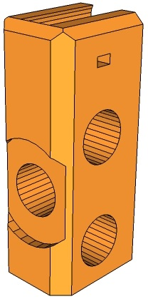 | 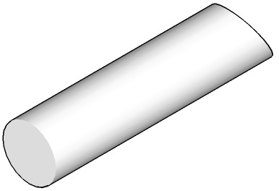 | 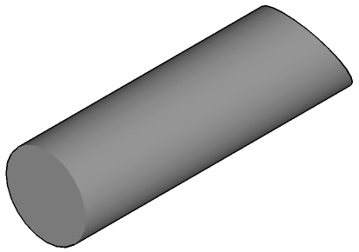 | 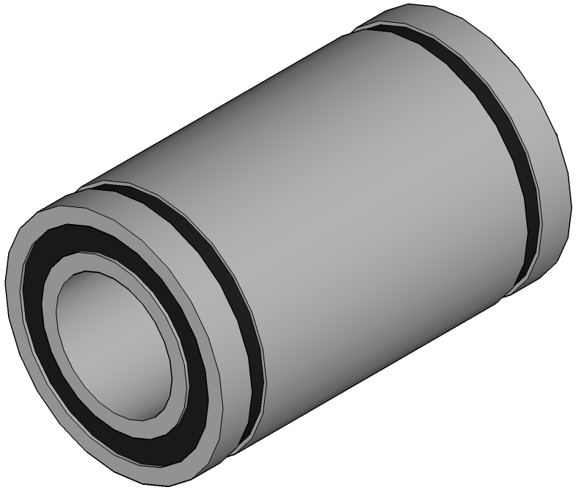 | 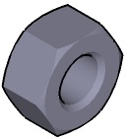 | 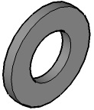
[4x]  Frame Corner | [2x]  350mm  Smooth Rod | [2x]  380mm M10 Threaded Rod | [3x]  LM8UU  Linear Bearings | [12x]  M10 Nut | [12x]  M10 Washer
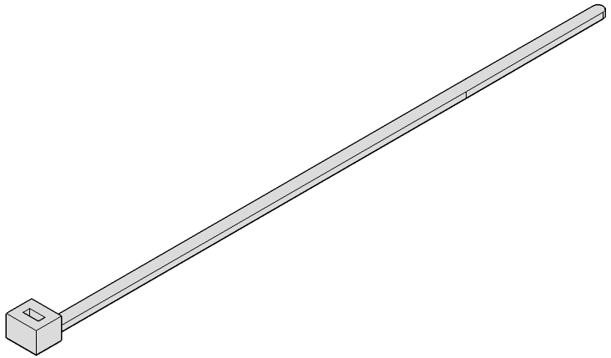
[4x]
Cable Tie
A
B

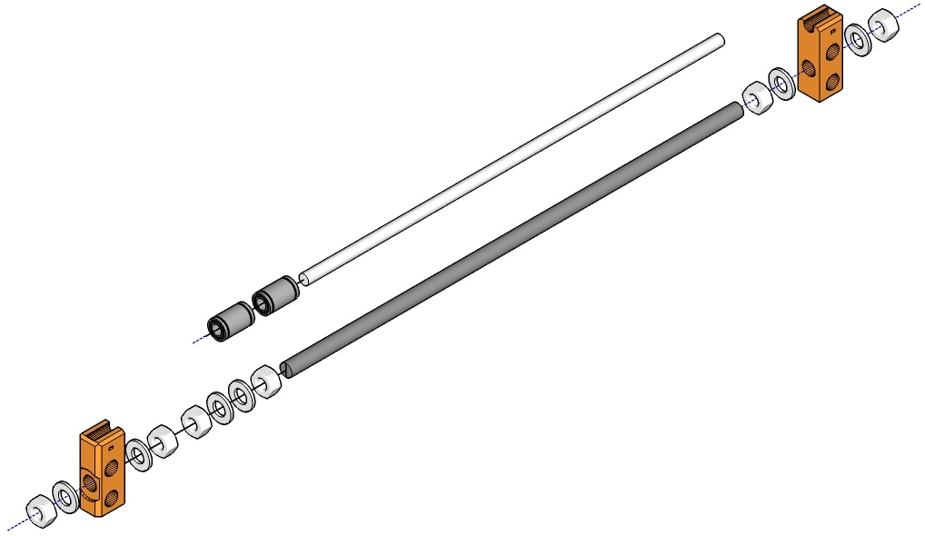

- Slide two LM8UU linear bearings along one of the smooth rods.
- Spin an M10 nut followed by two washers and another nut onto one of the threaded rods. These will be used later to fasten the Z axis lasercut frame to the Y axis frame. Spin them about 1/3 along the length of the threaded rod.
- On one end of the threaded rod, spin an M10 nut followed by an M10 washer. Push one of the frame corner printed parts onto the threaded rod oriented so that the washer recess faces the end of the rod. Slide another washer onto the rod so it fits into the washer recess in the frame corner, followed by a last M10 nut. Finger tighten at this point.
- Repeat at the other end of the rod with another M10 nut, washer, frame corner, washer and nut (in that order). At this point, you can use the frame guide in the poster supplied with your kit to set the spacing of the frame corners, or make sure their inside edges are at least 310mm apart. You can tighten the nuts at this point, but make sure you don't over-tighten them or you risk cracking the plastic parts.

- Press the smooth rod, with the two LM8UU bearings on it, down into the recesses at the top of the frame corners.
- Repeat steps 1 through 5 with the other smooth rod, threaded rod, frame corners, bearings, nuts and washers (NB: you only need on LM8UU bearing on the smooth rod).
- Thread cable ties through the holes in the frame corners to secure the smooth rods.

Assemble Y Axis Idler

[1x]  Y Axis Idler | [1x]  M3 16mm  Cap Head Screw | [2x]  M3 Nut | [1x]  M3 Washer | [2x]  M8 30mm  Cap Head Screw | [4x]  M8 Washer
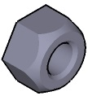 | 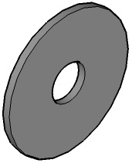 | 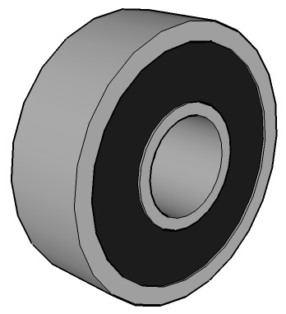
[1x]  M8 Nyloc Nut | [2x]  M8 Penny Washer | [1x]  608 Bearing

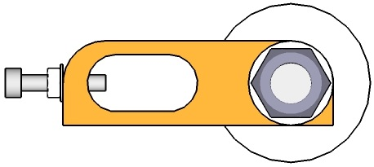
C

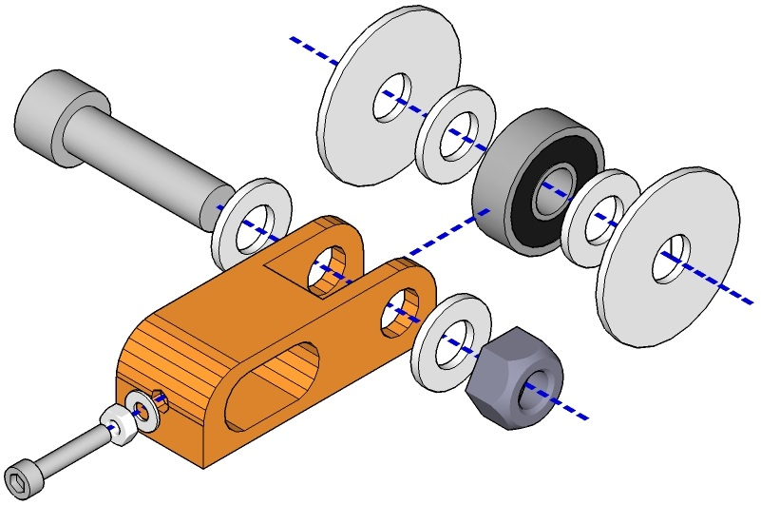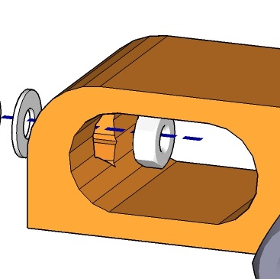

- Stack an M8 penny washer, followed by an M8 washer, the 608 bearing, another M8 washer and finally the last M8 penny washer. Push the stack into the Y axis idler holder printed part (there's only one end it can go in).

- Slide an M8 washer onto the M8 cap head screw and push through the idler holder to secure the washer / bearing stack. Secure with another M8 washer and the M8 nyloc nut. Tighten but do not compress the plastic – the nyloc nut will secure everything.
- Press an M3 nut inside the recess on the interior of the idler holder, as shown in the detail diagram above.
- Thread an M3 nut onto the M3 16mm cap head screw, most of the way up, and slide an M3 washer onto the screw. Insert the assembly into the outside of the hole where you placed the recessed M3 nut in the previous step and thread onto the recessed nut. This is the idler tensioner that you can use to adjust the tension of the Y axis belt once the Y axis assembly is complete.

Assemble Y Axis Motor Mount

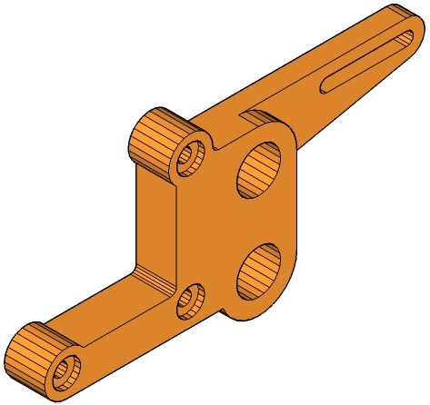 | 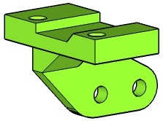 | 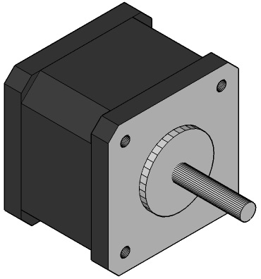 | 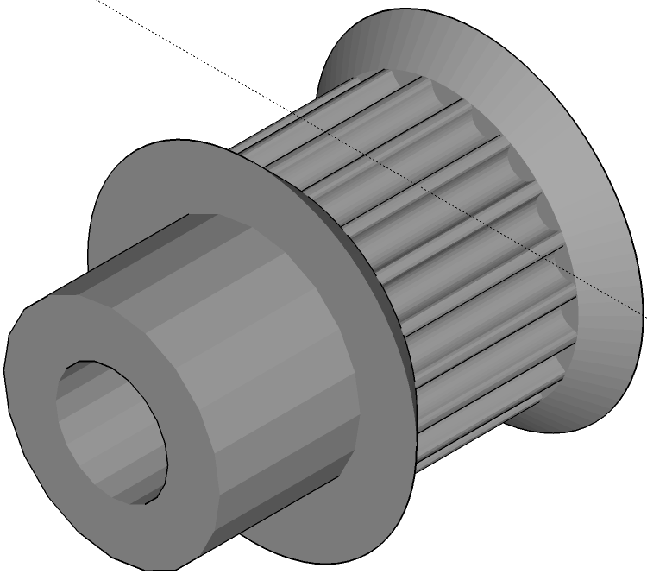 | 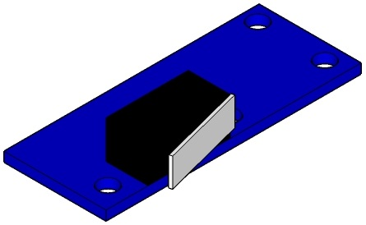
[1x]  Y Axis  Motor Mount | [1x]  Y Axis  Endstop Mount | [1x]  Nema 17  Stepper Motor | [1x]  GT2 Pulley | [1x]  End Stop | [2x]  M3 Nut
 | 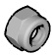 | 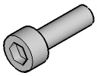
[6x]  M3 Washer | [2x]  M3 Nyloc Nut | [5x]  M3 10mm  Cap Head Screw | [2x]  M3 16mm  Cap Head Screw

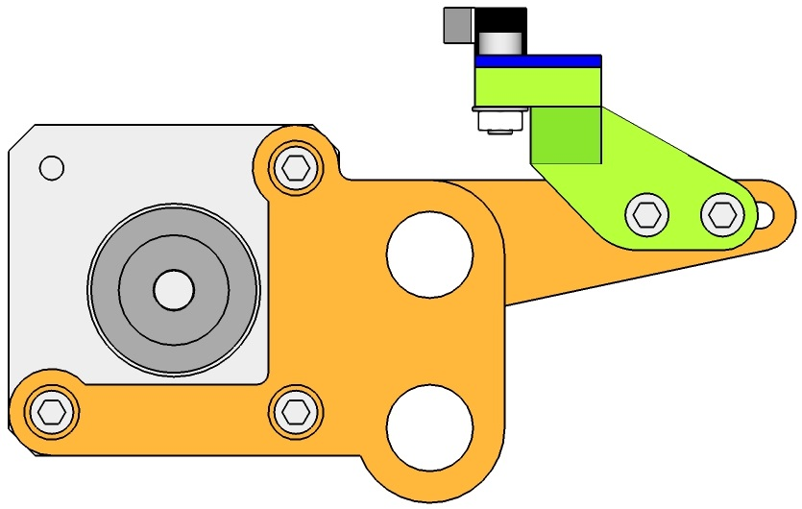
D
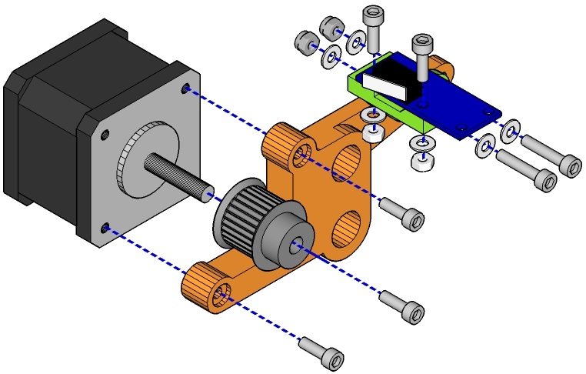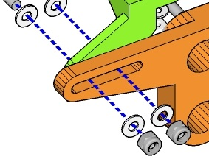

- Slide the GT2 pulley on to the motor shaft of the Nema 17 Stepper Motor and secure with the small screws provided. Make sure one of the screws is perpendicular to the flat spot on the motor shaft.
- Secure the stepper motor to the motor holder using three 10mm M3 cap head screws.
- Secure the end stop to the endstop mount using two 10mm M3 screws with M3 nuts. Use M3 washers where the nuts rest against the plastic part.
- Secure the endstop mount to the motor holder using two 16mm M3 screws, M3 nyloc nuts and washers.

Assemble Y Axis

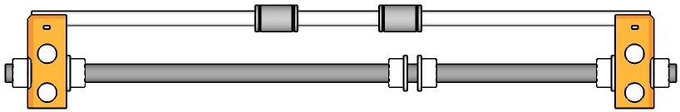 | 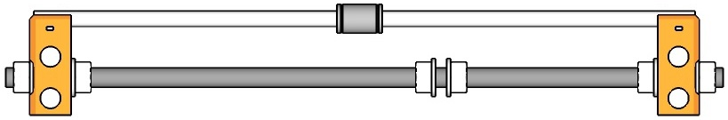 |  |  | 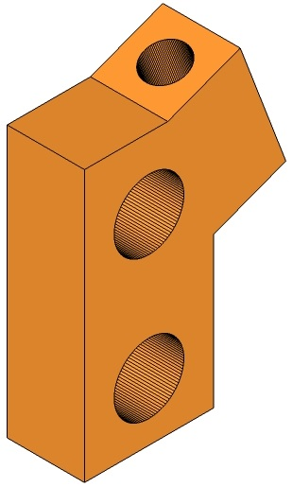
[1x]  Assembly A | [1x]  Assembly B | [1x]  Assembly C | [1x]  Assembly D | [2x]  Stabiliser Bottom | [2x]  210mm M10 Threaded Rod
[2x]  370mm M10 Threaded Rod | [30x]  M10 Nut | [30x]  M10 Washer

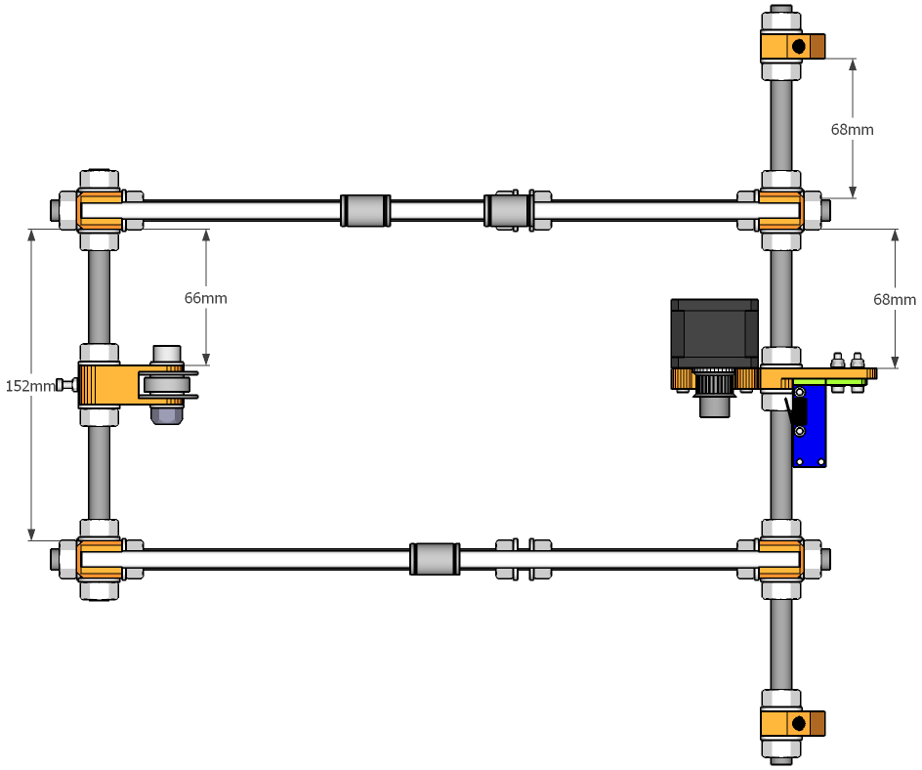
E

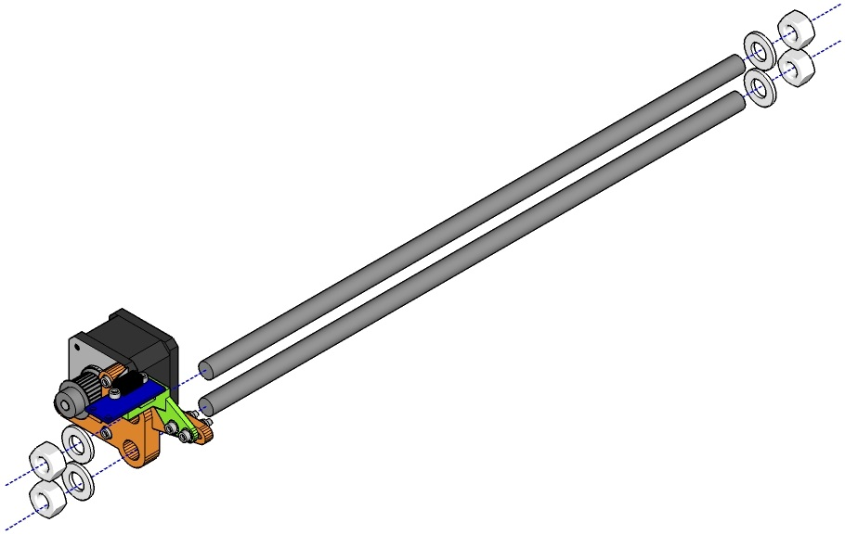

- Take the two 370mm M10 threaded rods and push the Y motor assembly D onto them. Secure with M10 nuts and washers on each side and on each threaded rod. Use the poster guide to position the motor assembly correctly. Check the measurements in the assembly E diagram above for where to position the motor..

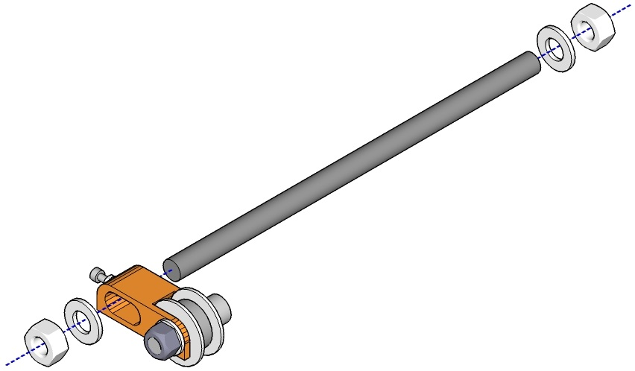

- Slide the Y axis idler assembly C onto one of the 210mm M10 threaded rods and secure with M10 washers and nuts on each side. The idler should be in the middle of the threaded rod.

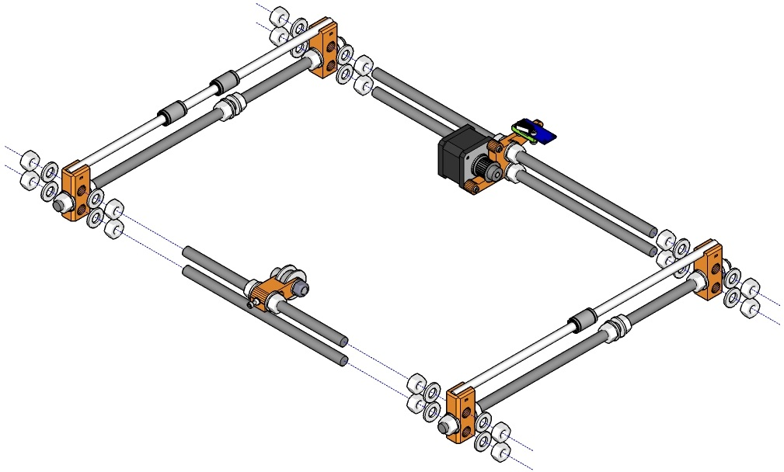

- Gather together assembles A and B, the assemblies put together in steps a) and b) above, the remaining 210mm M10 threaded rod, 16 M10 nuts and 16 M10 washers.
- Spin an M10 nut and slide a washer onto each end of each of the four threaded rods and line them up as per the frame layout poster. Slide assemblies A and B onto the threaded rods so that each rod goes through a hole on the frame corner and line up as per the frame layout poster or according to the measurements given for assembly E above. Finally, secure each threaded rod with another washer followed by an M10 nut. Tighten the nuts but do not over tighten as you may damage the frame corners.
- Make sure your frame is square by measuring diagonally opposite corners and making sure the measurements are the same.
- Make sure your frame is level by placing it on a flat, level surface and attempt to rock it. If the frame rocks at all, simply place something about 5mm high under one of the corners that doesn't move and pressing down on the two corners that do. Rinse and repeat until the frame is level.

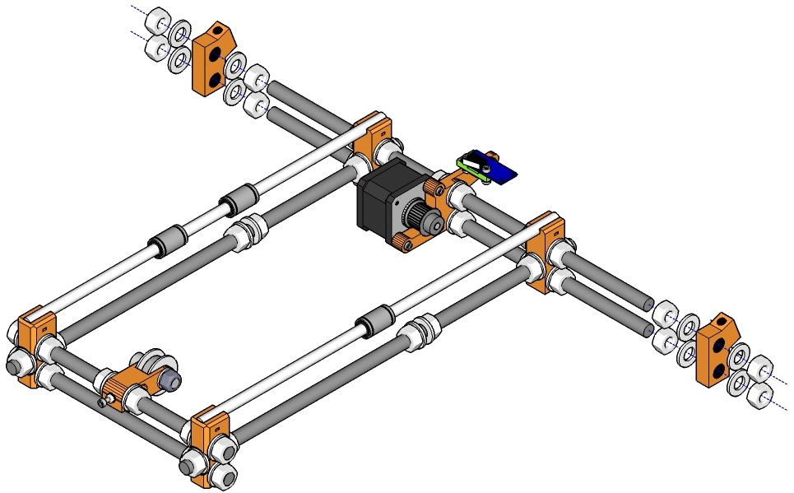

- Gather the two stabiliser bottom pieces, 8 M10 nuts and 8 M10 washers. Spin a nut followed by a washer onto the end of each of the longer threaded rods at the motor end and slide a stabiliser bottom piece onto each end, making sure that the slanted part with the smaller through hole is on the outer side of the frame. Position according to the frame diagram on the provided poster or the measurements for assembly E above and secure with 4 further washers and nuts, making sure not to over-tighten.

Attach Y Carriage and Belt to Y Frame

 | 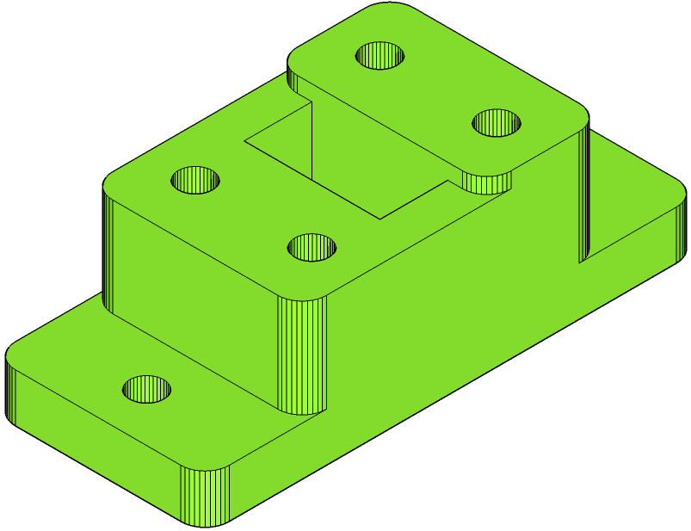 | 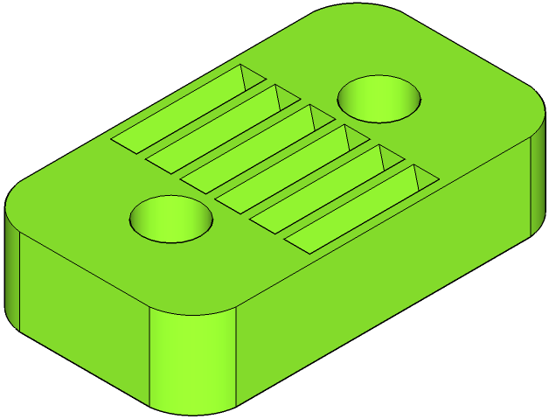 | 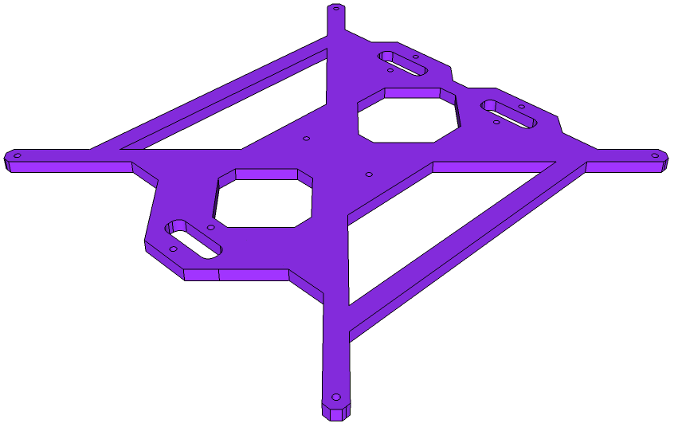 |  | 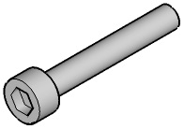
[1x]  Assembly E | [1x]  Y Belt Holder | [2x]  Y Belt Clamp | [1x]  Y Carriage | [2x]  M3 16mm  Cap Head Screw | [4x]  M3 20mm  Cap Head Screw
[2x]  M3 Nyloc Nut | [4x]  M3 Nut | [6x]  M3 Washer | [3x]  Cable Tie | [1x]  GT2 Timing Belt

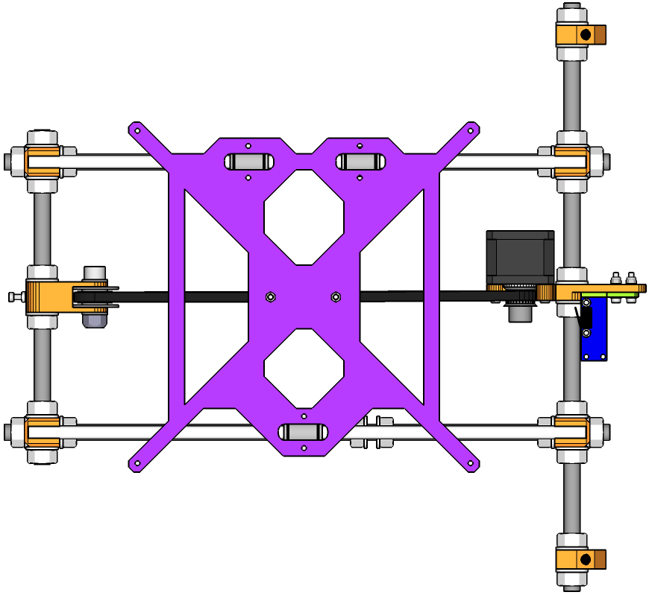
F

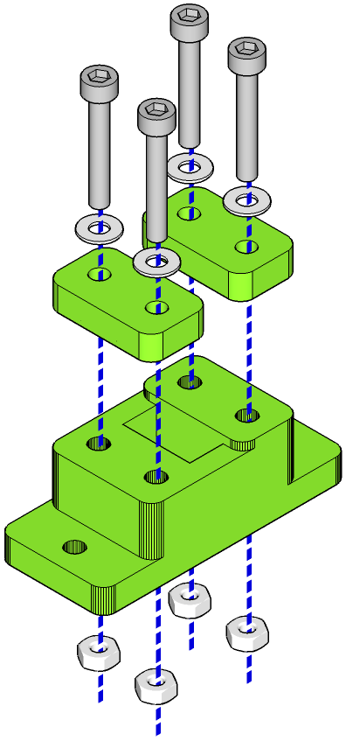

- Press-fit four M3 nuts into the recessed slots of the underside of the Y belt holder.
- Take the four M3 20mm cap head screws, slide a washer onto each screw and use them to secure the two Y belt clamps to the Y belt holder. Do not tighten down but leave room to attach and secure the Y belt later. Tighten down enough so that each screw is fully engaged with their respective nuts so they won't fall out later.

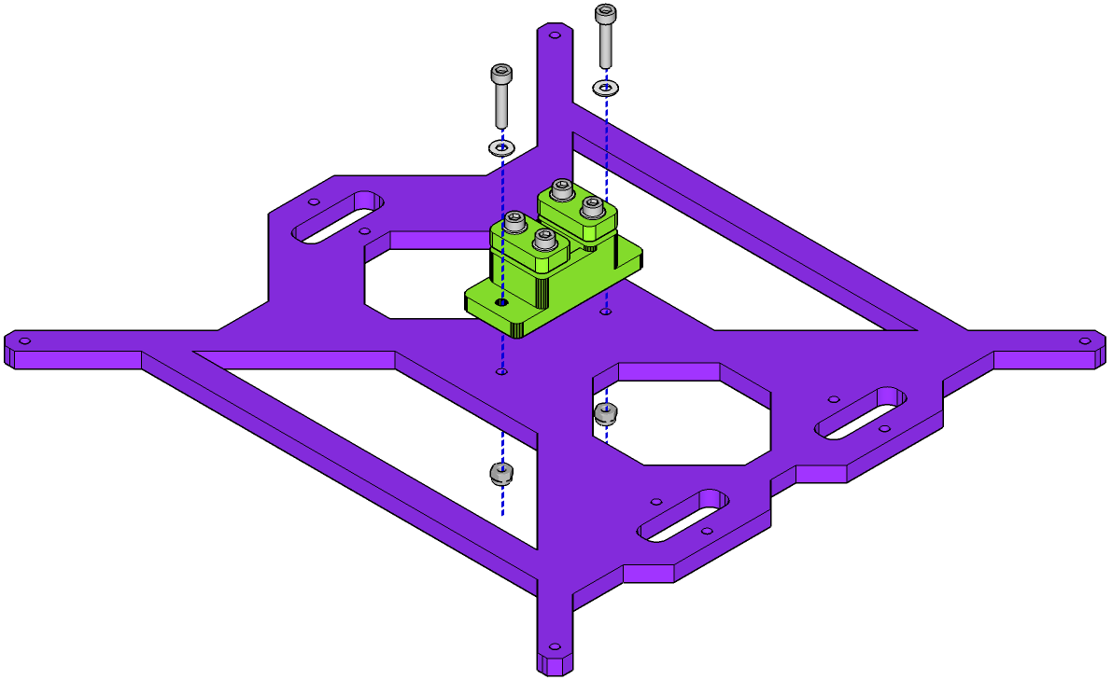

- Use the two 16mm M3 cap head screws, two nyloc nuts and two remaining washers to secure the Y belt clamp assembly to the Y Carriage, making sure the washers are on the plastic side. Do not over-tighten.

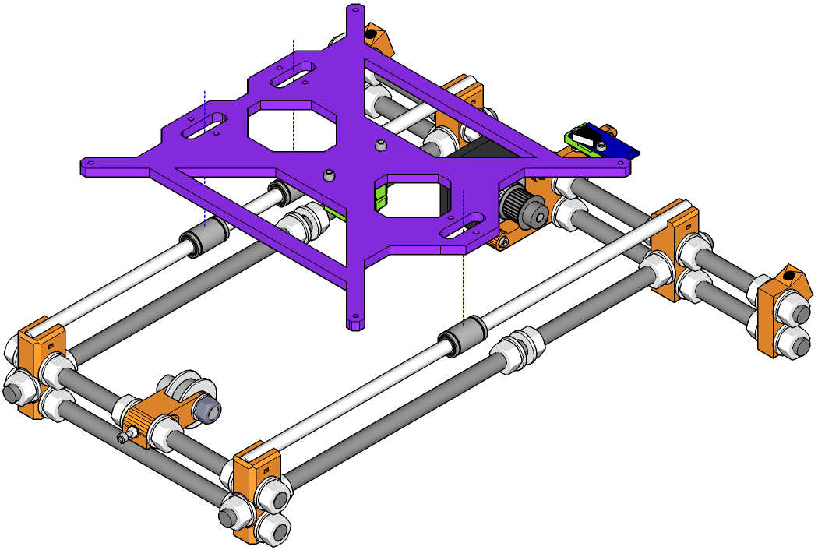

- Turn the Y carriage over so that the belt clamp is on the bottom and place on assembly E, so that each of the LM8UU linear bearings on the smooth rods line up with the three slots cut into the Y carriage. Use cable ties to secure the bearings to the carriage. Make sure that the locking part of the cable tie is on the top of the Y carriage so that it won't foul the Z frame when moving.
Alternatively you can use two cable ties to get a neater finish. Take a single cable tie and push it through one of the cable tie slots in the Y carriage, from the top. Loop it under the bearing and back through the slot on the other side. Instead of putting the tail through the cable tie's own lock, take another cable tie, cut off its head and use it to lock the first into place. You'll end up with something looking like this:

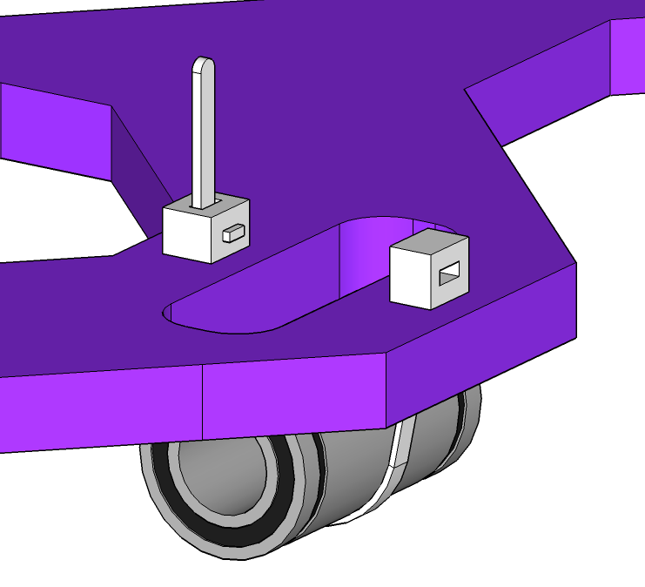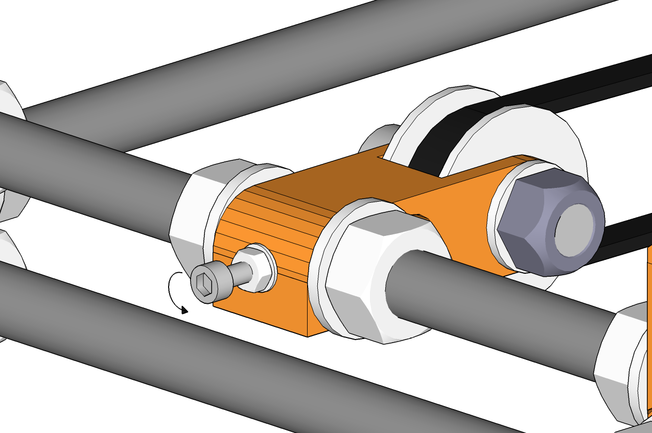
First cable tie, looped under the bearing.
Head of second cable tie. Tail of first is passed through here and trimmed (shown here untrimmed for clarity).
- Loosen the Y-belt tensioner as far as it will go by turning the cap head screw on the end of the idler ant-clockwise.

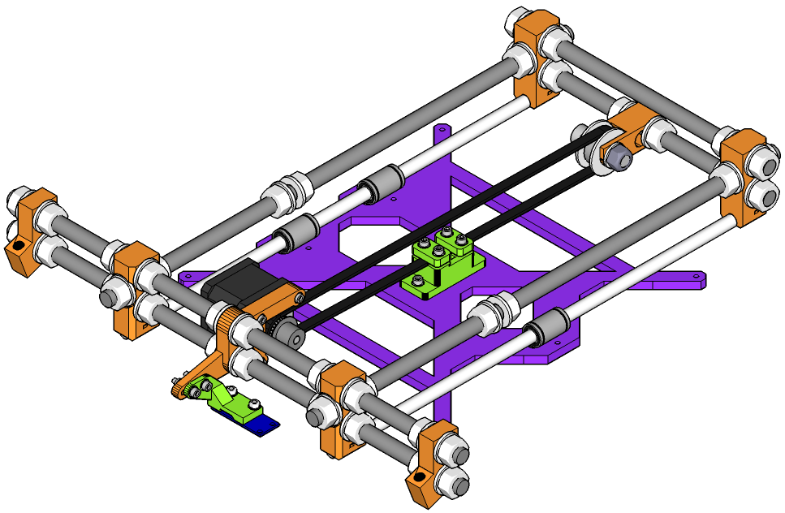

- Carefully turn the assembly over and rest it on the Y carriage.
- Take the length of GT2 timing belt, place one end under one of the clamps in the middle of the Y carriage and tighten the clamp down.
- Thread the belt around the motor and idler and back to the remaining clamp in the middle of the Y carriage. Pull tight and trim to length, ensuring there is enough length for the belt to be securely held under the full width of each clamp, plus a few mm more.
- Thread the loose end you just trimmed under the remaining clamp and tighten down.
- Return the assembly to its upright position.
- Tighten the belt by turning the cap head screw on the Y belt idler clockwise. Lock the tension by tightening the visible M3 nut on the screw.
- Turn the assembly back over and rest on its feet.

Assemble Bed and Attach to Y Carriage

 | 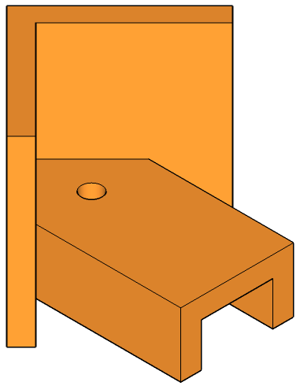 |  | 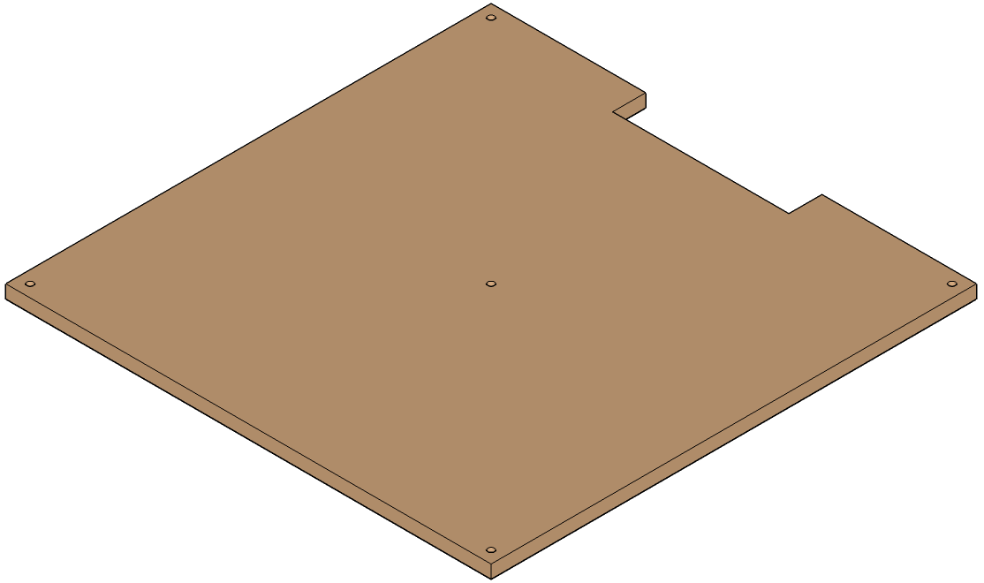 | 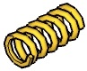 | 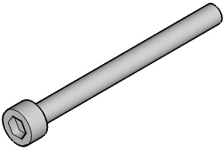
[1x]  Assembly F | [4x]  Bed Stabiliser | [1x]  MK2B Heated Bed | [1x]  Bed Insulator | [4x]  Spring | [4x]  M3 35mm  Cap Head Screw
[4x]  M3 Nyloc Nut | [8x]  M3 Washer | [1x]  Thermistor with Blue Silicon Leads | [1x]  Cable Tie | [1x]  Roll of Kapton Tape

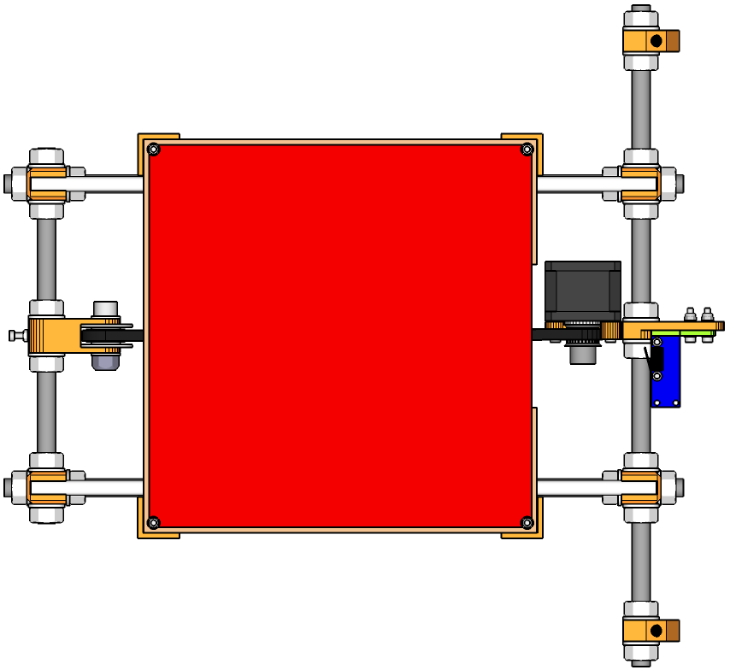
G

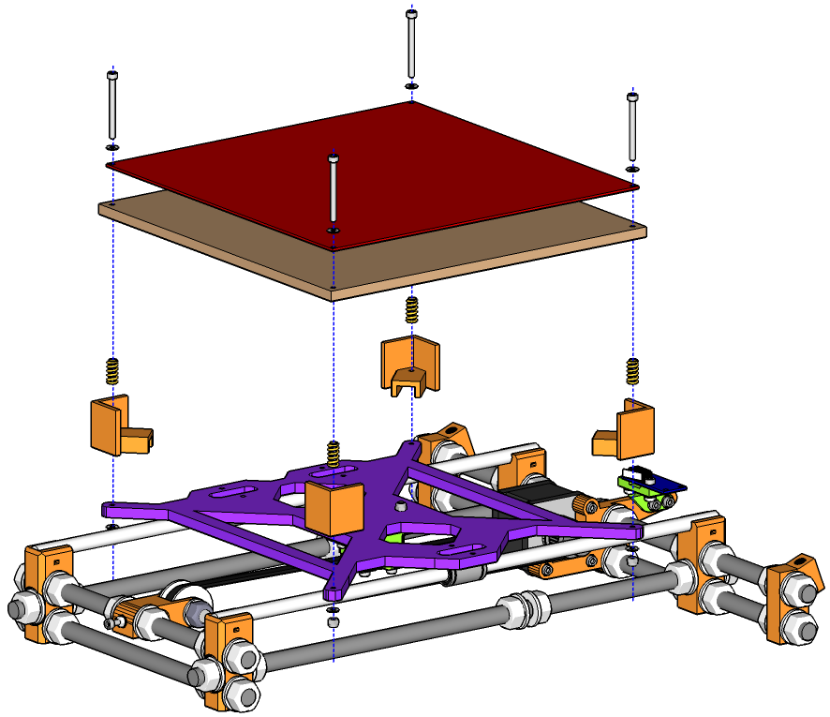

- Place the MK2B heated bed on top of the bed insulator so that the solder joints for the wires to the heated bed are facing down and within the cutout on the insulator.
- Gather the four M3 35mm cap head screws and four M3 washers, slide a washer onto each screw and push through the four corner holes in the bed and insulator to position them.
- Take the thermistor and carefully (thermistor leads are fragile) push the glass bead through the hole in the middle of the insulator and bed, from the insulator side. The glass bead should be level with the surface of the heated bed.
- Use lengths of kapton tape to secure the leads of the thermistor to the underside of the bed insulator. The leads should run to the cutout in the heated bed – the same side the wires to the heated bed are positioned. Use one length over the run of the leads and two or more perpendicular to the leads to keep them secure.
- Use a cable tie to tie the heated bed and thermistor wires together. This will help prevent the thermistor leads from detaching from the insulated bed during movement.
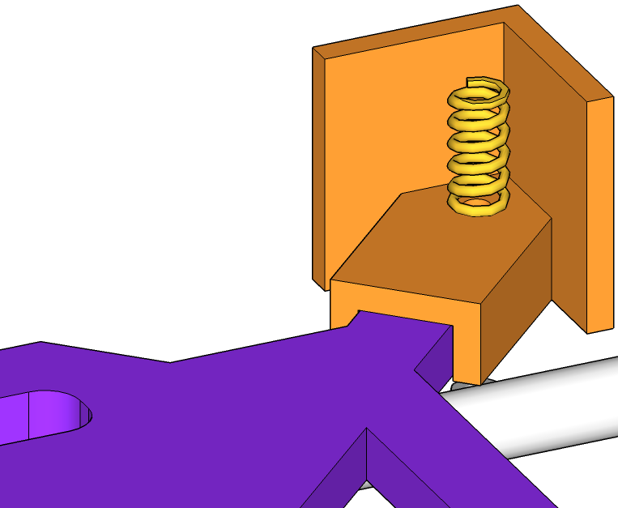
- Take each of the four bed stabilisers and place them on each corner of the Y carriage. Each stabiliser should fit snugly over an arm of the carriage. Place a spring within each stabiliser such that each spring is over the screw hole in the stabiliser.
- Take the heat bed / insulator and, turning it right-side up, rest on top of the four corner sprins on the Y carriage. The insulator should rest on the springs, not on the bed stabilisers.
- Push each 35mm cap head screw from the top, through the heated bed, bed insulator, spring, bed stabiliser and finally Y carriage (the holes are tight and you may need to screw them through instead of pushing). Secure on the underside with an M3 washer and M3 nyloc nut.
- At this point, it is a good idea to get the bed level by using a set of calipers to measure the distance between the top of the heated bed and the bottom of the Y carriage. Make sure this distance is the same at all four corners and your bed will be level.
- Be careful not to over tighten the 35mm M3 cap head screws at the four corners of the Y carriage. If too much of the length of the screw depends from the Y carriage, it will snag on the Z axis frame during movement. If necessary, add one or more additional M3 washers between the head of the screw and the heated bed to raise the screw. Check the clearance by moving the bed back and forth on the smooth rails.

Assemble X Axis Motor Mount

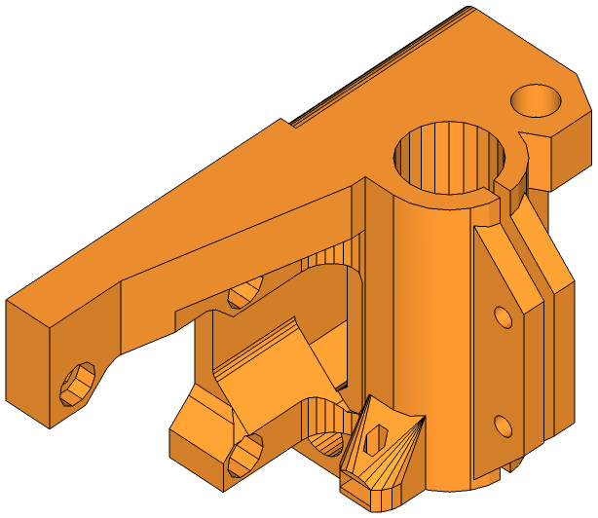 |  |  |  | 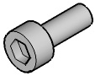 | 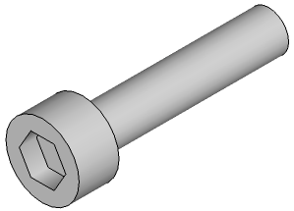
[1x]  X Axis Motor Mount | [1x]  Nema 17  Stepper Motor | [1x]  GT2 Pulley | [2x]  LM8UU  Linear Bearing | [3x]  M3 8mm  Cap Head Screw | [2x]  M3 16mm  Cap Head Screw
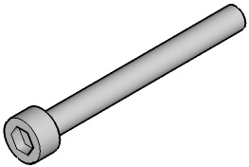 | 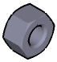
[1x]  M3 30mm  Cap Head Screw | [1x]  M5 Nut | [3x]  M3 Nyloc Nut | [1x]  M3 Nut | [5x]  M3 Washer

H

- Press-fit the M5 nut into the recess at the top-right corner of the motor mount, from beneath. The recess is a tight fit – you may need to use a pair of multi-grips to press the nut in properly. Don't use excessive force as you may crack the plastic part. Use a cloth under the jaws of the multi-grips to protect the finish of the top of the plastic part.
- Press the two LM8UU bearings into the bearing sleeve on the motor mount – one from above and one from below.
- Secure the two LM8UU bearings using two M3 16mm cap head screws, 4 washers and two nyloc nuts. The sleeve for the bearings should be clamped tight enough to prevent movement but not so tight the mount cracks. Gentle pressure is all that is required.
- Press an M3 nut into the recess at the side of the bearing sleeve; this is the Z axis endstop adjustment which can be used to fine-tune the height of your nozzle from the bed. Thread the 35mm M3 cap head through the nut from the top so that about 10mm shows through the bottom. Slide an M3 washer on from the bottom, followed by the M3 nyloc nut.

- Slide the GT2 pulley on to the motor shaft of the Nema 17 Stepper Motor and secure with the grub screws provided. Make sure one of the screws is over the flat spot on the motor shaft.
- Secure the stepper motor to the motor mount with the 3 M3 16mm cap head screws.

Assemble X Axis Idler Mount

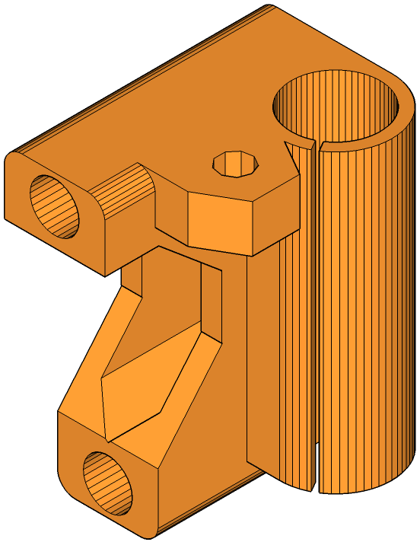 | 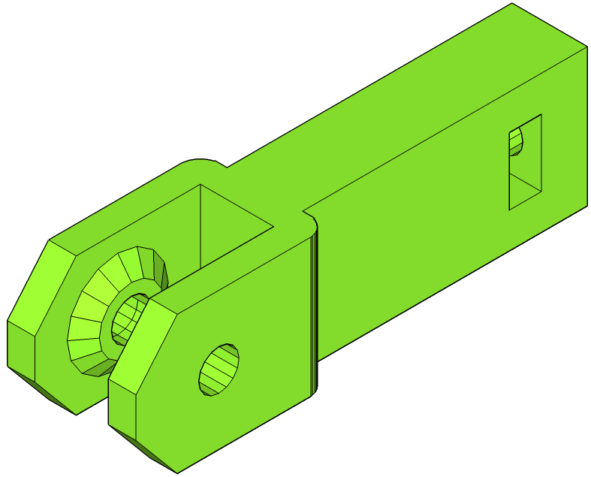 | 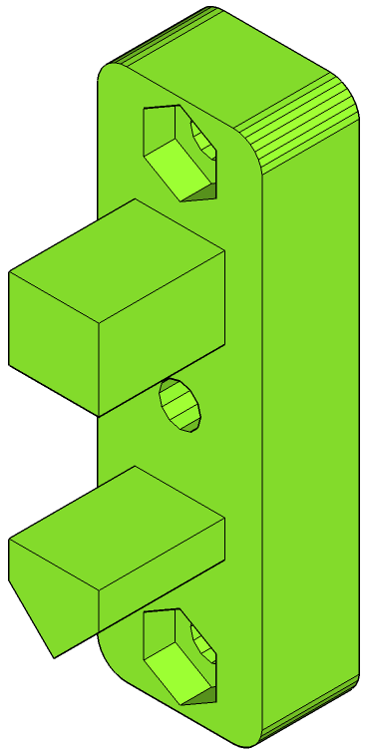 |  | 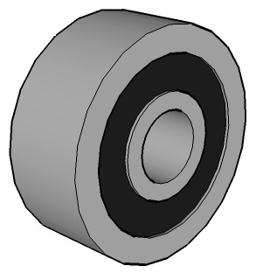
[1x]  X Axis Idler Mount | [1x]  X Axis Idler | [1x]  X Axis Belt Tensioner | [2x]  LM8UU  Linear Bearing | [1x]  624 Bearing | [2x]  M3 16mm  Cap Head Screw
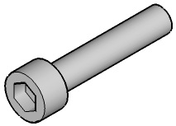 | 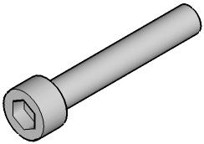 |  | 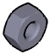
[2x]  M4 20mm  Cap Head Screw | [2x]  M4 25mm  Cap Head Screw | [1x]  M5 Nut | [4x]  M4 Nut | [2x]  M3 Nyloc Nut | [4x]  M3 Washer
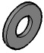 | 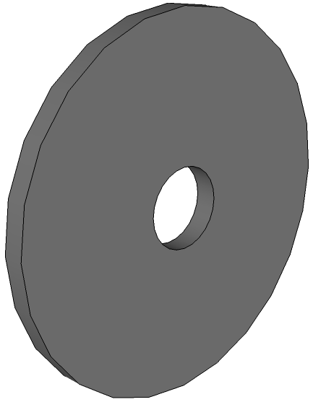
[5x]  M4 Washer | [2x]  M4 Penny Washer

I

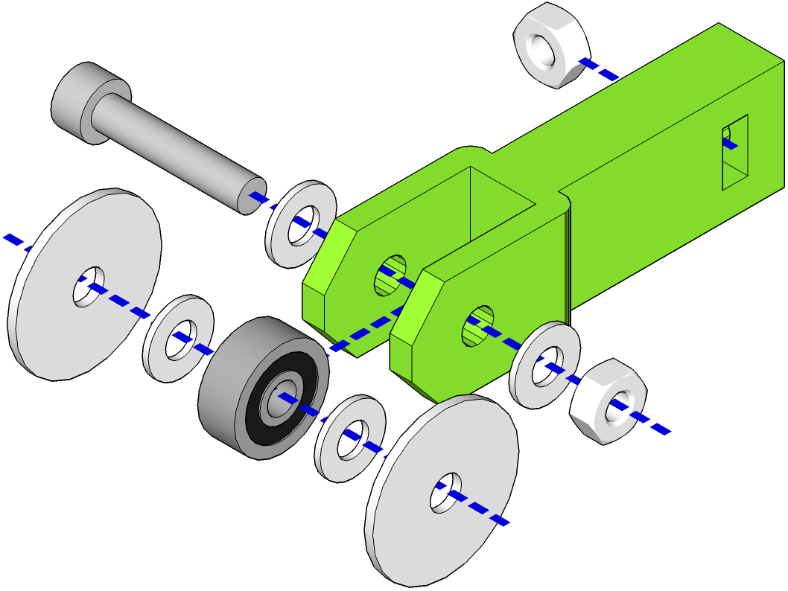

- Press an M4 nut into the recess in the back of the idler. Make sure the center of the nut lines up with the hole in the back of the idler.
- Stack an M4 penny washer, followed by an M4 washer, followed by the 624 bearing, followed by another M4 washer and then a final M4 penny washer. The stack should have the penny washers on the outside. Push the stack in between the arms of the idler holder and secure in place with an M4 20mm cap head screw, washers and nut.

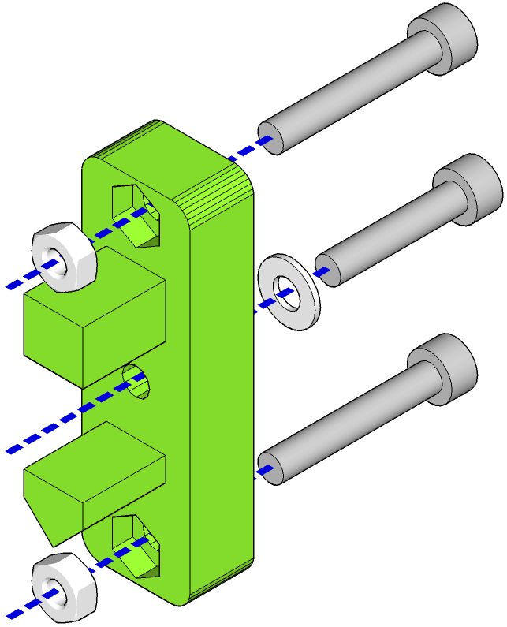

- Press an M4 nut into each of the recesses in the belt tensioner.
- From the opposite side, screw an M4 25mm cap head screw into each nut, enough so that the screw is fully engaged on the thread of the nut but not standing proud.
- Slide an M4 washer onto an M4 20mm cap head screw and push the screw through the hole in the middle of the belt tensioner from the flat side.

- Press an M5 nut, from the bottom, into the recess on the top left of the idler mount. As with the motor mount, use a pair of multi-grips to push the nut home and use a cloth to protect the surface of the idler mount. Be careful not to use to much force or you risk damaging the piece.
- Press the two LM8UU bearings into the bearing sleeve on the idler mount – one from above and one from below.
- Secure the two LM8UU bearings using two M3 16mm cap head screws, 4 washers and two nyloc nuts. The sleeve for the bearings should be clamped tight enough to prevent movement but not so tight the mount cracks. Gentle pressure is all that is required.
- Slide the belt tensioner assembly into the flat end of the idler mount.
- Push the idler through the idler mount and onto the middle M4 screw in the belt tensioner. Tighten the screw so the idler is flush and secure on the belt tensioner.

Assemble X Axis

 |  | 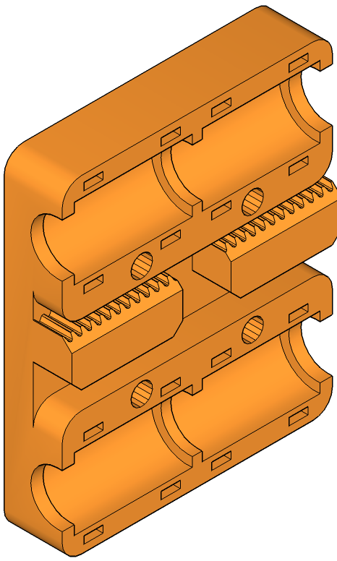 | 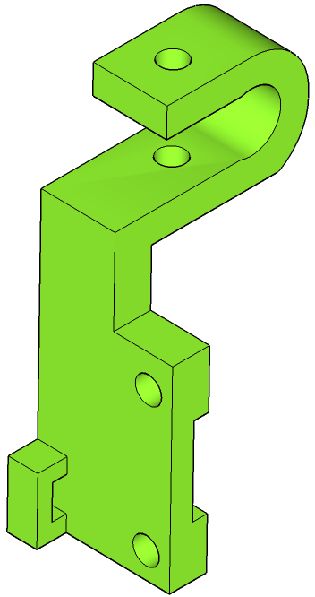
[1x]  Assembly H | [1x]  Assembly I | [1x]  X Carriage | [1x]  X Axis Endstop Holder | [1x]  Endstop | [4x]  LM8UU  Linear Bearing
[2x]  370mm  Smooth Rod | [8x]  Cable Ties | [1x]  M3 20mm  Cap Head Screw | [2x]  M3 10mm Cap Head Screw | [1x]  M3 Nyloc Nut | [2x]  M3 Nut
[4x]
M3 Washer

J

- Push the two smooth rods into the holes in assembly H, the motor mount. They should be a tight fit and push in 36 mm. If they are too tight, ream the holes out using an 8mm drill bit. Do this carefully by hand. Do not use a power drill or you will remove too much material.
- Press-fit the four LM8UU linear bearings into the recesses on the X carriage and secure with cable ties. Make sure that the locking part of the cable ties are on the same side as the bearings or they will interfere with the mounting of the extruder.
- Slide the assembled X carriage onto the two smooth rods. It should move freely. If it binds, carefully check the LM8UU bearings in their recesses in the X carriage. If any are not seated properly the carriage can bind.
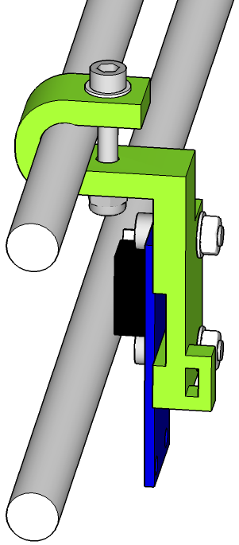
- Push assembly I, the idler mount, onto the two smooth rods. These should be a looser fit than the motor end to allow the idler mount to move on the smooth rods as belt tension is taken up.
- Using the two 10mm cap head screws, secure the end stop to the end stop mount, with washers and M3 nuts on the mount side.
- Push the end stop mount onto the top smooth rod. The detail diagram shows the placement and orientation of the mount. It needs to be placed this way so the X carriage will trigger the endstop properly. Secure with the 20mm M3 cap head screw, M3 nyloc nut and a washer on each end. Do not tighten at this point – you will adjust it once the X carriage has been placed on the Y axis.

Attach Z Motors to Z Axis Frame and Mount Y Axis

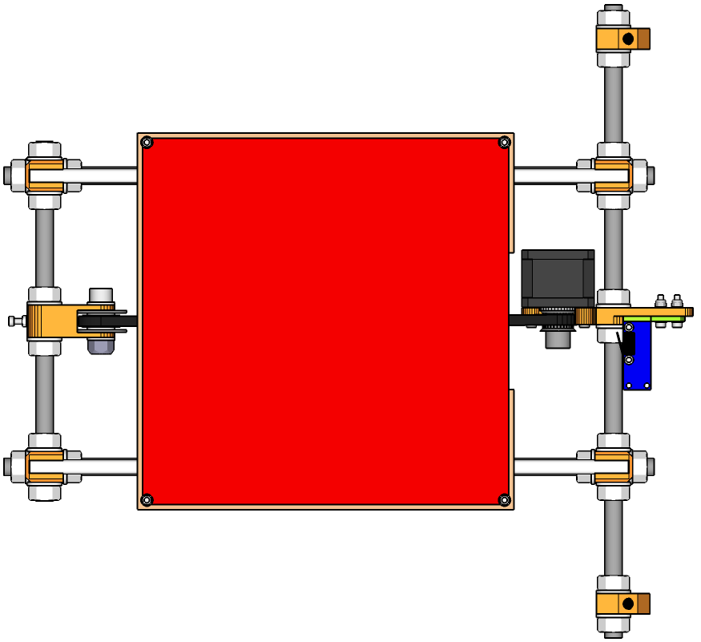 | 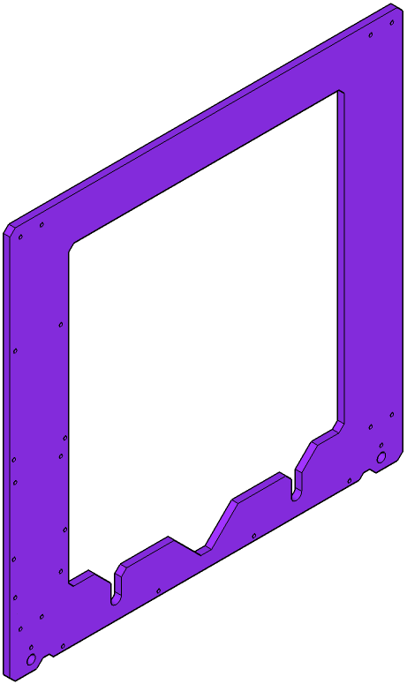 | 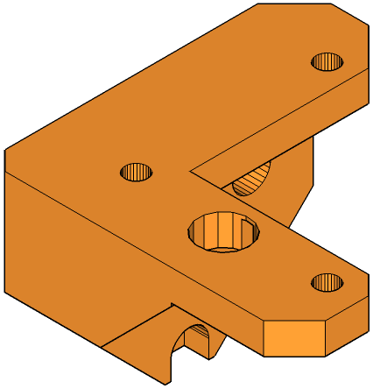 | 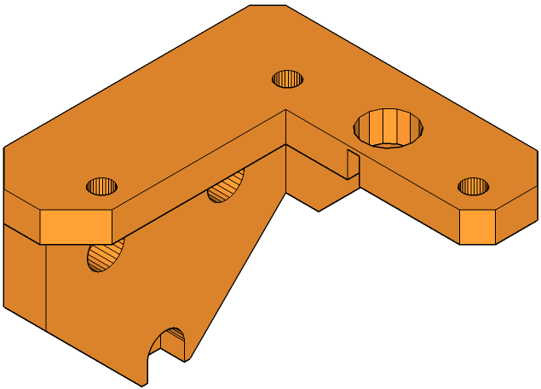
[1x]  Assembly G | [1x]  Y Axis Frame | [1x]  Z Motor Mount (Left) | [1x]  Z Motor Mount (Right) | [4x]  Spider Coupling | [2x]  Spider Coupling Insert
[2x]  Nema 17  Stepper Motor | [6x]  M3 16mm  Cap Head Screw | [4x]  M3 14mm  Cap Head Screw | [6x]  M3 8mm  Cap Head Screw | [6x]  M3 Nyloc Nut | [12x]  M3 Washer

K

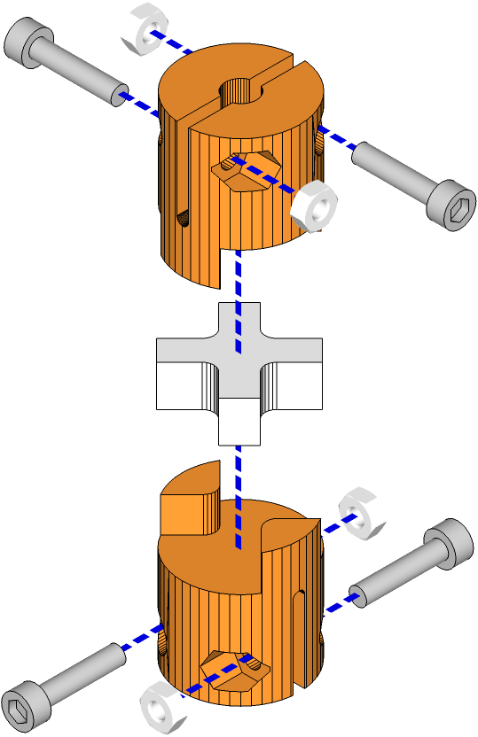

- Assemble a flexible spider couplings by taking one coupling half pressing the flexible insert into it, then pressing the other coupling half down onto the insert. Insert four 14mm M3 screws as shown and secure loosely with M3 nuts. Please note that two holes on each half of the coupler are round and two hexagonal; the screws should be inserted from the round end, so that the nuts are trapped in the hexagonal end.

- Secure the left and right Z axis motor mounts to the front of the Z axis frame plate using, on each side, three M3 16mm cap head screws through the front of the mount, and an M3 washer and nyloc not on each screw from the back. For reference purposes, the front of the Z axis frame plate has the mounting holes for the electronics on the left hand side.

- Secure a flexible coupling to each Nema 17 stepper motor by sliding the coupling over the motor shaft and tightening the two M3 cap head screws on the bottom of each coupling.
- Secure each Nema 17 stepper motor to their respective motor couplings using three M3 8mm cap head screws and three M3 washers.

- Loosen the free nuts on the long sides of assembly G. The Z axis frame will be secured by these, so make sure they're in the correct position, either by using the frame diagram on the supplied poster or the measurement given above.

- Pick up assembly G and pass it through the middle of the Z frame, then lower it onto the frame so that the long threaded rods slide into the recesses cut into the bottom of the frame. Make sure the frame is in the correct position on assembly G using either the frame diagram on the supplied poster, by positioning your printer build over the guide on the poster, or by using the measurement given above.
- Rest everything onto a flat and level surface, then tighten the M10 nuts on assembly G to secure the frame. Alternatively, to gain a little extra Z-height, lift the frame up so that the threaded rods rest on the bottom of the cutouts, then secure the nuts.

Attach X Axis to Z Axis

 | 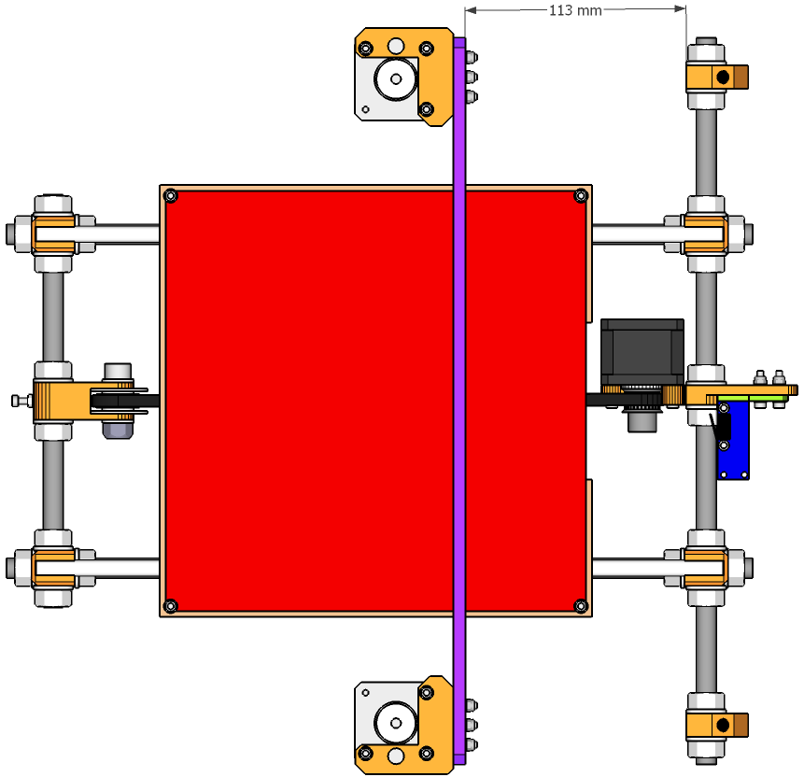 | 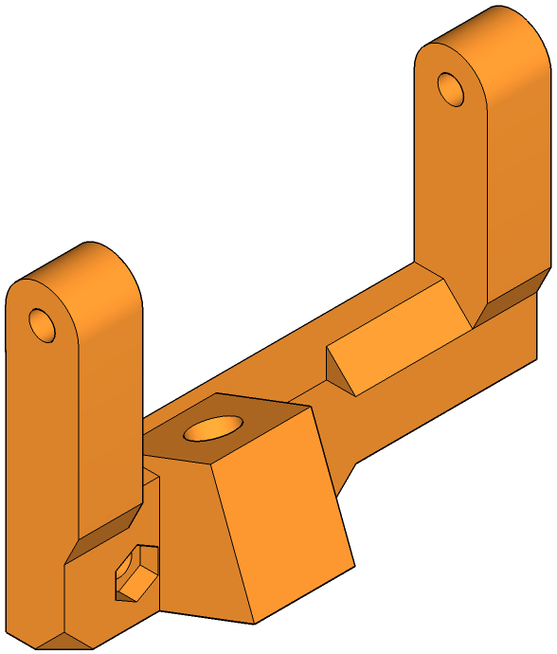 | 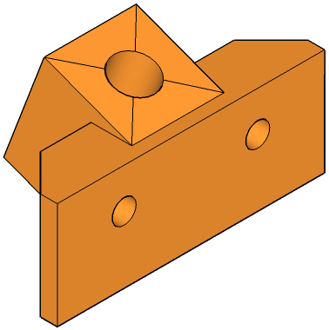 | 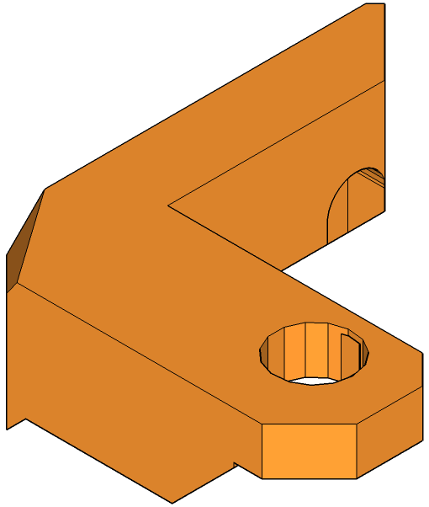 | 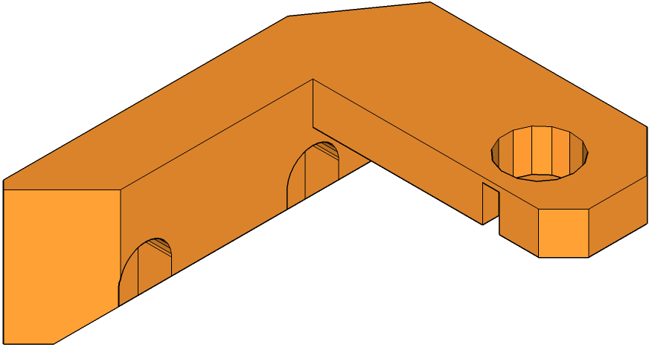
[1x]  Assembly J | [1x]  Assembly K | [1x]  Stabiliser Top  with LCD Mount | [1x]  Stabiliser Top | [1x]  Z Axis Top (Right) | [1x]  Z Axis Top (Left)
 | 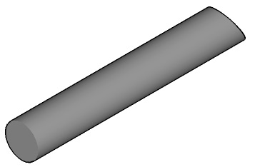
[2x]  320mm  Smooth Rod | [2x]  M5 30mm  Threaded Rod | [4x]  M3 20mm  Cap Head Screw | [4x]  M3 Nut

L

- Push a 320mm smooth rod into the recessed hole in each of the left and right Z axis motor mounts.

- Screw an M5 threaded rod into the recessed M5 nuts in the idler and mounter mounts on the X axis, assembly J. From the bottom, thread the rods into the nuts by about a third of the way along their length, making sure they are each screwed in by the same length.

- Slide the X axis, assembly J, down on to the vertical smooth rods attached to the Z motor mounts, making sure you guide the two M5 threaded rods down into the flexible couplers attached to the Z stepper motors. The threaded rods should slide all the way into the flexible couplers until they contact the stepper motor drive shafts.
- Lift the X axis, assembly J, so the M5 threaded rods are slightly above the stepper motor drive shafts (only a couple of mm is needed), but still within the flexible couplers, and secure using the grub screws provided. If the M5 threaded rods are in contact with the stepper motor drive shafts it can prevent the flexible couplers from flexing and may introduce Z wobble into your prints.

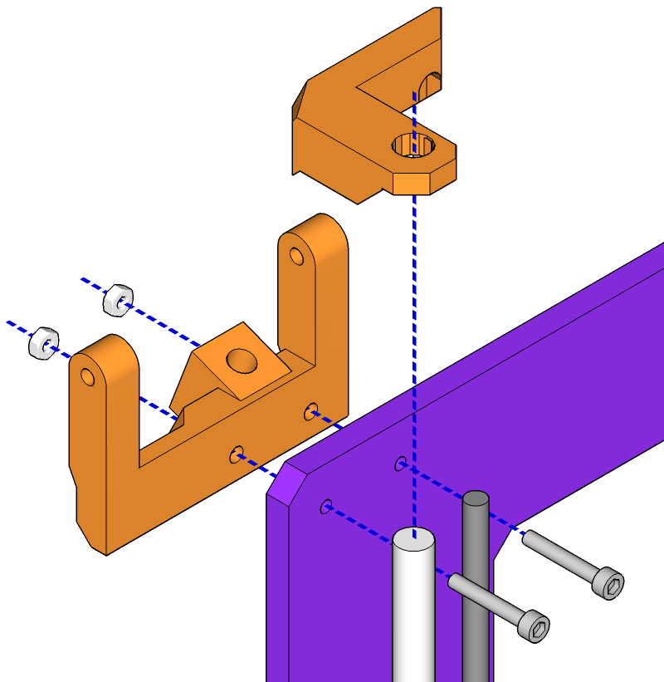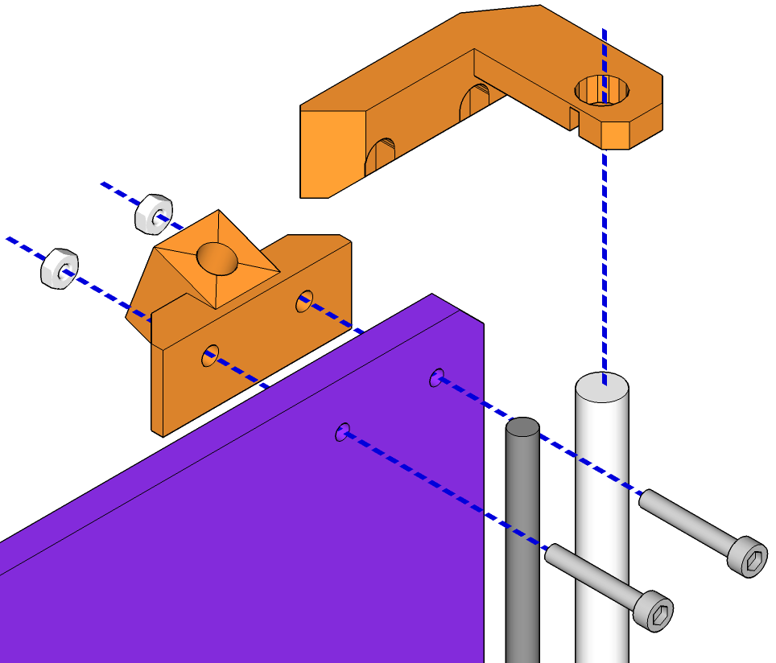

- Slide the left Z axis top mount down over the top of the left vertical smooth rod, line up with the holes in the frame and push two M3 20mm cap head screws through from the front. Push the stabiliser top with LCD mount piece, from the back, onto the two cap head screws and secure with two M3 nuts. The stabiliser top has recesses for the nuts, so you will need to tighten from the front.
- Slide the right Z axis top mount down over the top of the right vertical smooth rod, align with the mounting holes in the frame and push two M3 20mm cap head screws through from the front. Push the top stabiliser mount onto the two screws from the back and secure with two M3 nuts. Again, there are recesses for the nuts, so you will need to tighten from the front.

Attach Stabilisers, Endstop and Timing Belt

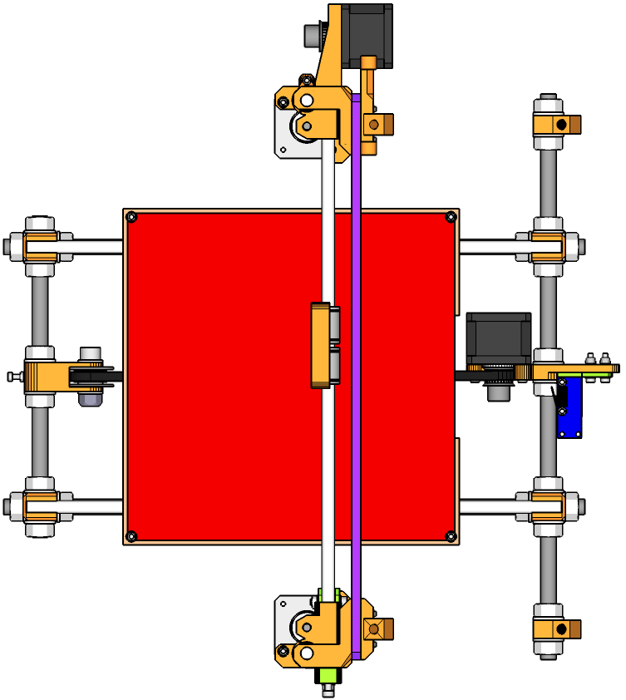 |  | 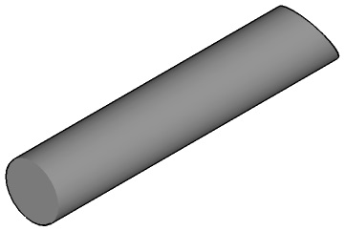
[1x]  Assembly L | [1x]  Z Axis  Endstop Mount | [2x]  M6 390mm  Threaded Rod | [1x]  Endstop | [1x]  GT2 Timing Belt | [1x]  M3 20mm  Cap Head Screw
 | 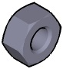 | 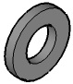
[2x]  M3 10mm  Cap Head Screw | [8x]  M6 Nut | [8x]  M6 Washer | [1x]  M3 Nyloc Nut | [2x]  M3 Nut | [4x]  M3 Washer

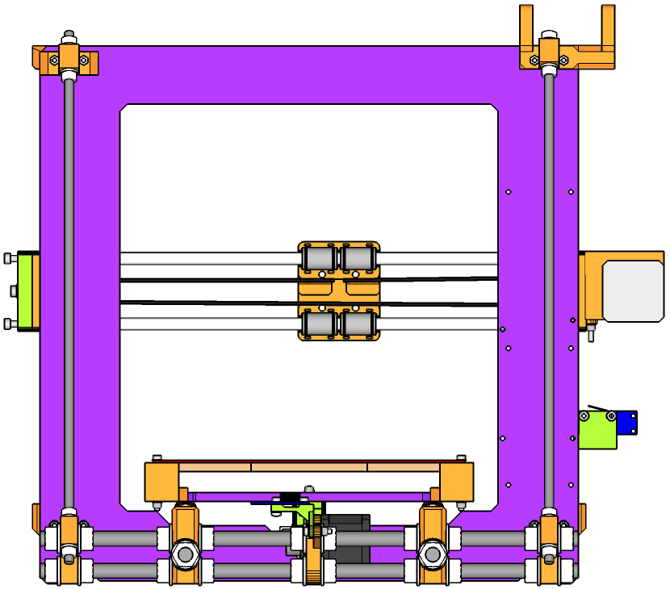
M
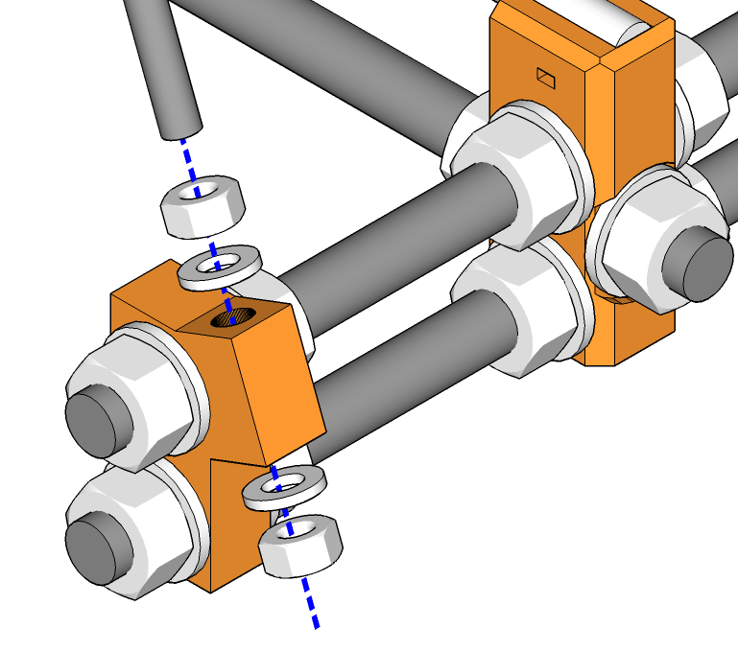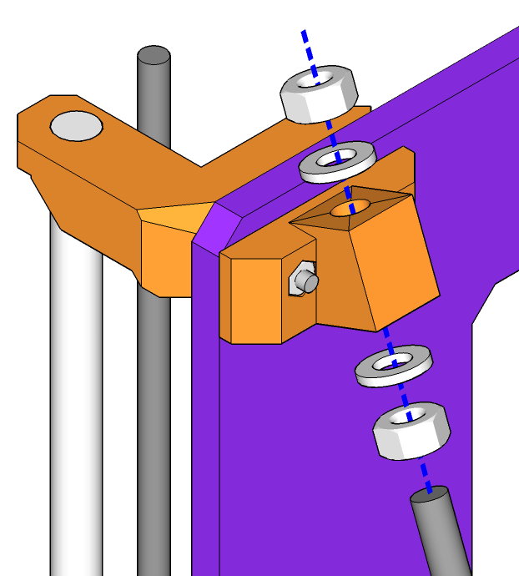

- Take the two M3 390mm threaded rods and, from the top, slide them through the holes in the top stabiliser mounts toward the bottom. Before sliding the rods through the holes in the bottom stabilisers, spin an M6nut onto the bottom of each, followed by a washer. Spin the nut up to give enough clearance so that, when pushed through the holes in the bottom stabilisers, each rod will com completely free of the top.
- Push the rods through so they come free of the top, then spin an M6 nut onto the top of each, followed by a washer. Spin the nut down at least 30mm, then push each rod back up into the top mount and secure at each end with another M6 washer and nut.
- Making sure your printer is on a flat and level surface, use a set square or A4 piece of paper folded in half, to check that the Z framework is at a right-angle to the base. If it isn't, adjust using the stabilisers. Lengthening the distance between the top and bottom stabiliser mounts will incline the plate toward the front of the printer, and vice versa.

- Attach an end stop to the Z axis endstop mount with two M3 10mm cap end screws, washers and nuts.
- Push the endstop mount onto the left-and vertical smooth rod. The end stop should be slightly higher than the flexible coupler (we will adjust this later). The two arms of the end stop mount should protude past the vertical M5 threaded rod – this prevents the end stop rotating on the smooth rod and missing contact with the X axis as it descends.
- Secure the endstop with an M3 20mm cap head screw, washers and nyloc nut.

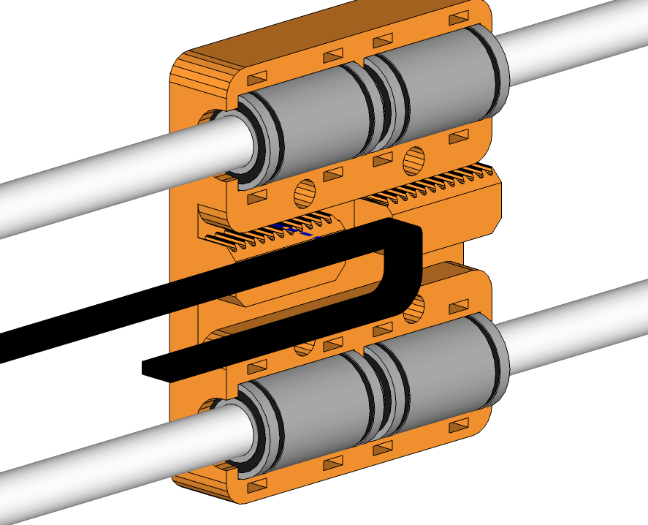
Loop 70mm of belt from here back through the slot pictured.
Press the belt into here.

- Take the remaining length of GT2 timing belt and measure about 70mm from one end. Loop the 70mm you measured back under the belt so the teeth are on the inside, then press the belt into one side of the back of the X carrage so the teeth on the belt engage with the teeth on the carriage, with 70mm of belt looping back through the slot under the X carriage teeth. press one end into the rear of the X carriage so that the belt end of the belt is fully captured within one of the toothed sections in the X carriage. The easiest way to push the belt into the X carriage is to grip the of the belt in a pair of needle-nosed pliers and push it in. Loop the free end of the belt around the pulley on the X motor, back through the gap, around the idler at the other end of the X carriage and back to the X carriage.
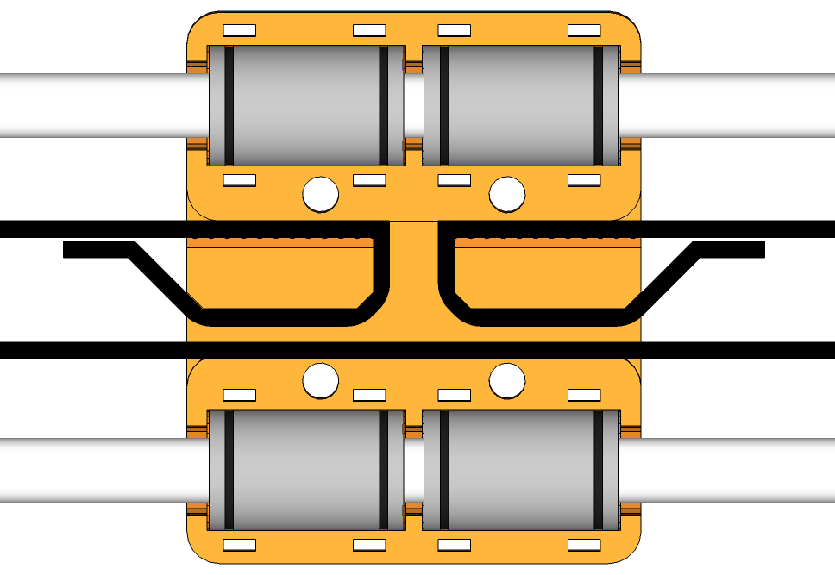
Loop the belt back and secure with a cable tie here.
Loop the belt back and secure with a cable tie here.

- Loop each end of the belt back on itself and secure with cable ties, as shown in the picture above. Trim for neatness. This step is largely optional, but gives extra security to ensure the belt does not slip.

- Tension the X belt by turning the two M4 cap head screws on the X belt tensioner clockwise.

Assemble Hot End and Mount

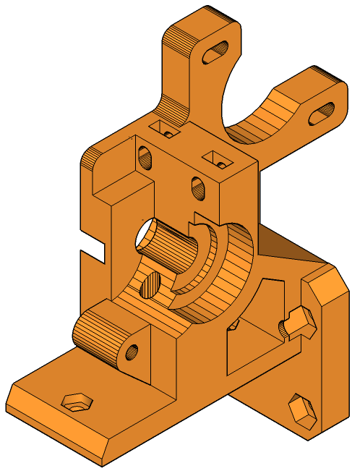 | 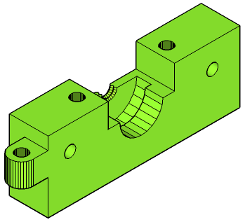 | 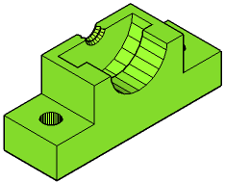 | 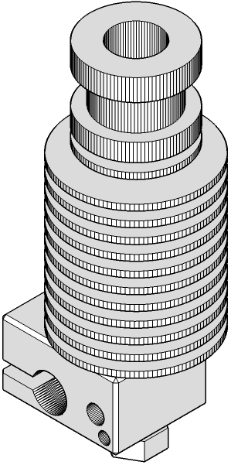 | 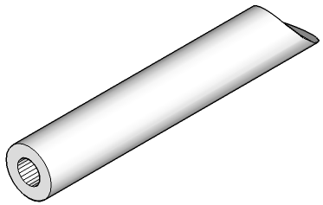 | 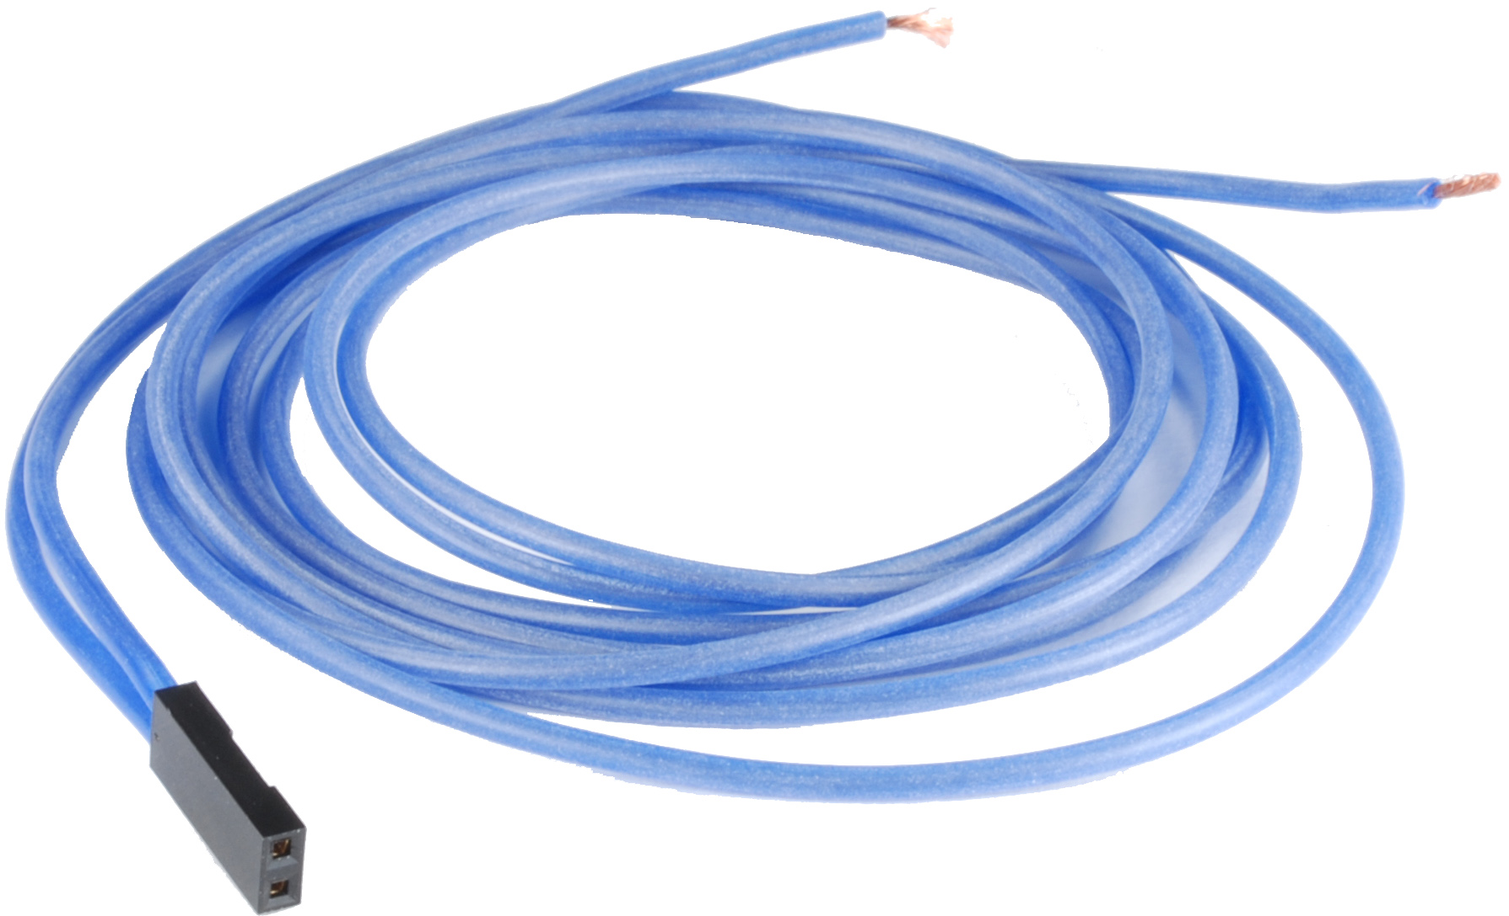
[1x]  Extruder Body | [1x]  E3D Hot End Mount | [1x]  E3D Mount Clamp | [1x]  E3D v6 Hot End | [1x]  PTFE  Extruder Liner | [2x]  Lengths of Blue Silicone Wire
[2x]  M3 30mm Cap Head Screw | [4x]  M3 20mm  Cap Head Screw | [4x]  M3 Nut | [4x]  M3 Washer
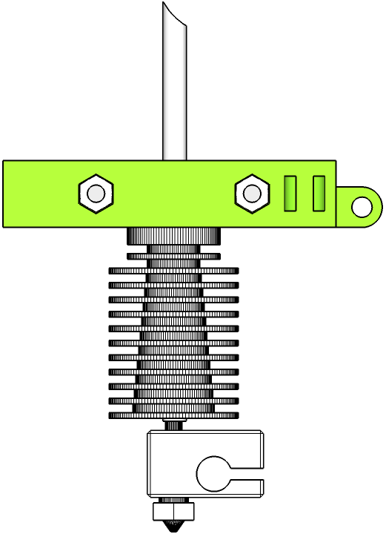
M
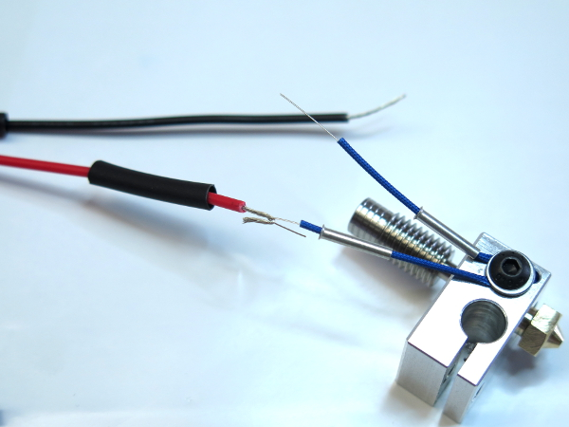
- Assemble the hot end according to the instructions on the E3D web site: http://e3d-online.com/E3D-v6-Assembly, using the cables and parts supplied with the thermistor package. The extruder is shown here and in diagrams without its fan or fan shroud for clarity and to avoid clutter.
- Take the PTFE tube and cut one end square using a craft knife. The squarer the better. The easiest way to do this is to get a square block of some sort and push the PTFE tube against it to keep it straight. Make sure a small amount of the tube protudes from the edge of the block and slide the blade of the knife down the perpendicular side, cutting the tube.
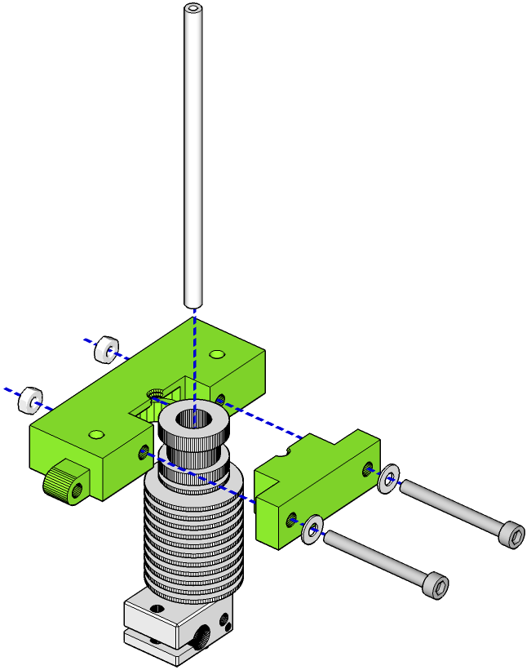
- Trim the tube to no less than 80mm long and slide it into the E3D extruder, square end first. Make sure the tube seats as far down into the hot end as it can.
- Slide the hot end, with the PTFE tube, into the hot end mount and clamp it down with the hot end clamp. The PTFE tube should stick up through the small hole in the top of the mount. Secure with two M3 30mm cap head screws, washers and nuts.
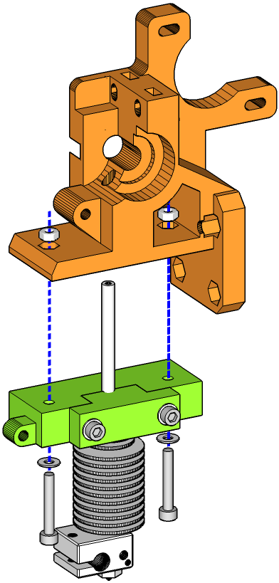
- Temporarily fix the hot end with mount to the extruder body by sliding the PTFE tube up through the guide hole in the bottom of the extruder and fixing the mount to the body with two M3 20mm cap head screws, washers and nuts.
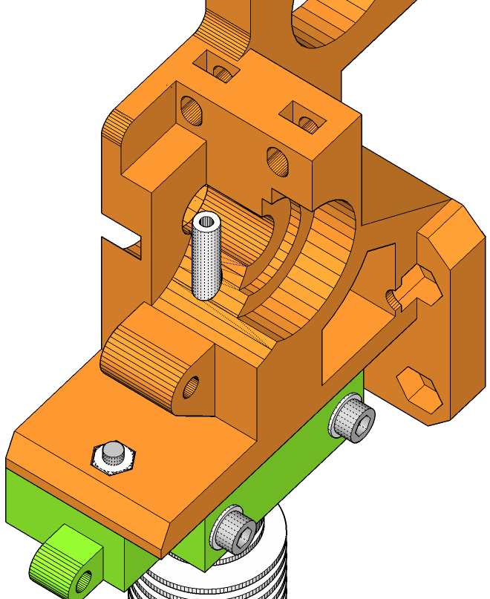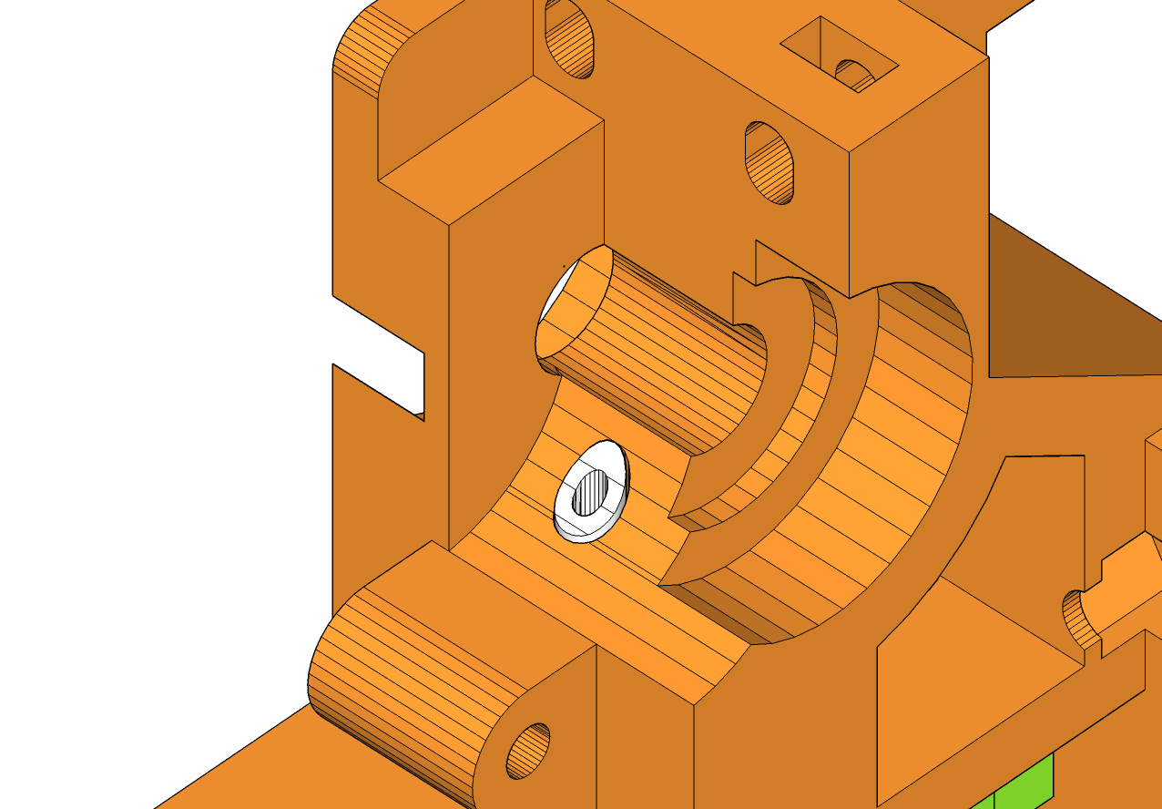
Trim here to conform to the curve of the extruder body.

- Looking down from the top of the extruder body, you should be able to see where the PTFE liner protudes through the body of the body of the extruder. Use a craft knife to trim the liner so it fits flush with the extruder.
Note: if you wish to extrude flexible filament with this extruder, the PTFE tube will need to be slightly longer so that the tube is as close as possible to the hobbed bolt and guidler wheel. Dry-fit the hobbed bolt to the extruder body and use this as a guide to trim the PTFE tube. Enough tubing is supplied with your kit to do this multiple times, if you make a mistake.
- Remove the extruder body from the hot end mount and lay the hot end assembly to one side.

Assemble Extruder

 |  | 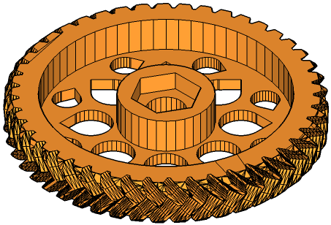 | 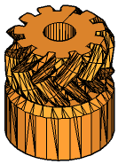 | 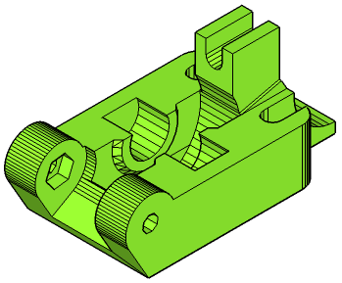
[1x]  Assembly M | [1x]  Extruder Body | [1x]  Herringbone Gear (Large) | [1x]  Herringbone Gear  (Small) | [1x]  Guidler | [1x]  Nema 17  Stepper Motor
 | 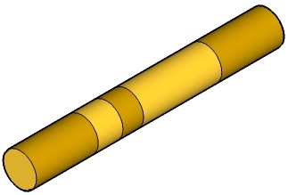 | 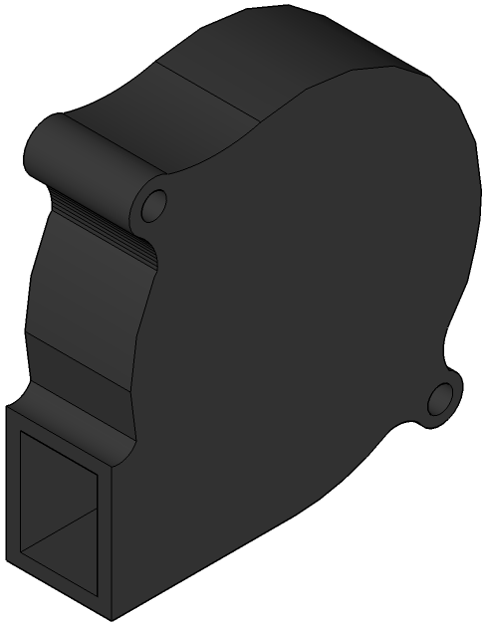 |  | 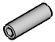 | 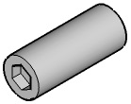
[3x]  608 Bearing | [1x]  Universal Hobbed Bolt | [1x]  Blower Fan | [2x]  Spring | [1x]  M3 10mm  Grub Screw | [1x]  M8 20mm  Grub Screw
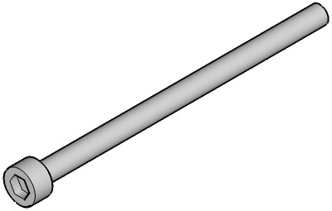 |  | 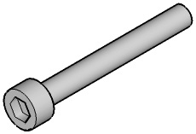
[2x]  M3 50mm  Cap Head Screw | [1x]  M3 30mm Cap Head Screw | [1x]  M3 25mm  Cap Head Screw | [2x]  M3 20mm  Cap Head Screw | [3x]  M3 10mm  Cap Head Screw | [2x]  M8 Nyloc Nut
[2x]  M3 Nyloc Nut | [5x]  M3 Nut | [6x]  M8 Washer | [13x]  M3 Washer

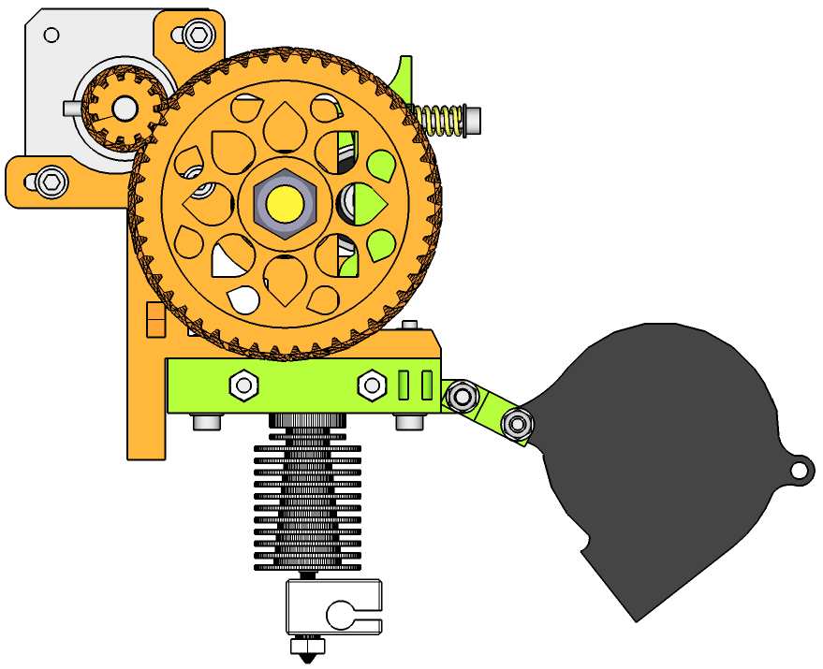
N

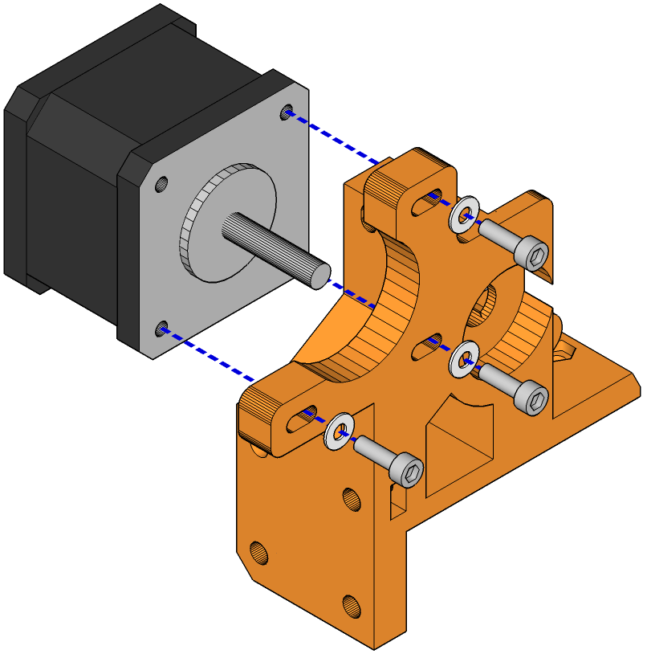

- Attach the Nema 17 stepper motor to the extruder body with three M3 10mm cap head screws and washers.

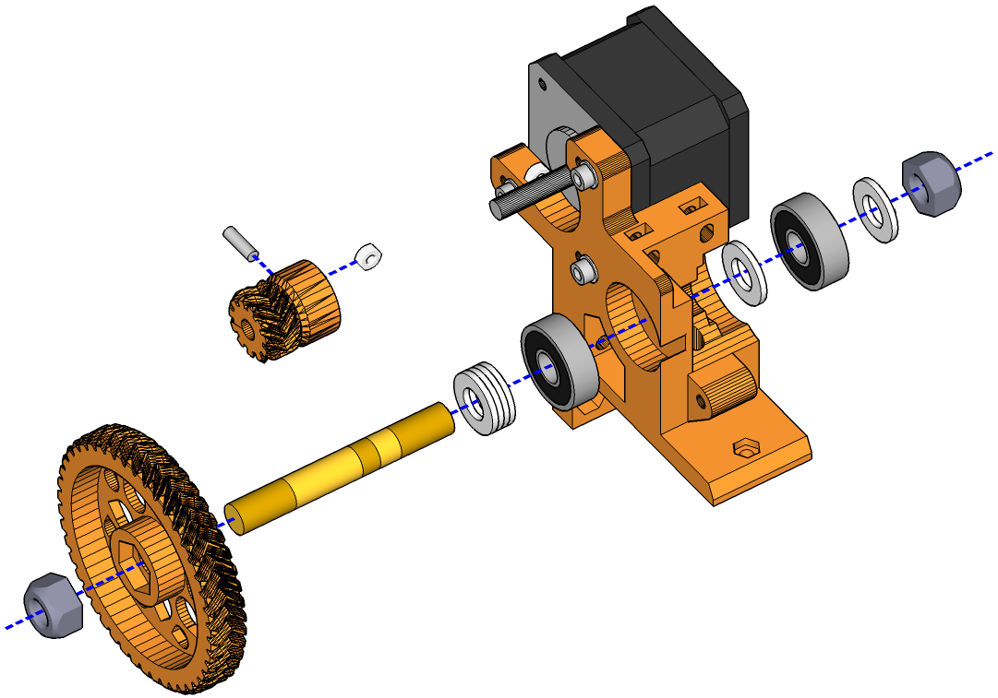

- Push-fit an M8 nyloc nut into the large herringbone gear.

M8 Nuts

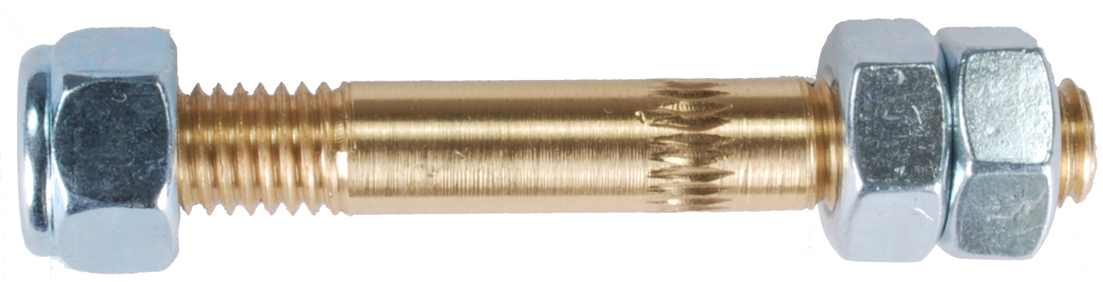
Hobbed Section
M8 Nyloc Nut

- Thread the universal hobbed bolt into the nut on the herringbone gear from the flat side of the gear, making sure that the hobbed bolt is correctly oriented. If the gear is on your left, thread the hobbed bolt from the right-hand side, through the gear, with the hobbed part of the bolt to the right. To tighten the bolt, thread the two standard M8 nuts onto the right of the hobbed bolt, tighten them together with two M8 spanners, then use a spanner on the outermost nut to tighten the hobbed bolt into the nyloc nut pressed into the large herringbone gear. Use two M8 spanners to loosen the standard M8 nuts and remove from the hobbed bolt. The image above illustrates how it fits together, although the large herringbone gear is excluded for clarity. Approximately 2mm of the hobbed bolt should protude from the nyloc nut.
- Stack four M8 washers and slide them onto the hobbed bolt, followed by one of the 608 bearings.

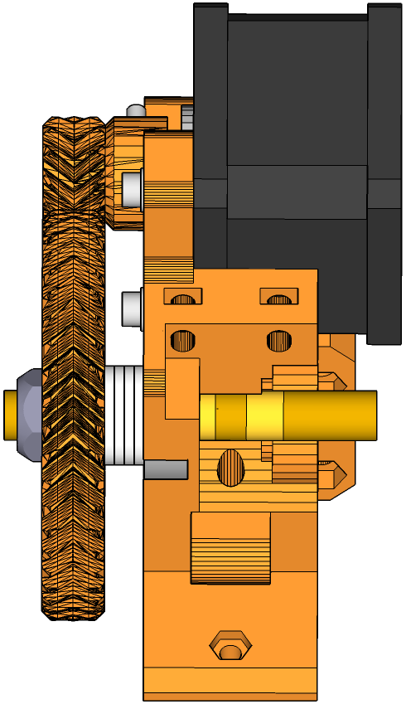
Hobbed section of bolt here should line up with the guide hole.
Guide hole.
There may be a slight lip here causing binding.

- Slide the large herringbone gear, with the hobbed bolt and washers/bearing, into the extruder body from the side of the motor shaft. Note the position of the hobbed section over the PTFE liner. If they're not lined up, screw or unscrew the nyloc on the end of the hobbed bolt to adjust the position (you can use the trick with the two M8 nuts to make this easier).
- Press an M3 nut into the recess in the base of the small herringbone gear and use the M3 grub screw to secure the nut, from the hole in the side of the small gear.
- Pull the large herringbone gear back out of the extruder body by about 20mm. Mesh the small and large herringbone gears together and slide the hobbed bolt back into the extruder body and small herringbone gear onto the stepper motor drive shaft at the same time.
- Secure the small herringbone gear onto the stepper motor drive shaft by tightening the grub screw, ensuring that the screw engages with the flat of the drive shaft.
- From the other side of the extruder, slide an M8 washer followed by a 608 bearing and another washer. Secure with the remaining M8 nyloc nut Tighten enough to prevent side-to-side movement of the hobbed bolt, but not enough to prevent it turning freely.
- Test the rotation of the herringbone gears. If they bind at all, check that the gears are aligned correctly. If they are aligned correctly you may need to take a small file, such as a nail file, and remove some material along the edges of one or both of the gears. Check for a lip on the shiny side of the gear and use the file to remove. Don't get over-enthusiastic with the file – you won't need to remove much.

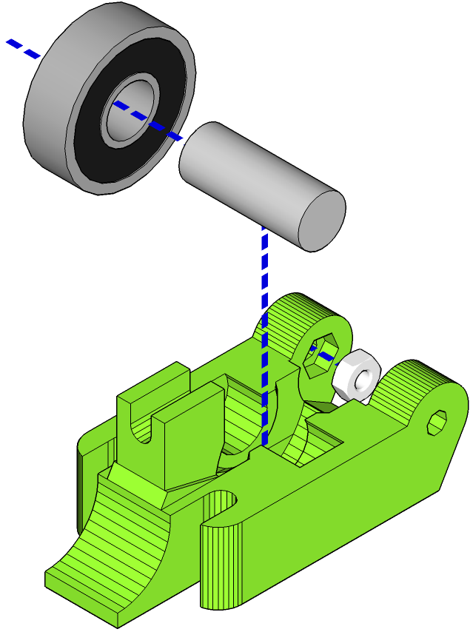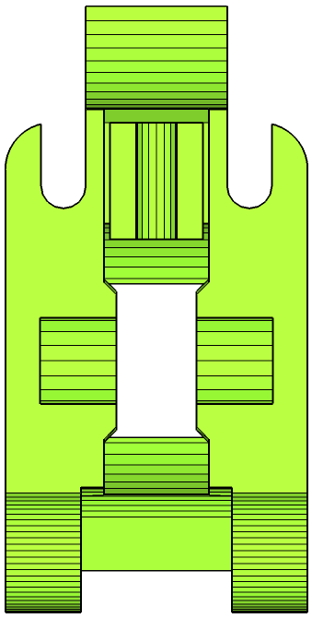
Remove material from lip here (on both sides) if bearing is too tight.
Press M3 Nut in here.

- Slide the M8 grub screw into a 608 bearing and press the grub screw into the recess in the guidler using a pair of multi-grips. Use the multi-grips on the grub screw only – not on the surface of the bearing. Press each side in gradually, alternating sides, until the grub screw snaps into the recess. If the bearing is a tight fit, remove some of the lip on the inside of the recess with a file.
- Press an M3 nut into the recess on the inside wall of the Guidler hinge. If the guidler is placed in front of you with the raised part uppermost, the nut should be pressed into the right-hand-side recess.

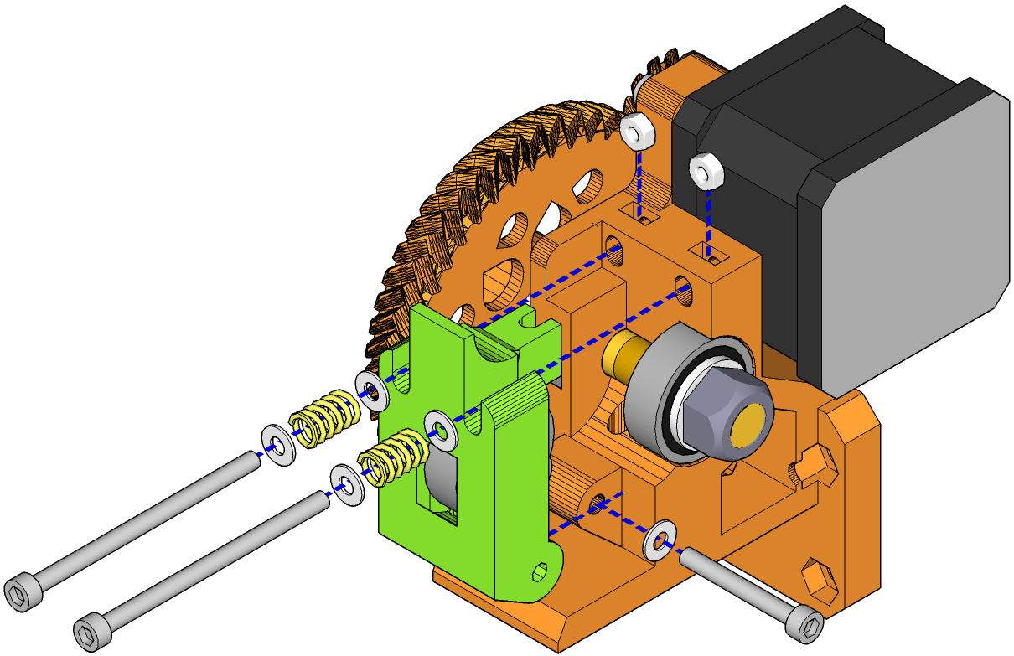

- Push the guidler onto the extruder body and secure at the hinge with an M3 25mm cap head screw and washer.
- Slide an M3 nut into each of the recesses at the top of the guidler near the stepper motor.
- Take the two M3 50mm cap head screws and, on each, slide an M3 washer followed by a spring and another M3 washer. Thread the nuts through the holes in the guidler and into the M3 nuts you inserted in the previous step. Please note that there are alternative, lighter silver-coloured springs included with your kit to allow you to set the guidler tension to your preference.

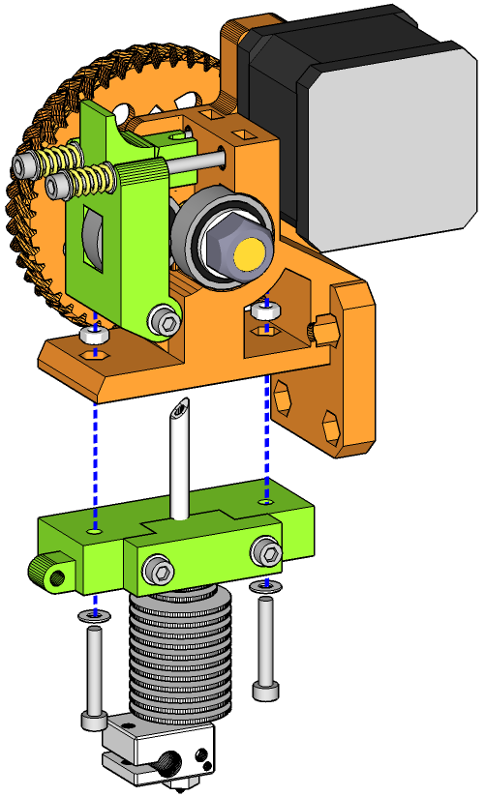

- Reattach the hot end and mount to the extruder using two M3 20mm cap head screws, M3 nuts and washers.

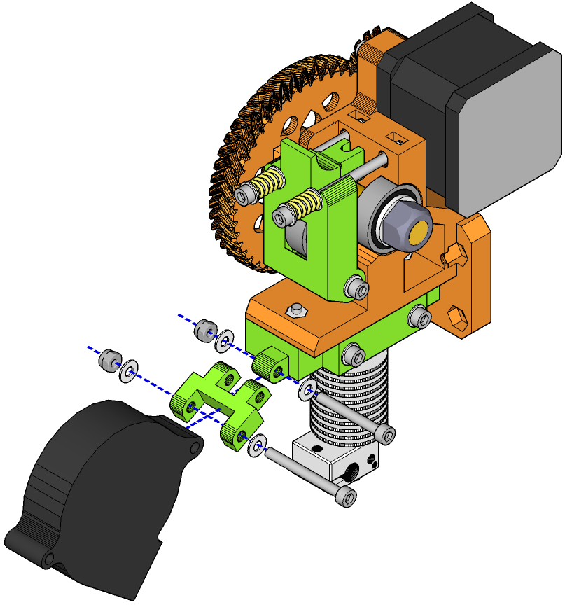

- Attach the blower fan to the blower fan mount with an M3 30mm cap head screw, nyloc nut and two washers.
- Attach the blower fan mount to the hot end mount with an M3 25mm cap head screw, nyloc nut and two washers. Tighten enough that the fan does not move freely. Make sure the fan points at the hot end nozzle but does not extend below it.

Attach Extruder to X Carriage

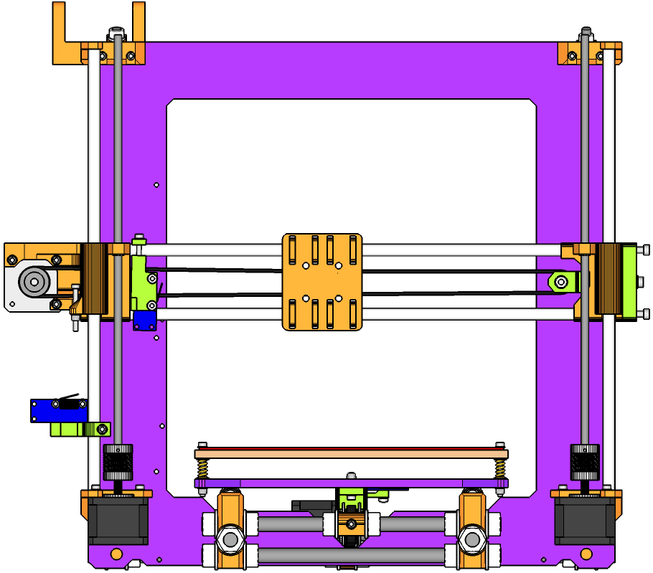
[1x]  Assembly M | [1x]  Assembly N | [4x]  M4 20mm  Cap Head Screw | [4x]  M4 Nut

O

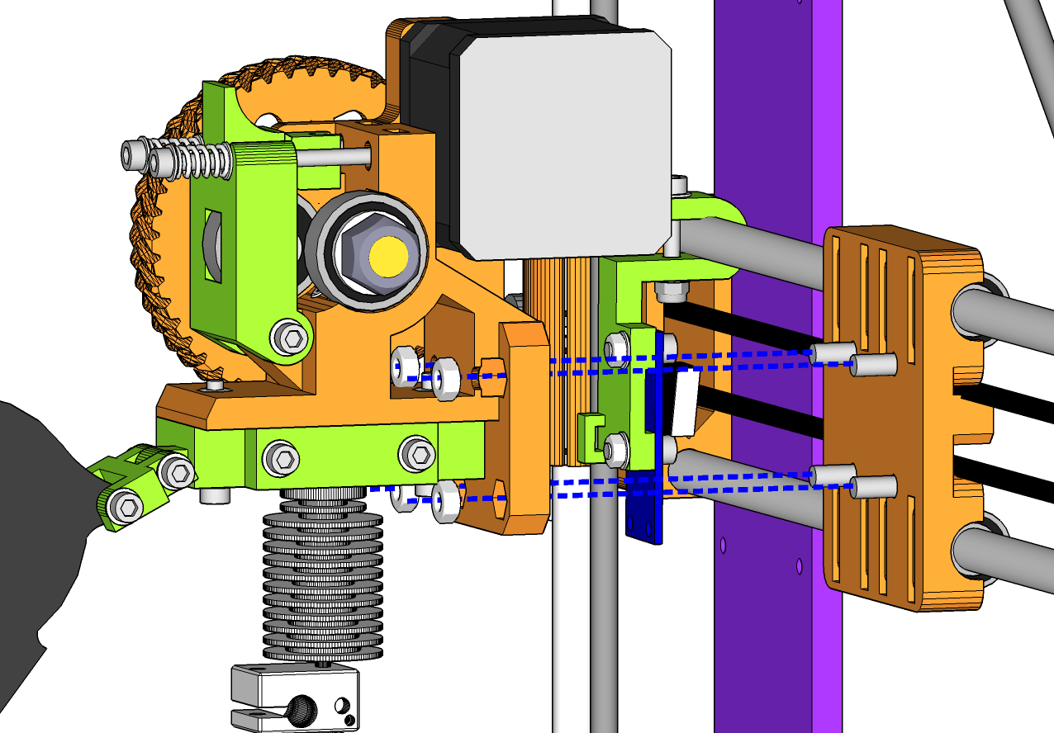

- Attach the extruder / hot end to the X carriage with four M4 20mm cap head screws and M4 nuts. The heads of the screws should be on the carriage side and there are recesses for the nuts within the body of the extruder.

Attach Electronics

 | 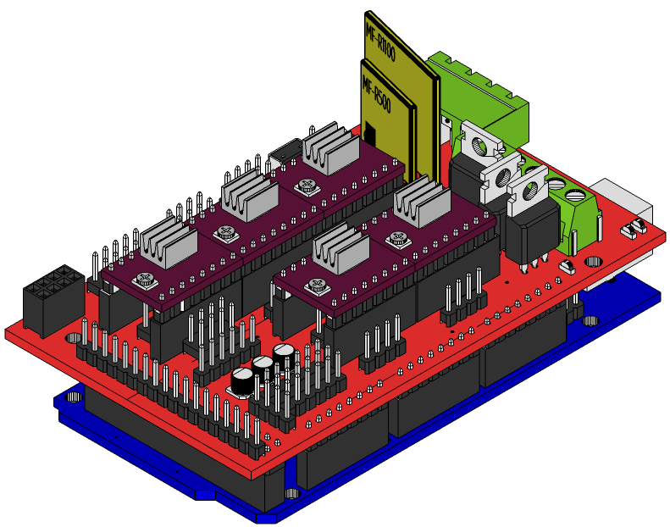 | 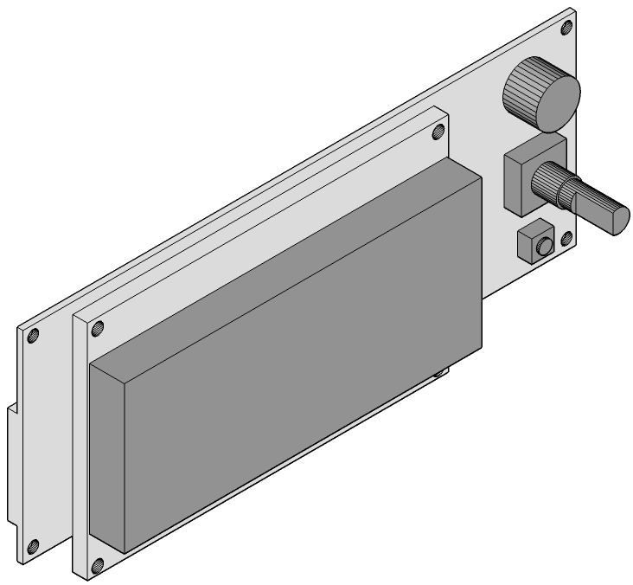 | 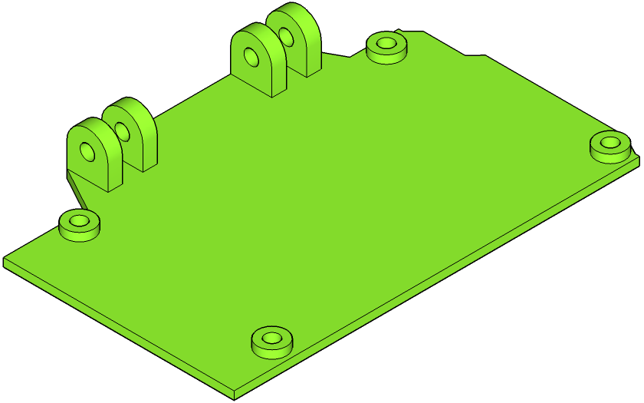 | 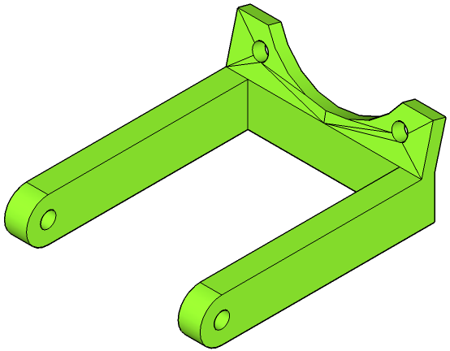 | 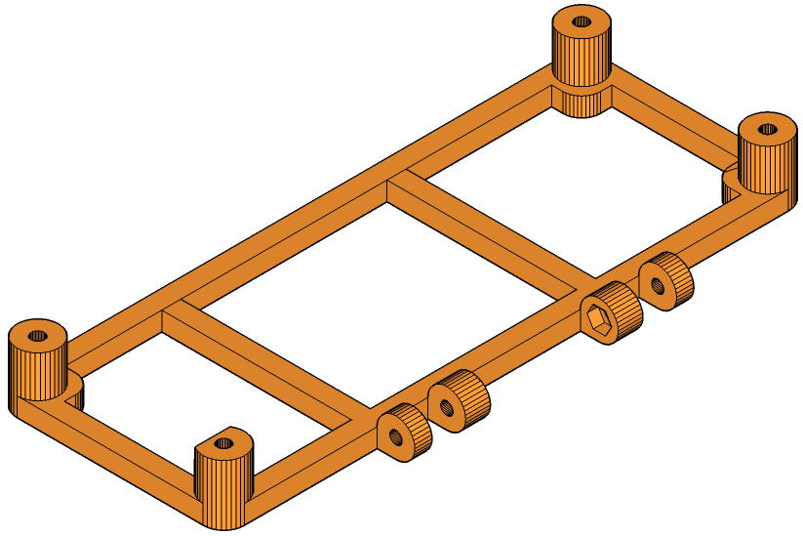
[1x]  Assembly O | [1x]  RAMPS / Arduino Package | [1x]  Smart Controller  (with cables) | [1x]  Arduino Tray | [1x]  RAMPS Fan Mount | [1x]  Smart Controller Holder
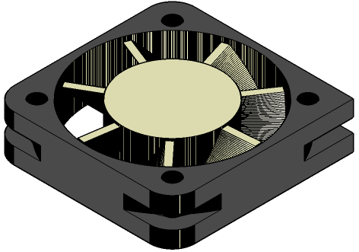
[1x]  40mm Fan | [6x]  M3 25mm  Cap Head Screw | [6x]  M3 20mm  Cap Head Screw | [4x]  M3 Nyloc Nut | [6x]  M3 Nut | [14x]  M3 Washer

P
Please note that you may want to save doing this step until after you have completed the software installation part of this manual. Installing drivers and software requires plugging your electronics into your computer, which is a little easier the first time if it's not attached to your printer. Further, if you intend to check the vref settings of your stepper drivers (more detail of which is contained in the wiring chapter), it is also easier to accomplish if your board is not attached.

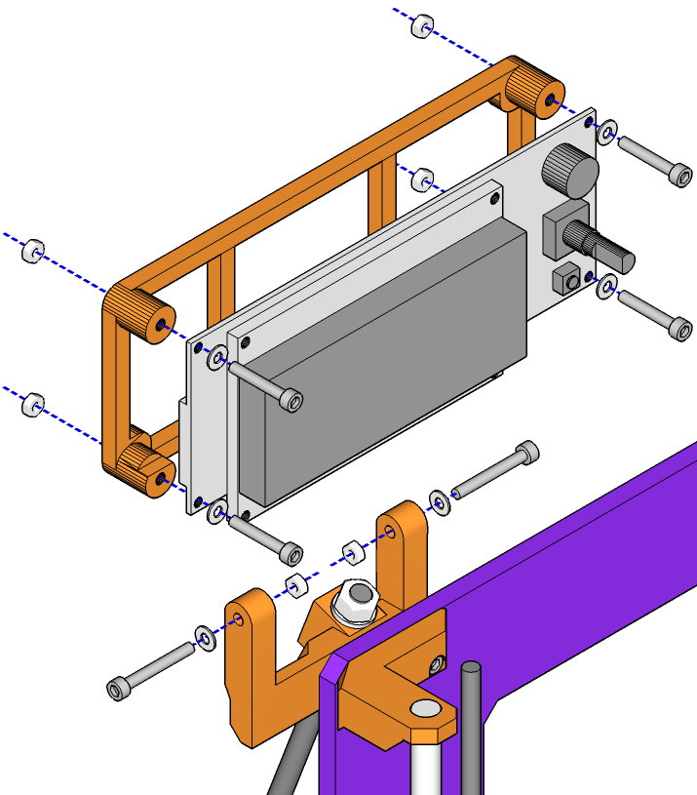

- Secure the smart controller to its holder using four M3 25mm cap head screws, nuts and washers. The nuts fit in recesses at the back of the holder.
- Secure the holder to the mount at the top of the printer frame using two M3 20mm cap head screws, nuts and washers. The nuts fit in recesses on the mount.

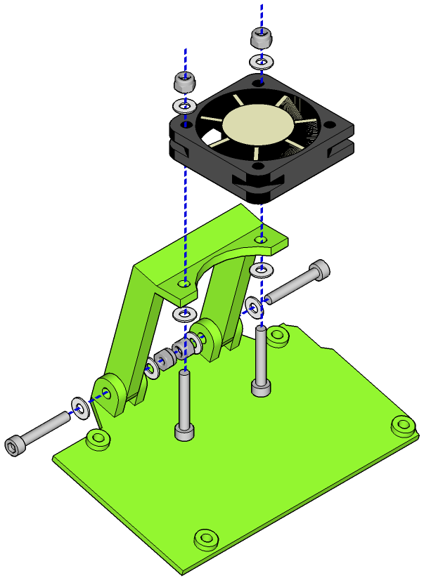

- Secure the 40mm fan to the RAMPS fan mount using two M3 20mm cap head screws, four washers and two M3 nyloc nuts.
- Attach the RAMPS fan mount to the arduino tray using two M3 20mm cap head screws, four washers and two M3 nyloc nuts.

- Place the Arduino tray on your work surface so that the fan mount is to the left. Lay the Arduino / RAMPS boards (which come pre-assembled and connected in your kit) on top of the Arduino tray so that the screw-in connectors on the RAMPS board are at the bottom. The cutouts on the corners of the Arduino and its tray should line up, as should the mounting holes.
- Offer up the electronics and tray to the rear of the Z axis frame and mount with one M3 30mm cap head screw at the top, as per the diagram above, and another at its diagonally opposite corner. There are multiple mounting holes on the frame for different electronics packages; the ones illustrated with are specifically for the Arduino. Secure at the front of the frame with M3 washers and nyloc nuts. The cap head screws will extend from the RAMPS board through the Arduino board, so please be careful not to over-tighten as you will damage the boards. Tighten only just enough so the boards do not move – the nyloc nuts will keep them secure.

Clip Borosilicate Printing Surface to Bed
- Take the borosilicate glass sheet that came with your kit, lay it on the print bed and clip it down at all four corners with the butterfly clips provided. Make sure the clip on the front left corner is 30-40mm from the edge of the glass sheet, or it will foul the hot end when the hot end is homed.
You've now finished the nuts-and-bolts part of putting your kit together. Stand back, admire your new printer, give yourself a pat on the back, take a few deep breaths, then dive into the next sections.

Toolchain and Software Installation
The software used to design and print on your printer is divided into two categories: CAD (Computer Aided Design) and CAM (Computer Aided Manufacturing). The toolchain is the chain of software tools you will use to get from a design concept to a printed piece. Alternatively, you can download ready-made designs from sites such as thingiverse.com and use the CAM part of your toolchain to print the design.

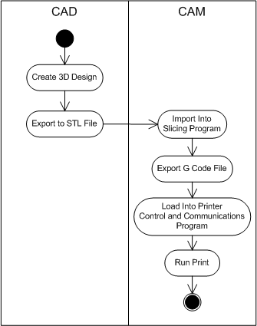

The above diagram illustrates the broad steps involved in getting from a design to a printed object.
- First, you create a design for an object using the software package of your choice. Once your design is complete, you export it to an STL file, which is a file that breaks up your design into a series of triangles and describes them in terms of the x, y and z coordinates of each point of each triangle and their edges. This is the CAD or Computer Aided Design part of the process. Alternatively you can download any number of STL file designs from sites such as http://www.thingiverse.com or http://www.youmagine.com.
- Next, you import the STL file into a slicing program, which converts the file into a series of instructions specific to your printer. The instructions are called G code and are a kind programming language used to control automation. The process is called slicing as your printer prints in slices or layers laid down sequentially one on top of the other.
- Finally, the G code file is loaded into a printer control and communications program, sent to the printer and the print begun. This and the previous step are the CAM or Computer-Aided-Manufacturing part of the process.
There are many software tools available that will help you perform these steps and any number that combine more than one of the above steps into a single package. You can read a fairly comprehensive list at the reprap wiki: http://reprap.org/wiki/Useful_Software_Packages.
The software provided with your printer covers the CAM part of CAD/CAM. It comprises pronterface, an open source 3d printing host software package and Slic3r, an open source slicing program. Together these form a powerful 3D printing CAM toolchain. You can download the latest versions of these free from the internet, as per the download and configuration instructions in the following two chapters. In addition, you will need the Arduino development environment, which includes software drivers to allow your computer to talk to your printer's electronics, and will be necessary if you want to upgrade the firmware on your printer (also covered in the following chapters).

Installing the Arduino Development Environment
The latest version of the Arduino development environment can be downloaded from here:
http://arduino.cc/en/Main/Software
Make sure you download the latest version (1.0.6 as at time of writing) and not the beta version (1.5.7 as at time of writing). It will be clear on the download page which is which. Installation packages for Windows, Mac OS X and Linux are provided on the download page. For Windows, make sure you download the Windows Installer package, which also installs the USB drivers for the Arduino board that comes with your kit.
Once you have downloaded the installation package, open it to start the installation process. At some point near the completion of the installation, you will be asked if you want to install the device driver software. Click on the “Install” button to install the device driver.
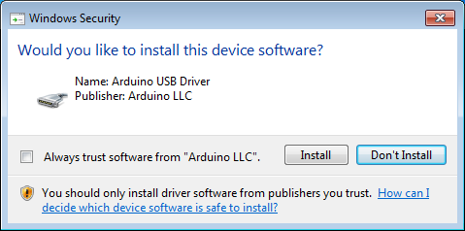
Once the device driver and Arduino software have completed installing, use the supplied USB cable to connect your electronics to a spare USB port on your computer. Your computer will automatically detect the board and install the device driver appropriately.
Once the driver has installed, you will be shown a message like the one below. Take a note of the COM port shown – you will use this later when using Pronterface to control the printer, or the Arduino development environment to flash firmware to the printer.
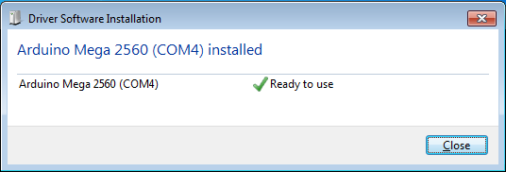
Keep the controller board plugged into your computer for now, so you can test communications with the board in the next chapter.

Installing Pronterface and Slic3r

Getting Pronterface
Pronterface is part of the Printrun package developed by kliment (https://github.com/kliment). Printrun is a series of scripts developed in the Python programming language for controlling a 3D printer.
- printcore.py is library to aid writing reprap hosts.
- pronsole.py is a command-line tool for controlling a 3D printer.
- pronterface.py is a graphical tool with the same functionality as pronsole.py.
- webinterface.py is a tool to allow you to control a 3D printer through a browser.

For ease of use, Pronterface is available as a pre-compiled binary, from the following locations:
- Windows: http://koti.kapsi.fi/~kliment/printrun/
- Mac OSX: http://koti.kapsi.fi/~kliment/printrun/
- Linux: You can run printrun directly from source. Download the latest version from github: https://github.com/kliment/Printrun

Installing Pronterface
To install Pronterface on Windows, open the zip file you downloaded and extract the contents to an appropriate directory on your computer, such as:
C:\Program Files (x86)\
Note that you may need to provide administrator privileges to copy Pronterface to the Program Files directory on Windows.
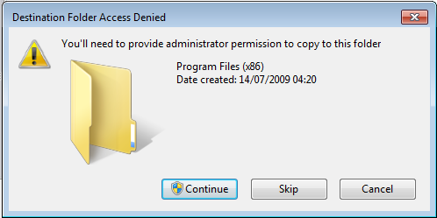
Once you have copied Printrun and Pronterface to its destination directory, open that directory in Explorer (it will be named something like “C:\Program Files (x86)\Printrun-Win-Slic3r-10Mar2014” and right-click on the “pronterface.exe” file. Click on the “Send To” menu option, then “Desktop (create shortcut)”. This will create an icon for Pronterface on your desktop you can use to start the progrm.
To install Pronterface on Mac OS X, download the file first then navigate to your downloads folder in Finder. Extract the zip file and move the extracted Pronterface application to your applications folder. The first time you open Pronterface, you will need to control-click on the application first, then click on Open. This will give the application the correct permissions to run on your machine.

Getting Slic3r
Slic3r is included with the pre-compiled Windows binary package given in the previous chapter. The latest version of Slic3r is also available from http://www.slic3r.org. We recommend getting the latest version from slic3r.org, as it has the latest fixes and getting the correct configuration to work within pronterface can be tricky.

Installing Slic3r
If you have downloaded the latest version of Slic3r and you want it integrated with Pronterface, download the application zip file from the Slic3r website and open it. You will see a Slic3r subdirectory first in the opened zip file, which you should copy to the directory you installed Pronterface to, overwriting the existing Slic3r subdirectory.
To install Slic3r on Mac OS X, download the application from the Slic3r website. Open the downloaded dmg file and drag the Slic3r application to your Applications folder. The first time you run Slic3r, control-click on the application icon and select Open. This will give the application the correct permissions to run on your machine.

Configuring Pronterface
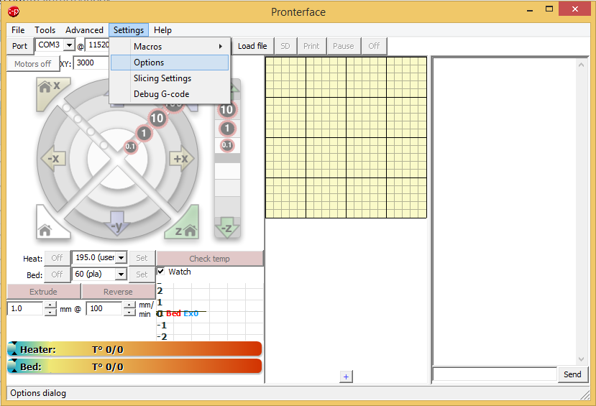
To configure Pronterface, start Pronterface and click on the Options menu option, then Settings. The following window will appear.
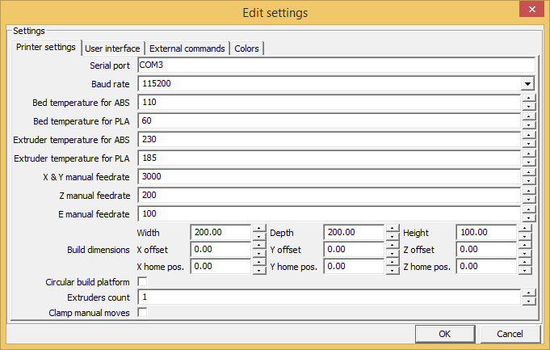
In chapter 8.1, when you connected your electronics to your computer, a COM port was given when the Arduino driver completed installation (sample window below).
With luck, you remembered to take note of the com port and can enter it in the “Serial port” box in the Pronterface settings window. Don't worry if you didn't, though, as Pronterface will detect available COM ports, including the one your printer is plugged in to, when you click on the “Port” button on the main window.
Copy the Pronterface settings from the screen shot above to your installation of Pronterface. The speed settings are particularly important; the temperature settings are something you can tune later to your personal preferences. Click the “OK” button when you're finished.
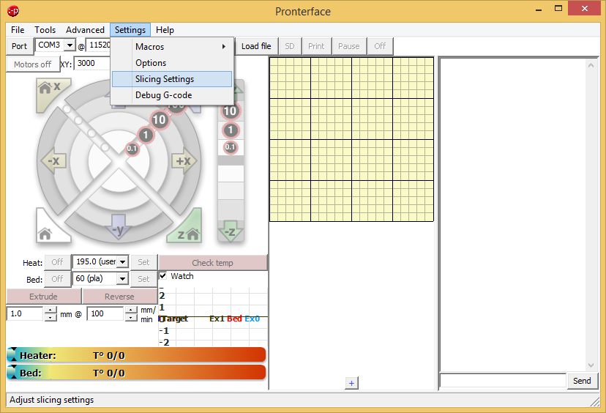

Configuring Slic3r
We have created a configuration bundle for Slic3r to get you started.
http://www.3dkarma.com/content/7-downloads
Download the Slic3r configuration bundle file and save it to your hard drive.
To configure Slic3r, start Slic3r (in Windows, navigate to the directory you installed Slic3r in and double-click on slic3r.exe). Hint: in Windows, to make starting Slic3r easier next time, you can pin Slic3r to your task bar by starting Slic3r, then right-clicking on the icon in the task bar and clicking on the “Pin this program to taskbar” option.
Once Slic3r has started, click on the “File” menu, then “Load Config Bundle” and load the configuration bundle file you saved to your hard drive. Slic3r will then be fully configured with the default settings for your printer and you can exit the program.
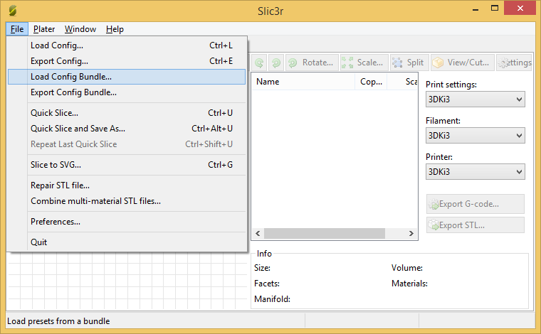

Wiring

RAMPS
Your kit comes supplied with an Arduino Mega 2560 board (the brains of the operation), RAMPS 1.4 controller board (which hooks everything together) and four stepstick stepper driver breakout boards. These have been pre-assembled, had the correct firmware loaded and pre-configured, ready for connection to your printer.

The following diagram illustrates how everything should be connected to the RAMPS board. Regardless of how complex the diagram looks, wiring your printer is reasonably straightforward and simply a matter of plugging in the supplied leads in the correct orientation. Make sure you follow the colour guide and get the wiring orientation correct and your printer should work first time.
Each wiring step is broken down into subsequent chapters.
Please ensure that your printer's power supply is not connected to the mains when wiring your printer.

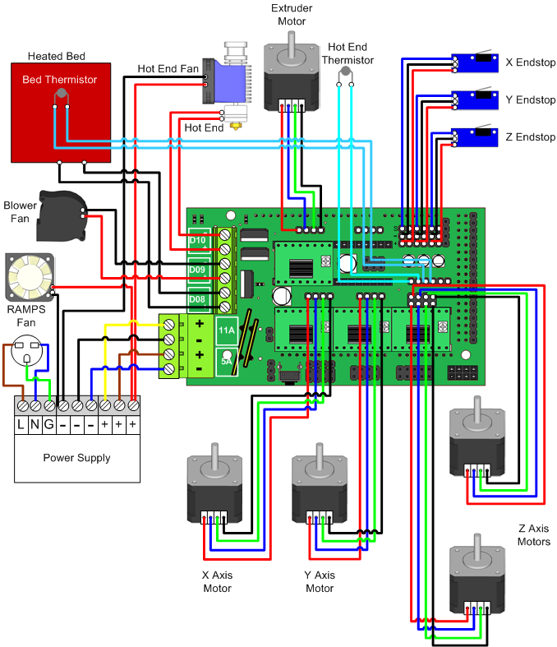

A Note About Stepper Drivers
Your kit is supplied with four A4988 stepstick stepper drivers. These are an improved version of the original stepstick. The new stepstick has a higher current limit and has been designed and manufactured with four layers instead of two, improving heat dissipation. The new version also has a higher current limit (2A) instead of 1A or 1.5A on older versions of the driver.
Your stepper drivers need to be configured with a current limit or reference voltage. Setting the current limit too high will cause overheating; setting it too low and your motors won't have enough power to operate properly. The stepper drivers in your kit have been pre-set to the correct values, but should you choose to check or modify these for yourselves, the reference voltage for the stepsticks supplied with your kit should be set to the current rating or your stepper motors divided by 2.5. For 1.2A stepper motors, then the current limit should be set to 0.48V for the X and Y stepper motors and the extruder. For 1.5A motors, 0.6V should do. As the two Z stepper motors are by default wired in parallel, the vref should be doubled to 0.96V or 1.2V, depending on the stepper motor.
With the stepper motor drivers plugged in to your RAMPS board, RAMPS plugged in to the Arduino Mega and your Arduino Mega connected to your computer with the supplied USB cable, you can check the vref with a multimeter with the negative probe on the negative terminal of one of the power connections (make sure you screw the connection down so it makes contact properly) and the positive probe on the trimpot of the stepper driver.

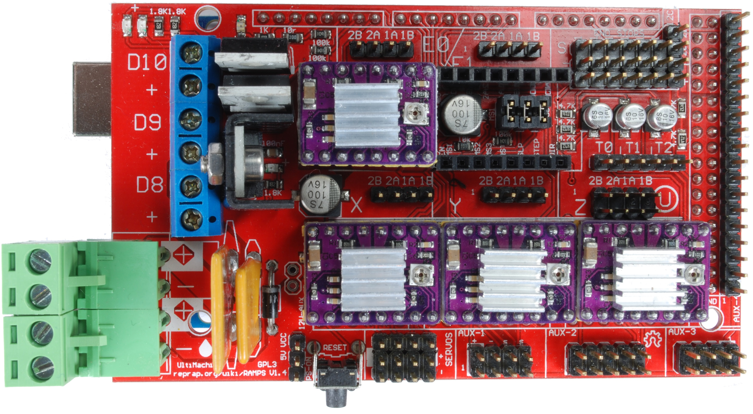
Negative probe here.
Positive probe on trimpot here.

Turn the trimpot counter-clockwise to increase vref; clockwise to decrease it. If you have one, use a ceramic screwdriver to turn the trimpot, to avoid short-circuits if your hand slips.

Cabling
Your kit comes supplied with a generous length of braided cable sheath. You can use this to wrap bundles of cables to keep your printing looking smart. The bundle leading to your extruder and hot end is a good use for the sheathing.
Routing of your cables is important to prevent fouling. For the cable bundles connected to the heated bed and hot end, ensure that there is enough cable length to allow for full travel and that the cables are routed so they do not foul on other parts of the printer. For example, route the hot end / extruder cable bundle over the top of the printer. Use cable ties to secure your cables to the framework of the printer.
There are strain relief points built into the hot end of the printer and the X axis end stop holder. These are designed to prevent the movement of the printer causing stress where wires may break away from there connection points over time and to help route cables appropriately. Use a cable tie to secure wires to each of these relief points.

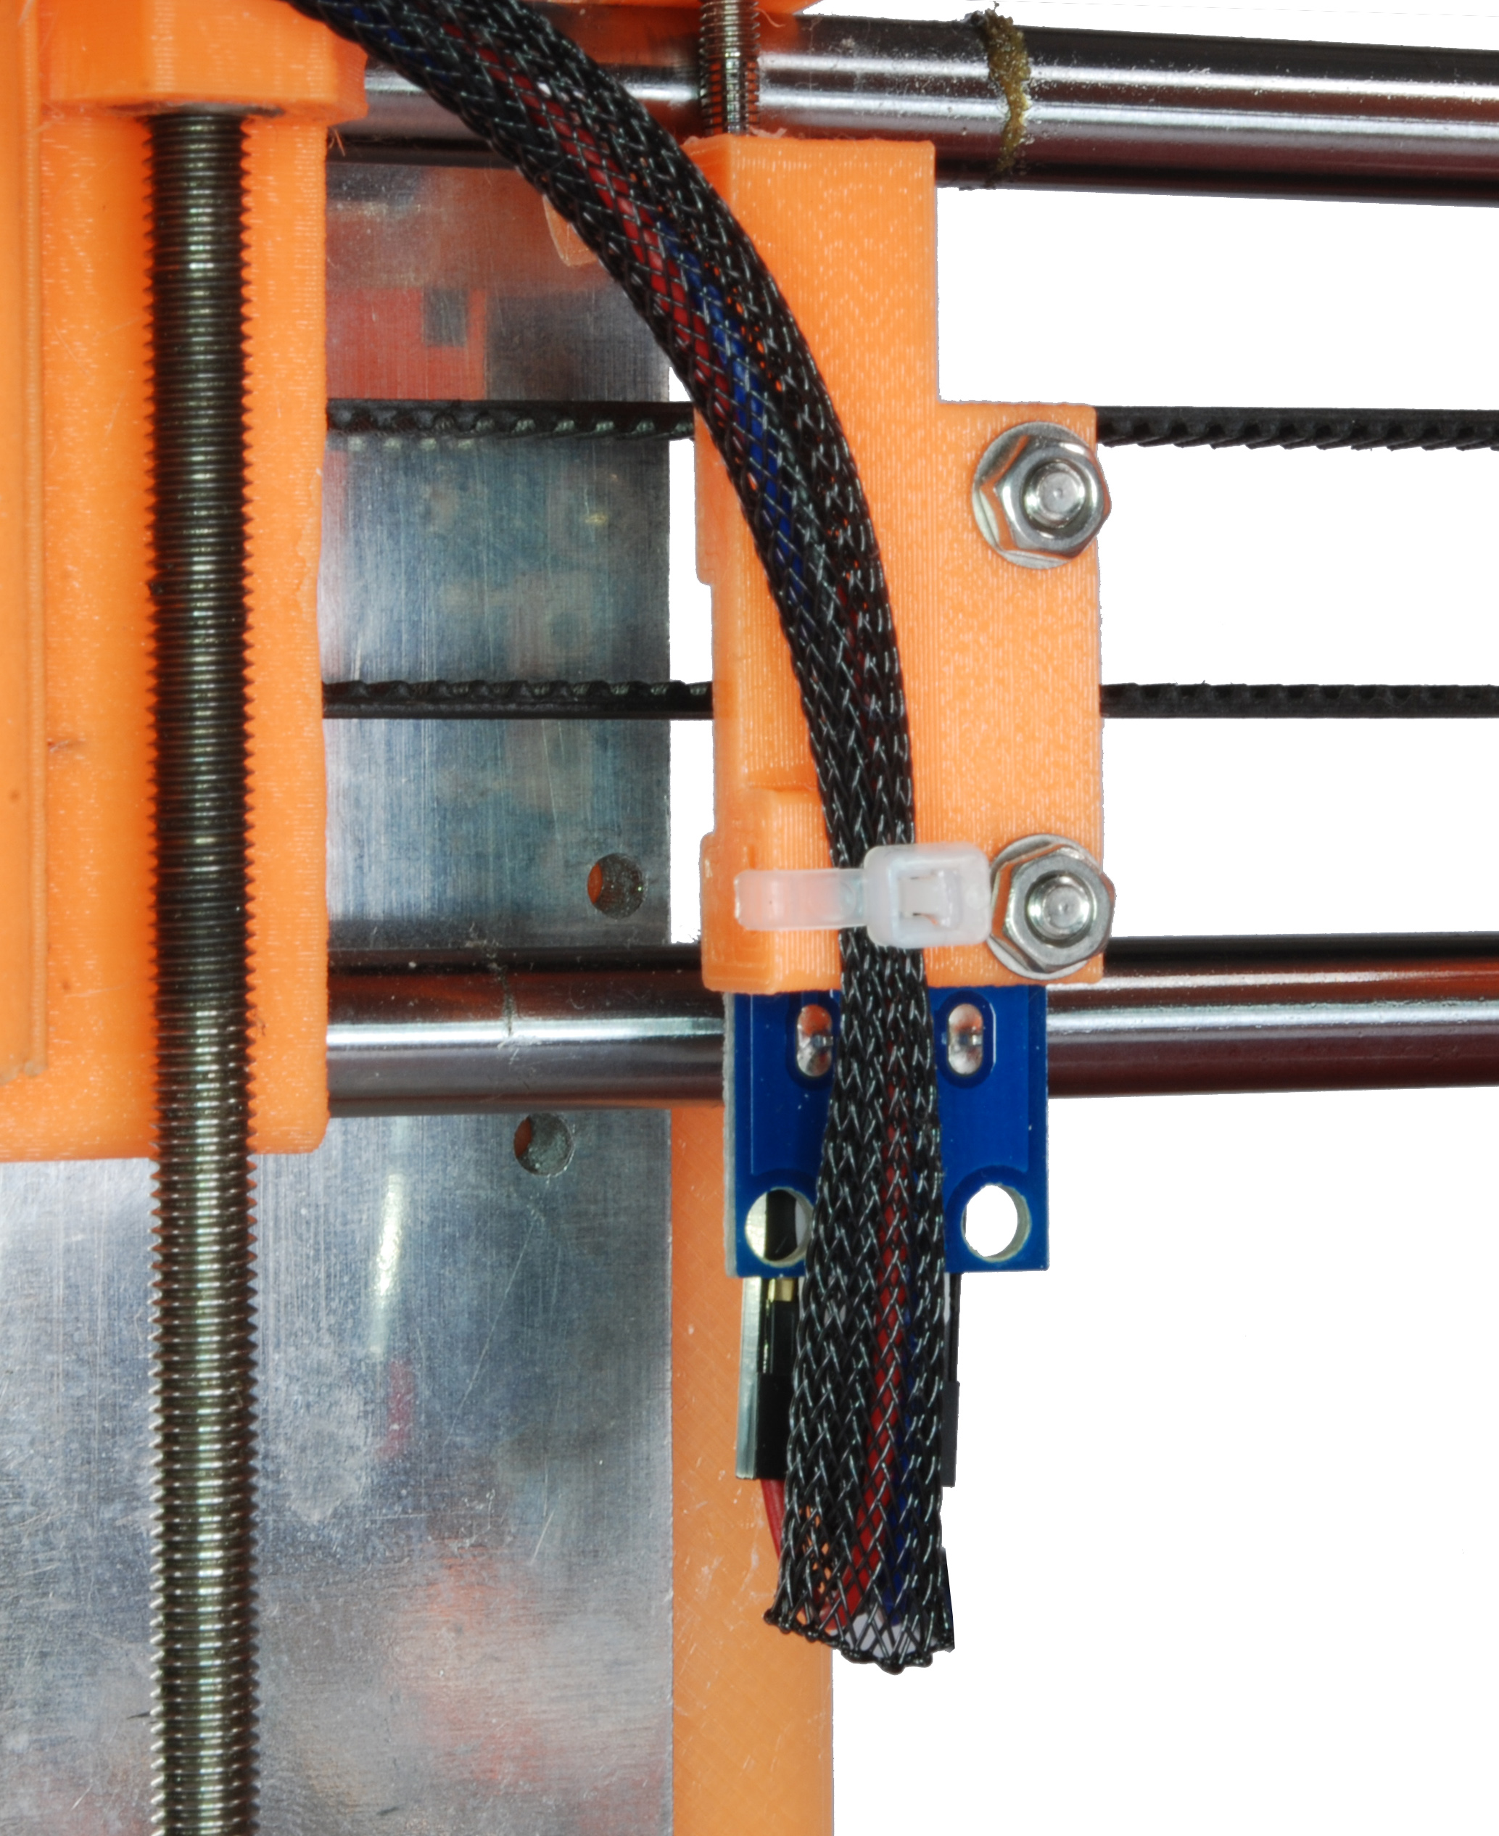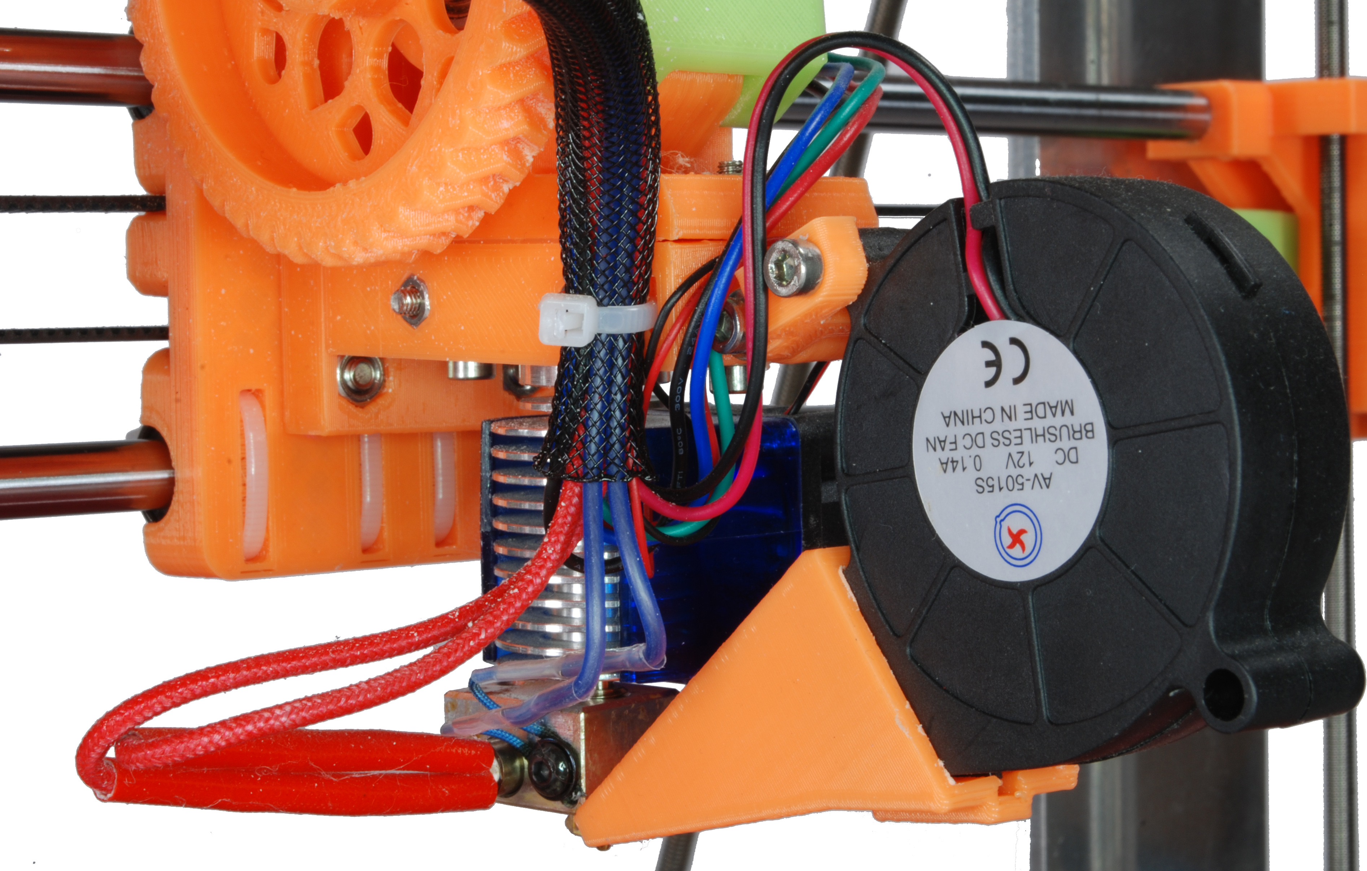

To ensure that the bundle of cables (power and thermistor) coming from the heated bed are routed correctly and do not foul, use a cable tie to gather them together near to where the power cables are soldered to the heated bed.

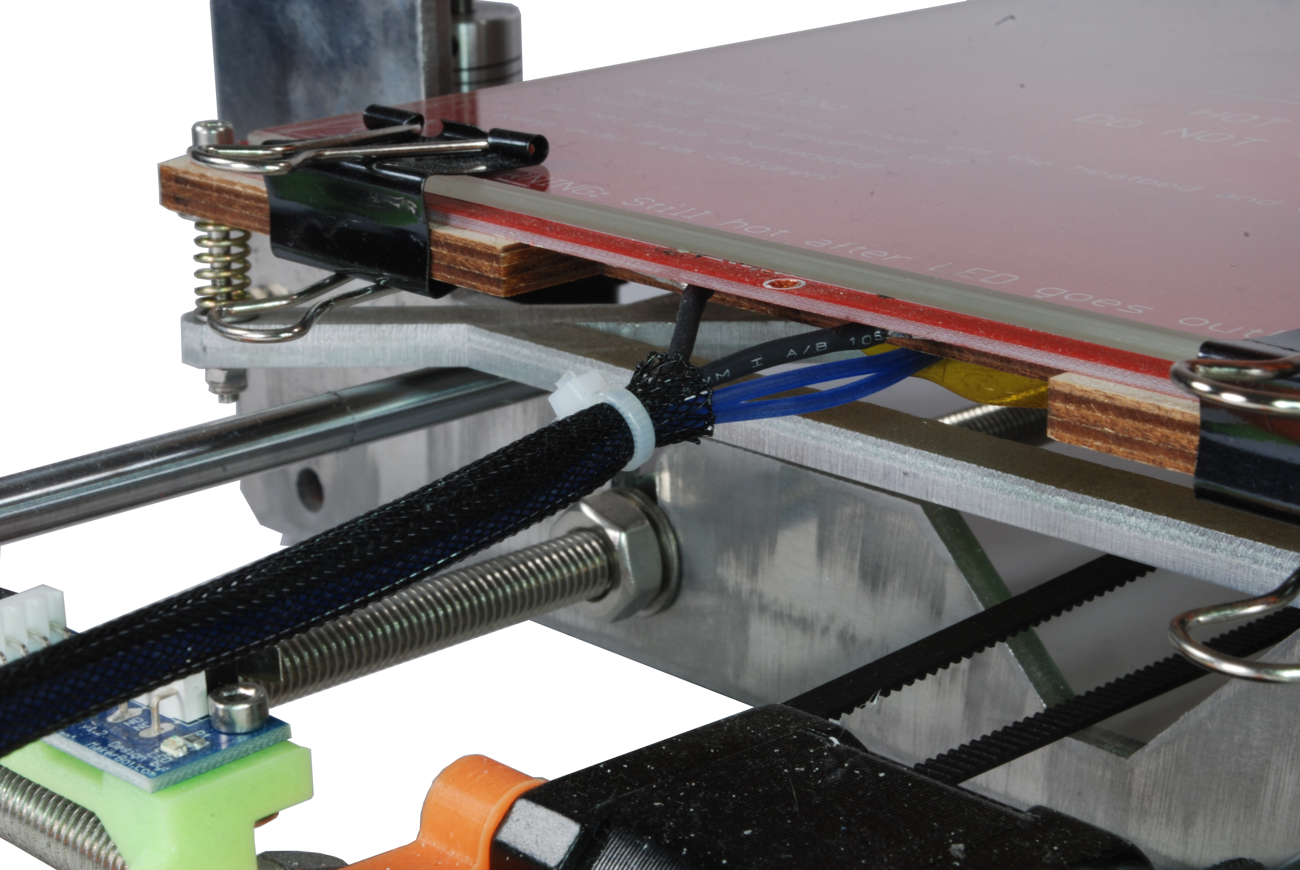

Extruder and Stepper Motors
The connections on the RAMPS board for the extruder and X, Y and Z axis stepper motors are clearly marked on the board as E0, X, Y and Z respectively, above their respective stepper drivers. Simply plug each stepper motor onto the correct pins, in the correct orientation. The two Z axis stepper motors plug into the two rows of pins above the Z axis stepper driver, one above the other.
Please ensure that the USB cable is disconnected from your RAMPS board and it is powered off before connecting or disconnecting stepper motors or you risk damage to the stepper drivers.

Extruder
Z Axis 1
X Axis
Y Axis
Z Axis 2

To orient the plugs correctly, look at the colours of the wires in the plug. These will either be red-blue-green-black, in order, or blue-red-green-black. For the former (red-blue-green-black), the black wire should be right-most when plugged into the RAMPS board. For the latter (blue-red-green-black), the black wire should be left-most. You won't damage your electronics if you get these the wrong way around – the stepper motor will simply rotate in the wrong direction.

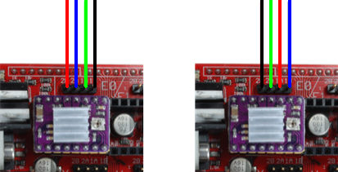

Thermistors
In the middle to the far right of the RAMPS board is a set of 6 pins labelled T0, T1 and T2. The hot end thermistor (blue silicon wires) plugs into T0 and the heated bed (also blue) plugs into T1. If you eventually add a second hot end to your printer, the thermistor for the new hot end will plug into T2. The orientation of the wires does not matter.

Heated Bed Thermistor
Hotend Thermistor

End Stops
The end stop cables are supplied in ribbon cable form with a single white connector at one end and four black connectors at the other. For each end, stop, plug the white connector into the end stop (it can only go in one way). The end stops plug into the 6 x 3 bank of pins above the thermistor connections, each thermistor into a vertical column of three pins. There are three connections for minimum travel end stops (supplied) and three for maximum travel end stops (not required). There are four connectors on each individual end stop that comes with the kit, but only three on the RAMPS board . The middle two connections are both common, or negative, and one of these (either one) can safely be left unplugged.
To connect the end stops properly, you need to connect the signal, common and positive pins from the end stop to the connections on the RAMPS board. Looking down on and end stop from the top, the pins are housed in white plastic on the left of the board. The top-most pin is the signal pin, the next two are common and the bottom is power.

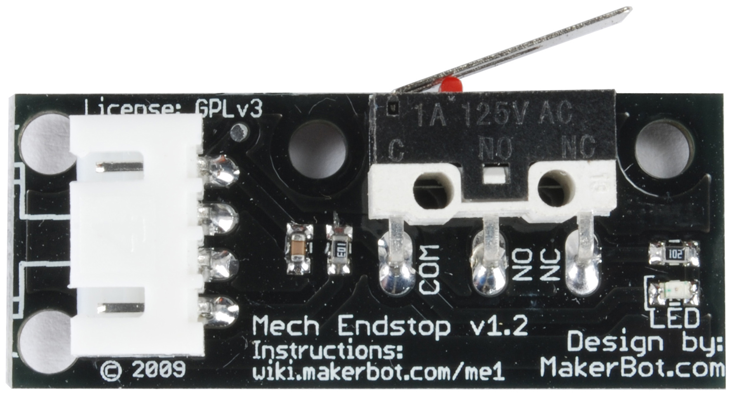
Signal
Common
Common
Power

Trace the signal wire from the end stop, down the connecting cable to the corresponding terminal at the end of the cable. This will plug into the topmost pin for the corresponding end stop on the RAMPS board. The next pin down is the common pin, onto which you can plug either of the ribbon cable's two middle connectors. The bottom-most is the power pin, onto which you can plug the last connector from the ribbon cable.

Signal
Common
Power

The X axis end stop plugs into the first column of pins, the Y into the third and the Z into the fifth. Your RAMPS board is also capable of supporting maximum-travel end stops, but these are not required for normal operation as the maximum travel is programmed into your board's firmware.

Z End Stop
Y End Stop
X End Stop

Smart Controller
Your smart controller package comes with the smart controller board, two ribbon cable connectors and an adapter for connecting to your RAMPS board.

Push the adapter board onto the pins at the far right of your RAMPS board and connect the two ribbon cables with the red striped cable on each oriented so they are at the bottom. If you were looking at your board as mounted on your printer, they would be oriented to the right.

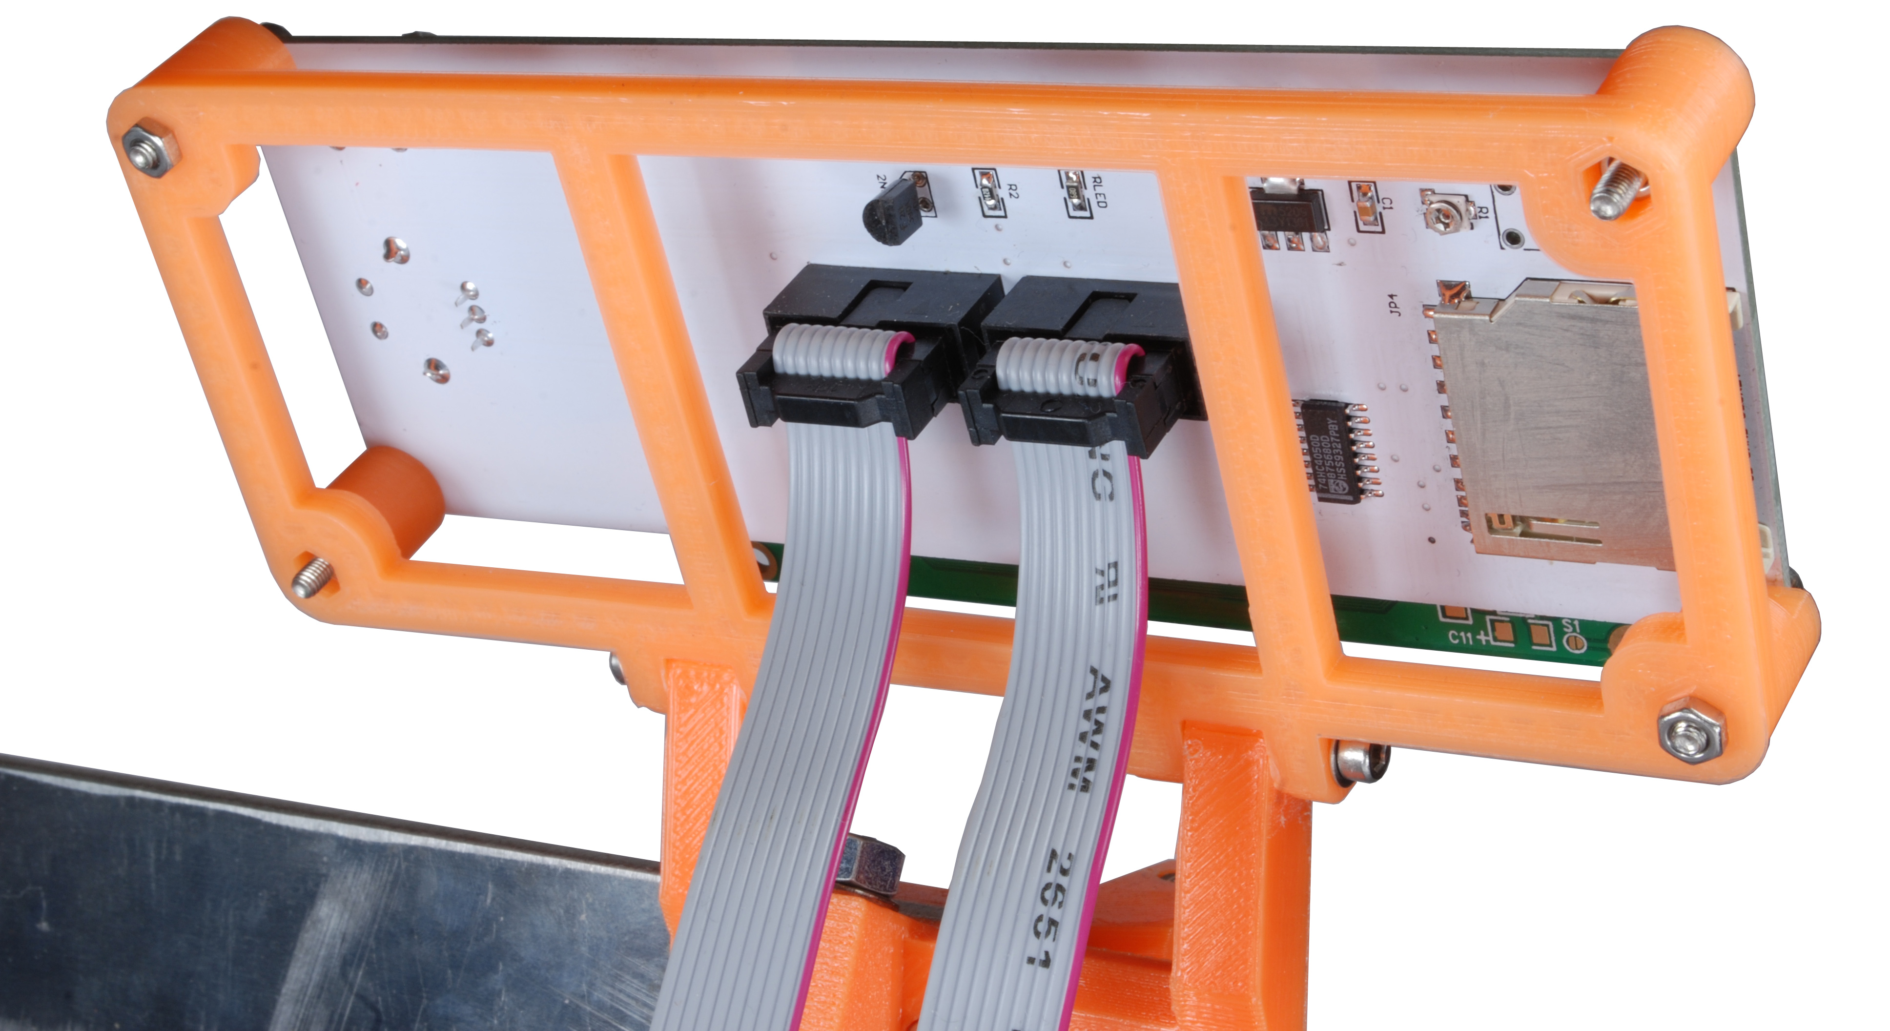

Connect the two cables to the back of the smart controller (your smart controller must be mounted to your printer for this step) with the red wire on each to the right, facing the back of the smart controller.

Heated Bed, Blower Fan and Hot End

Heated Bed
Blower Fan
Hot End

The heated bed, blower fan and hot end each connect to the terminals marked D8, D9 and D10 on the top left of the RAMPS board, respectively. The hot end does not have polarity: it has two red wires that can be connected to either way around to the D10 terminals. The heated bed and blower fan each have a red and black wire that need to be connected correctly. The blower fan needs to be connected to the D9 terminal with the red wire connected to the positive or lower of the two D9 screw connections as pictured above, and the heated bed to D8, with red to positive or lower again.

Power Supply and Cooling Fans
Before doing anything else with your power supply, first check that it is set to the correct input voltage. The voltage selection switch is on the right-hand side of the power supply, pictured below.
REMEMBER – please don't plug your power supply into the mains until all wiring is completed and you've double-checked it to make sure all connections are correct and none are loose. You're dealing with dangerous high voltages and large currents.

Input Voltage Selection Switch

The voltage selection switch should be set to 220V or 110V, as appropriate for your domestic supply (in the UK this is 220V).
Looking at your power supply from the front, there are 9 screw terminals beneath an amber plastic shield. Lift the shield from the front (it is hinged at the back) to get access to the screw terminals. These are, from left to right, 3 12v positive terminals, 3 common terminals and earth, neutral and live from your domestic supply.
Taking your white twin-and-earth cable, wire it to the power plug supplied with your kit according to the instructions with the plug (remember – brown is live and blue is neutral).

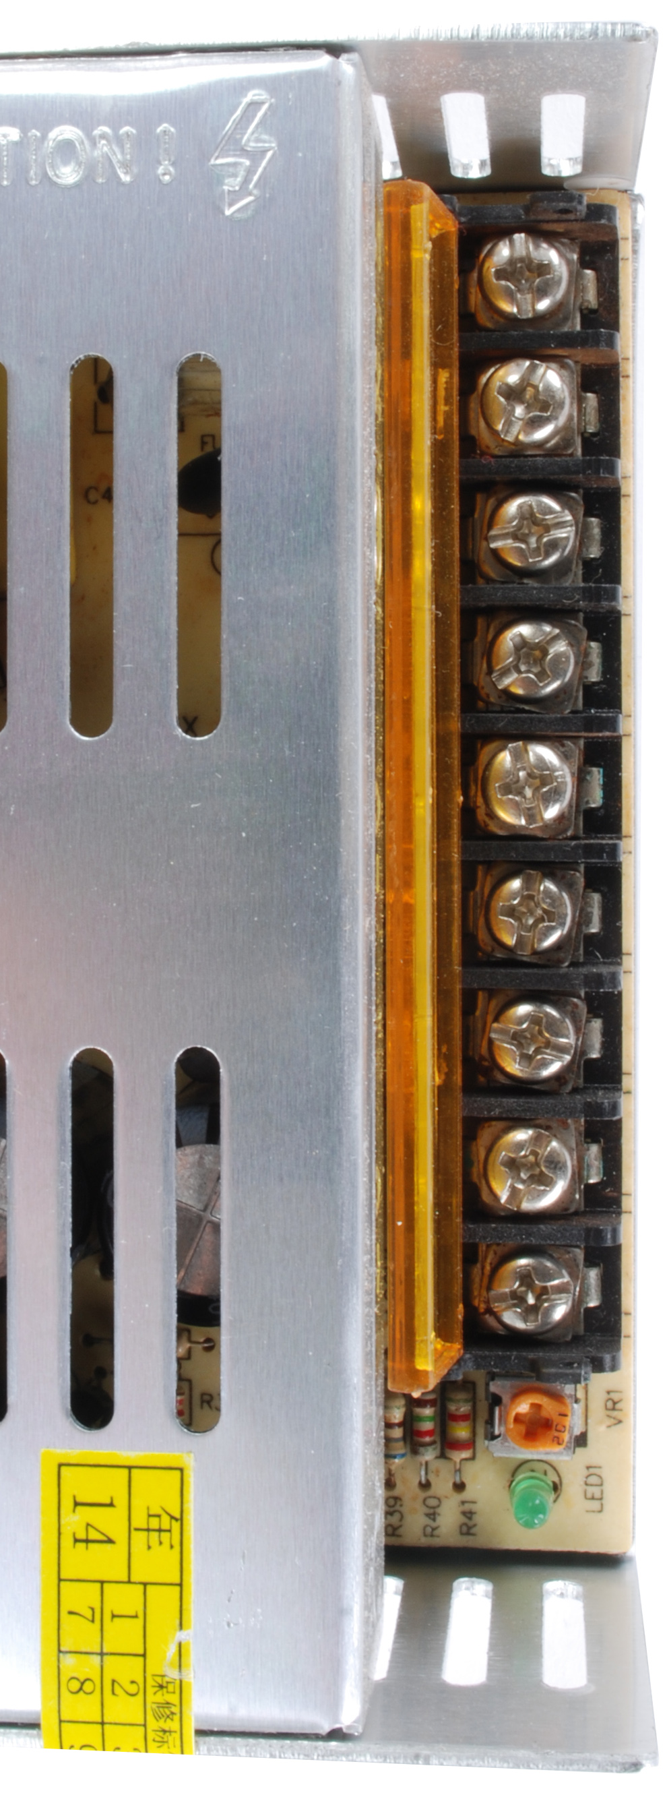
Live (Brown)
Common (Blue)
Earth (Yellow/Green)
Connect the brown, blue and yellow/green wires from the twin-and-earth cable to the live, common and earth terminals of your power supply respectively.

Blue (-ve)
Black (-ve)
Brown (+ve)
Yellow/Green (+ve)

Taking your black four-core cable, connect the blue and black wires to two of the negative terminals on your power supply and the brown and yellow/green wires to two of the positive terminals.

Brown (+ve)
Blue (-ve)
Yellow/Green (+ve)
Black (-ve)
Connect the other end of the four-core cable to the four screw terminals at the bottom left of your RAMPS board. The brown and yellow/green wires should connect to the two positive terminals, as marked on the board, and the blue and black to the two negative terminals.

E3D Fan (-ve)
E3D Fan (+ve)
RAMPS Fan (+ve)
RAMPS Fan (-ve)

Finally, connect the two red wires from the RAMPS cooling fan and E3D cooling fan and connect them to the remaining free positive terminal on the power supply. Connect the two black wires from the two fans to the remaining free negative terminal on the power supply. You can tidy your cables by using cable ties to join the fan cables to the four-core cable.
Please note that your printer will be powered as soon as you plug it in. To turn off your printer, disconnect it from the mains.
Assembly of your printer should now now be complete. You should have something that looks like this:

Commissioning and Calibration
Commissioning your printer is the process of making sure everything works the way it should do. Calibration is the adjustments required to get your printer printing at a high level of quality.

Commissioning your Printer
- Drop a little 3-in-1 oil onto each of the Y axis smooth rods and move the bed back and forth to ensure the rods are lubricated along their length. Drop a little onto a paper towel and wipe onto the Z axis smooth rods. The rods should be slightly oily to the touch. Drop a little onto each Z axis M5 nut. Don't overdo it – nothing should be dripping off.
- Plug your printer's power supply into the mains. The RAMPS and E3D cooler fans should start to spin and the smart controller should light up and display a welcome message. Be ready to unplug the printer in case of any short circuits. If the smart controller does not display a welcome message, unplug the printer and check the smart controller cables are plugged in the right way.
- Plug your printer's electronics into your computer using the supplied USB cable, start Pronterface and connect to your printer by selecting the printer's COM port from the combo box at the top-left of the Pronterface user interface, then clicking on the Connect button. If your printer's COM port does not appear in the combo box, click on the Port button and try again. Make sure the connection speed combo box is set to 115200 and click on the Connect button.
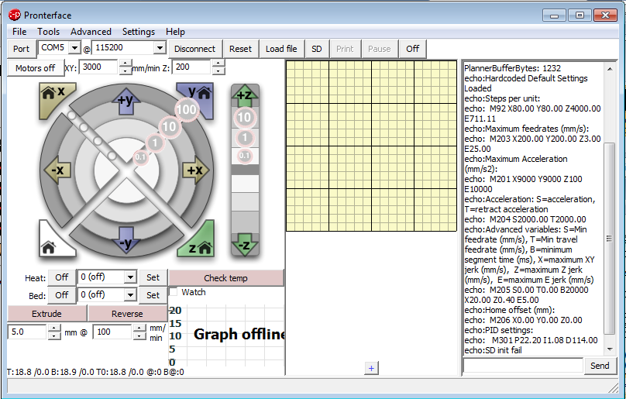
After a few seconds, you should see a series of messages relating to the configuration of your printer appear on the right hand side – this is where all messages from your printer will appear. Ignore the “SD init fail message” - this will appear if you do not have an SD card plugged in to your printer. If you don't, check the cable connection to your printer, the com port setting in pronterface and the connection speed.
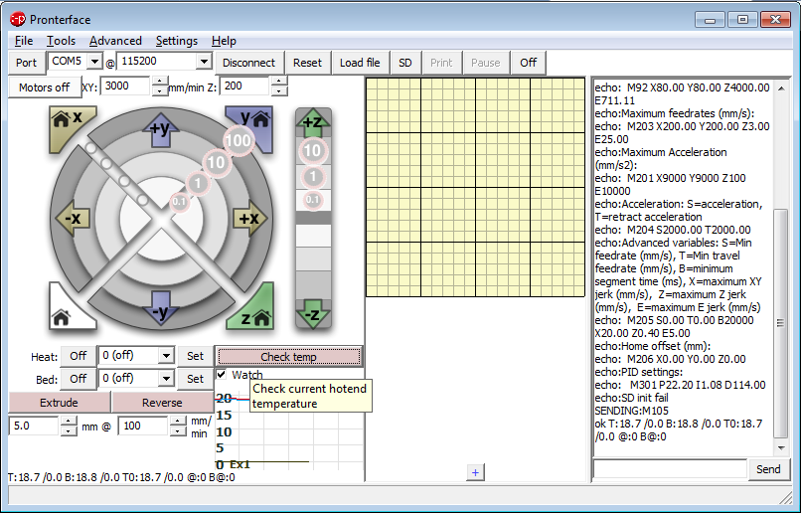
Click here to get temperature readings.
- Check if your printer's heated bed and hot end thermistors are wired correctly by clicking on the “Watch” check box above the temperature graph. You should start seeing temperatures in the graph and reported at the bottom-left of the window. Pronterface sometimes starts a little small, so click and drag on the bottom-right corner of the window to expand it, so you can see the full temperature graph and reported temperature. You will get a reported temperature something like this:
T:18.7/0.0 B:18.8/0.0 T0:18.7/0.0 @:0 B@:0
The first part of the temperature, T:18.7/0.0, reports on the current temperature of the currently selected hot end and the target temperature. In this case, the current temperature is 18.7 degrees celsius with a target of 0.0. We have not set a target temperature for the hot end, so the printer is reporting 0.0 as the target. The next part of the reading, B:18.8/0.0, gives the current and target temperature of the heated bed. In this case, 18.8 degrees celsius with a target of 0.0. The hot end and heated bed temperatures should agree within a few tenths of a degree and should reflect the ambient temperature of the room. You can also click on the “Check temp” button above the graph to get the current temperature.
- Check that the hot end is working correctly by selecting the value for PLA from the “Heat” combo box. Watch the graph and current temperature to make sure your hot end heats up to and stabilises at the correct temperature. If your hot end does not heat up, shut down pronterface, disconnect your printer from the mains and your PC and check your connections. Once you have tested your hot end, click on the “Off” button for the hot end.
- Check that the heated bed is working correctly by selecting the value for PLA from the “Bed” combo box. Watch the graph and current bed temperature to make sure your bed heats up to and stabilises at the correct temperature. It will take longer for your bed to heat up than your hot end. If your bed does not heat up, shut down pronterface, disconnect your printer from the mains and your PC and check your connections. Once you have tested your heated bed, click on the “Off” button for the bed.
- Check your end stops are wired correctly by clicking on the field to the left of the “Send” button at the bottom-right of the pronterface window, entering M119 and clicking on “Send.” The M119 command tells the printer to report endstop status. Your printer should respond with the following:
This means that each of the X, Y and Z end stops are currently open, or not triggered.
Reporting endstop status
x_min: open
y_min: open
z_min: open
- Test each of the end stops by pressing the lever with your finger until it clicks. An LED on the end stop should light up. With your finger still depressing the end stop lever, send M119 to the printer again. You should get the following, depending on the end stop:
Repeat for each of the end stops in turn.
If you don't get the results described above in steps g) and h), shut down, disconnect and check your end stop wiring.
Reporting endstop status
x_min: TRIGGERED
y_min: open
z_min: open

Move Z Axis Up by 1mm
Move Z Axis Down by 1mm
Move Y Axis Toward Endstop by 10mm
Move X Axis Away From Endstop by 10mm
Move Y Axis Away From Endstop by 10mm
Move X Axis Toward Endstop by 10mm
- Check the movement of the X axis by moving the X carriage back and forth along its full length of travel. Ensure it does not foul on anything and correctly contacts the end stop. Move the X carriage to the center of the print bed by hand, then use pronterface to move the X axis 10mm to ward the end stop, by clicking on the 10mm circle by the -X arrow. If the axis does not move or moves in the wrong direction, power down, disconnect and check your wiring and the location of the X end stop (it should be nearest to the motor mount). Move the X axis back to the center of the print bed by clicking on the 10mm circle by the +X arrow.
- Check the movement of the Y axis by moving the bed back and forth along its full length of travel by hand. Ensure it does not foul on anything and correctly contacts the end stop. Move the bed to the middle of its travel by hand, then use pronterface to move the bed 10mm toward the end stop by clicking on the 10mm circle by the -Y arrow. If the bed does not move or moves away from the end stop, disconnect, power down and check your wiring and the orientation of the bed. Move the print bed back to the center of its travel by clicking on the 10mm circle by the Y arrow.

Home X Axis
Home Y Axis
Home Z Axis
- Please read this entire step before undertaking it. Check homing of the X and Y axes by first clicking on the X home button, then the Y home button. When you click on the X home button, the X carriage should move toward the X end stop. If it does not, manually trigger the end stop to stop the movement, otherwise your printer may be damaged. When you click on the Y home button, the Y carriage should move toward the Y end stop. If it does not, manually trigger the end stop to stop the movement, otherwise your printer may be damaged.

Measure the distance between these two points.
Measure the distance between these two points.

- quare your X carriage to the frame by measuring the distance between the X motor mount and top mount on the left, and idler mount and top mount on the right. If they are not the same, manually turn one of the threaded rods to raise or lower that side of the X axis and re-measure. Rinse and repeat until the measurements are the same.
Distance between bottom of Z axis endstop and top of Z motor mount should be 50mm.
- Raise the Z end stop so it is 45mm above the Z motor mount, then check the Z axis movement by clicking on the second gray square above the -Z arrow. This should move the Z axis down 1mm. If it does not, power down, disconnect and check your wiring.
- Please read this entire step before undertaking it. Make sure the Z endstop is 50mm above the Z motor mount, screw the fine adjust screw on the X axis motor mount down so at least 10mm of its length protudes below the X axis motor mount, then press the Z home button on pronterface. The X axis assembly should move down until it triggers the end stop before the hot end touches the print bed, then stop. If it does not, manually trigger the end stop to stop the movement, then power down, disconnect and check your wiring.
- Move the X and Y axes to the middle of their travel (if you can't move them by hand, click on the “Motors Off” button on pronterface first). Slide a piece of paper under your hot end, then lower the Z end stop by a couple of mm and home the Z axis again. Repeat until the hot end is just above touching the paper.
Fine adjust with this screw.
- Use the Z axis height adjustment screw to fine-tune your Z height so that the hot end just touches the piece of paper on the bed. You should feel a slight drag when you pull the paper from under the nozzle. Adjust by turning the screw clockwise to raise or counter-clockwise to lower, then re-home the axis.
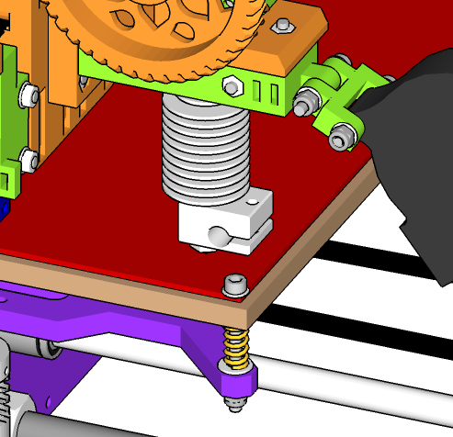
Move the hot end to each corner and adjust these screws in turn to level the bed.
- Level your print bed by moving the hot end to each corner of the print bed in turn, placing a piece of paper under the nozzle, homing the axis and using the screw in each corner of the bed to raise or lower that corner so the height is correct: so that the piece of paper slightly drags when pulled from underneath the nozzle. Be careful not to lower the print bed too much or the print bed screws will contact the aluminium frame as the bed moves back and forth on the Y axis.

Load filament in here.
Turn this gear clockwise to load filament.
- Raise the Z axis by about 30mm and use pronterface to heat the hot end to the temperature required for PLA (185 degrees Celsius) and wait until the correct temperature is reached. Load filament into your extruder through the guidler into the top until it contacts the hobbed bolt. Continue pushing on the filament and turn the large gear clockwise until the bolt engages the filament and starts pulling it through. Continue turning the large gear until you see filament start to ooze out of the hot end. Use pronterface to extrude 20mm of filament to check that the extruder is working correctly. If not, power down, disconnect and check your wiring. If you can't move the large gear by hand, use pronterface to turn off the motors first.

Set extrusion length here.
Press this button to extrude.

Calibrating Your Printer
There is an excellent guide to calibrating your printer on the reprap wiki here:
http://reprap.org/wiki/Calibration#Motherboard
Most of the calibration work has already been done for you and is contained in the pre-configured Slic3r settings for your printer, however it is worth running through the calibration process to familiarise yourself with the operation and tuning of your printer. Pay special attention to calibrating E-steps per mm – this can vary slightly from printer to printer of the same model and is important to get right for quality prints.
Start with section 3.6, bed surface preparation, and work through the reprap guide. The previous sections are covered in this manual.
In the reprap wiki calibration guide, you will cover:
- Calibrating your extruder to extrude the correct amount of filament.
- Calibrating your layer height slicing settings to your printer's optimum layer height (this has been pre-configured in the Slic3r settings available for your kit, but it is still a valuable calibration exercise).
- Calibrating your infill settings to print top layers well. Note that the calibration guide discusses Infill Width over Thickness, which is not a setting available in Slic3r. In Slic3r, where the reprap wiki says to adjust Infill Width over Thickness, instead modify the default extrusion width setting in Slic3r under Print Settings / Advanced. Where the reprap wiki says to adjust your feet rate, modify the extrusion multiplier setting under Filament Settings.
- Calibrating the correct temperature for the type and colour of plastic you use.
- Calibrating the perimeter width for your printed objects, to ensure your prints are dimensionally correct.
- Maximising your printer's ability to print bridges or print in mid air.
- Improving print precision.
- Reducing or eliminating oozing of molten plastic from your hot end.
- Improving the ability of your printer to print overhangs.

Printing With Your Printer
Now you've finished calibrating your printer, you're ready to start printing with it. We recommend printing two parts you can add to your printer that will help improve your prints and get you started with your printer. These are available on Thingiverse, along with thousands of other designs for objects you can download and prints. The two parts are:

A duct for your blower fan.  http://www.thingiverse.com/thing:494350 | 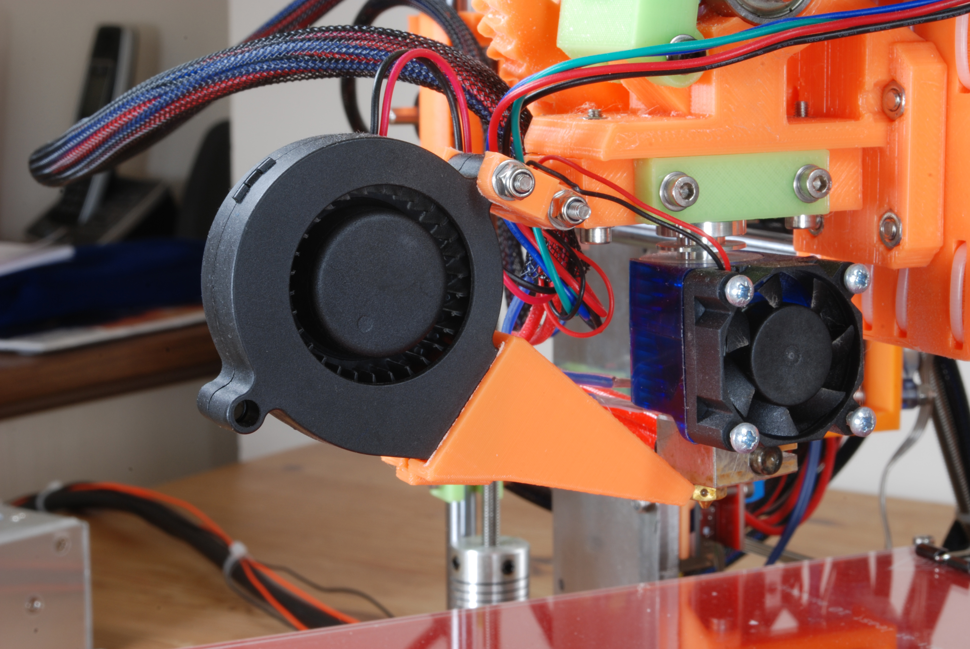
A guide and dust cleaner for your filament.  http://www.thingiverse.com/thing:494338 | 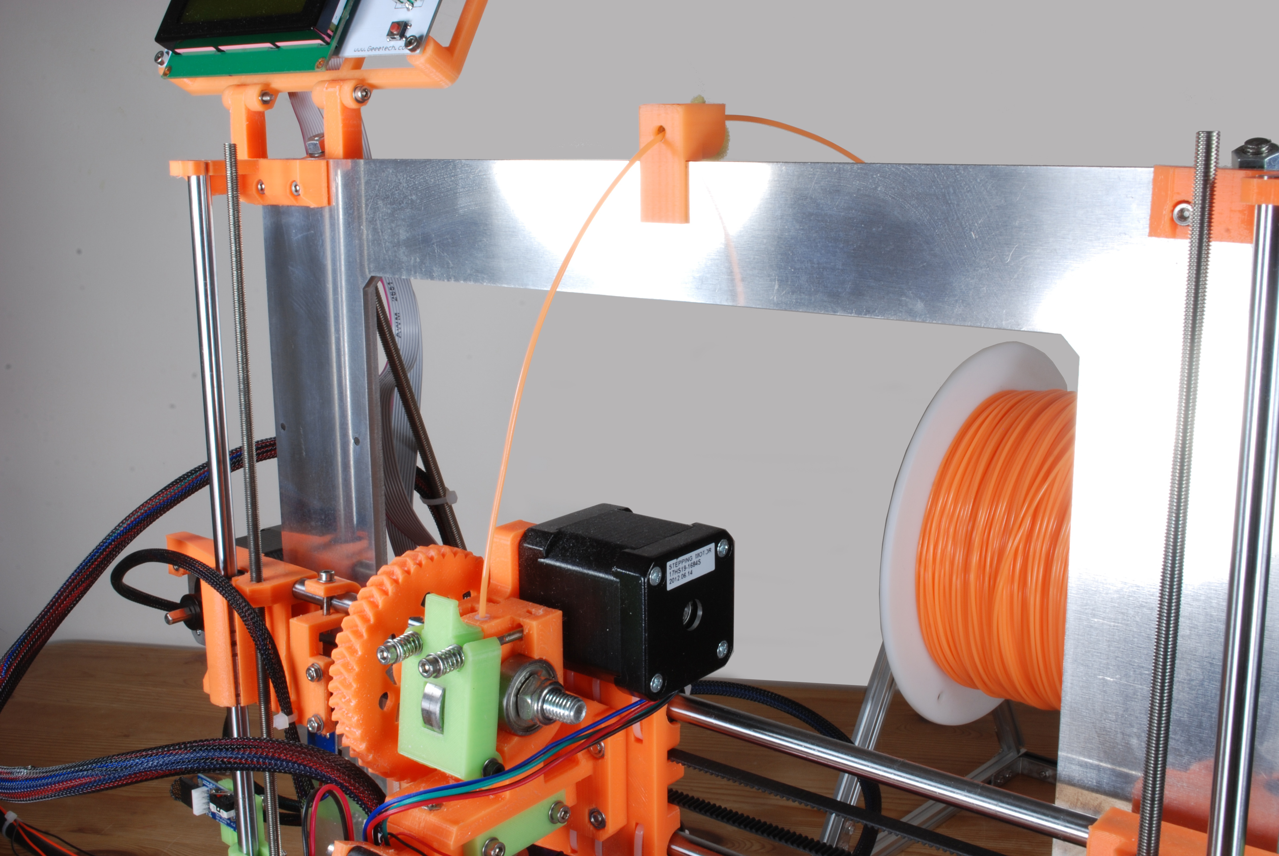

Printing with your printer is a three stage process:
- Download a design from Thingiverse, YouMagine or one of the other 3D design libraries, or create one using the CAD program of your choice such as Sketchup. Your design should be saved in the form of an STL file; this is the file type your slicing software requires.
- This is an optional step, but is good practice. Download and install Netfabb free version (http://www.netfabb.com) and load your STL file into it. NetFabb will tell you if there are any problems with your file and give you some basic options for repairing it, prior to slicing. It is always good practice to make sure your STL file is good before slicing, or you may end up with something impossible to print. If NetFabb free is unable to fix your STL file, you can use their online repair service at https://netfabb.azurewebsites.net/ - this generally does an excellent job of repairing problematical STL files.
- Start Slic3r. In the plater tab, make sure your printer settings are selected in the “Print settings,” “Filament” and “Printer” combo boxes on the right of the window (these are the settings you installed from the configuration bundle downloaded from our website in a previous chapter).
- Using a set of calipers, measure the diameter of your filament. This can vary slightly from manufacturer to manufacturer and roll to roll and is important to get right so the printer extrudes the correct quantity of plastic. Enter your measurement into Slic3r by clicking on the “Fiilament Settings” tab, then enter the measurement in the “Diameter” field in the “Filament” section. Save your settings by clicking on the diskette button next to the settings name combo box, then click on the “Plater” tab to return to the plater.
- Load your STL file into Slic3r either by clicking on the Add button on the Plater tab, or dragging an STL file from Explorer to the grid on the window.
- Click on the “Export G-code” button to have Slic3r slice your STL file and create a set of instructions for your printer. Make a note of where you save the file.
- Start Pronterface and connect to your printer by selecting the correct COM port at the top left of the window and clicking on the “Connect” button. Load the gcode file you created in the previous step, by clicking on “File” and “Open” in the menu. You should see a preview of the print appear.
- Click on the “Print” button at the top of the Pronterface window. You should see the heat graph at the bottom of the window start to show the bed heating. Once the bed has heated, the printer should home, heat the hot end then start to print. If you don't see the bed heating, make sure the “Watch” check box is selected. Pronterface will display the progress of the print as it progresses.

Maintenance

Regular Maintenance
Maintaining your printer is fairly straightforward. On a regular basis you should:

Action | Frequency
Clean the print bed. | Before every print.
Level the print bed. | Before every print. Once you have confidence that your bed is staying consistently level, you can perform this step less often.
Inspect all connections to ensure they are secure and not in danger of a short circuit. | Before every print.
Visually inspect the end stops to ensure they are in their correct positions and that they will be triggered correctly. | Before every print.
Visually inspect the printer to ensure the integrity of the printer. | Before every print.
Inspect plastic parts for signs of wear. Replace if needed. Don't forget you can download STL files from our web site to print your own replacement parts. Pay special attention to the herringbone gears on the extruder – these experience the most wear. | Every two months; more often if you use your printer frequently.
Inspect all smooth rods for lubrication: touch the rods to ensure there is oil on them. They should never be dry to the touch. Do the same for the Z axis threaded rods. | Every month; more often if you use your printer frequently.
Clean your hot end. | Every month; more often if you use your printer frequently.
Check and tighten all nuts and bolts. | Every month; more often if you use your printer frequently.
Check and tighten grub screws on pulleys. | Every month; more often if you use your printer frequently.
Check the tension on the X and Y belts. Tighten if needed. | Before every print.

Cleaning the Print Head
The print head needs to be regularly cleaned both internally and externally.
Clean the hobbed bolt by unscrewing the guidler tensioner bolts, releasing the guidler and blow out any debris from the hobbed bolt (a sharp breath or can of compressed air will do the trick).
Clean the outside of the nozzle of any old extruded plastic to prevent old burnt plastic contaminating your prints. This is easiest to do with a pair of tweezers when the hot end is hot.
Clean the inside of the nozzle to prevent it blocking by:
- Heating the hot end to 230 degrees celsius and push some filament through the nozzle, either manually by turning the large herringbone gear or by using pronterface.
- Set the hot end temperature to 100 degrees celsius and allow the temperature to stabilise.
- Retract the filament completely out of the extruder either by hand or using pronterface. You should see something like a straw at the end of the filament – this is created when the filament is dragged out of the hot end and should bring any contaminants out with it. You may need to vary the lower temperature by 5 degrees up or down to get his effect. Too hot and molten plastic will be left in the hot end; too low and the filament will break off.
- Rinse and repeat as necessary until you are confident your hot end is clean.

Licence, Attributions and Thanks

Licence
The 3DKi3 Prusa i3 Printer source (STL) files and manuals are provided under the Attribution - ShareAlike Creative Commons (CC BY-SA 3.0) licence, more detail of which can be found at http://creativecommons.org/licenses/by-sa/3.0/.

Attribution
The bulk of the 3DKi3 Prusa i3 3D Printer is derived from the Einstein variant of the Prusa i3 by JBFromOZ, http://reprap.org/wiki/JBFromOZ#Single_Plate_Style.
The X axis idler mount and belt tensioner are derived from the "i3 rework of z motor mount and x idler with tensioner" by djvdpant, http://www.thingiverse.com/thing:247992.
The frame braces are derived from "Stabilizer for Prusa i3 Z-axis – Diagonal bars + Gluepads" by paolo68, http://www.thingiverse.com/thing:100128.
The spider couplings are derived from "Spider Coupling with rubber insert: 4.75mm stepper motor to 8mm threaded shaft" by MiseryBot, http://www.thingiverse.com/thing:7678.
The extruder is derived from "Greg's Wade reloaded - Guidler, Tilt Screws, Fishbone Gears" by jonaskuehling, http://www.thingiverse.com/thing:18379.

Thanks
Many thanks to zoot from the reprap forums (http://forums.reprap.org/profile.php?262,39870) for his help improving and correcting the build manual.

